1
WORLD SOLAR GUIDE

Part 1

The Case for Solar Photovoltaics

An Analysis of the Potentials and Challenges

Jon D. Canaday, Ph.D.

jon.canaday@world-solar-guide.com

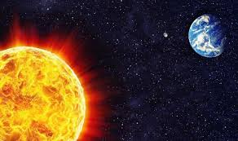

Image from detechter.com

Dedication

This guide is dedicated to the works of pioneering scientists during the past two centuries whose insights will provide significant contributions towards saving planet Earth in the twenty-first century. In the early 1800’s, Allesandro Volta, Humphry Davy, Michael Faraday, and William Grove developed foundations for electrolysis and fuel cells. Also in this period, Edmond Becquerel demonstrated the photovoltaic effect. During the late nineteenth century, Svante Arrhenius derived a model for atmospheric warming. In the nineteenth century and the first part of the twentieth century, James Clerk Maxwell, Max Planck, and Albert Einstein explained the nature of light in classical and quantum terms.

www.world-solar-guide.com

Copyright © 2023, Jon D. Canaday
2
World Solar Guide – Part 1
1. Introduction 5

2. The Earth in its Planetary Context 6
2.1 Our Solar System
2.2 Planet Temperatures

3. Energy Supplies 11
3.1 Fossil Fuels
3.1.1 Coal
3.1.2 Oil
3.1.3 Natural Gas
3.1.4 Fracking
3.2 Nuclear Energy
3.2.1 Nuclear Fission
3.2.2 Nuclear Fusion
3.2.3 Problems and Risks of Nuclear Energy
3.2.4 Reduction of Nuclear Weapons
3.3 Renewable Sources
3.3.1 Solar
3.3.2 Wind
3.3.3 Geothermal
3.3.4 Biomass
3.3.5 Hydro
3.3.6 Ocean

4. Energy Demand 24
4.1 World Energy Demand
4.2 The G20 Countries
4.3 The United States

5. Environmental Factors 28
5.1 The Carbon Cycle, Carbon Budget, Carbon Neutrality, and Carbon Debt
5.2 United Nations International Panel on Atmospheric Change
5.3 Paris Agreement of 2015
5.4 Inadequacies of the Paris Agreement Pledges
5.5 Pathways for Renewable Energy Sources
5.6 Renewable Energy for World Peace

6. Economic Considerations 42
6.1 Supply and Demand
6.2 GDP and Employment
6.3 Social Costs of Carbon
6.4 Carbon Tax/Trading

3
7. Projections of World Energy Supply and Demand 49
7.1 Energy Projections
7.2 Analysis of Transition Scenarios

8. A Plan for Global Solar Panel Installation 52
8.1 Can Solar Energy Alone Power the World?
8.2 Variable Renewable Energy
8.3 Solar Cell Materials
8.3.1 Photons and Materials (Summary of Appendicies)
8.3.2 Materials and Efficiencies
8.4 Plan Assumptions and Limitations
8.5 Global Installations of Solar Panels
8.6 Cost Analyses
8.6.1 Module Costs
8.6.2 Installation Costs
8.6.3 G20 Installations
8.6.4 Levelized Cost of Energy
8.6.5 Subsidy Costs
8.7 Financing Renewable Energy Projects
8.8 Current and Projected Installations
8.9 Comparison of Energy-Source Land-Use Areas
8.10 Guidelines Limitations
8.11 Areas for Research and Development
8.12 Space-Based Solar Power
8.13 Comparison of Solar Systems
8.14 The Future of Solar Photovoltaic Energy
8.15 A Simple Management Model
8.16 Educational Programs for Renewable Energy and Environmental Sciences
8.17 Professional Organizations for Solar Energy

9. Summary of Perspectives 92

10. Conclusions 94
11. References 95

12. Appendices
12.1 Appendix 1, Arrhenius Model for Atmospheric Warming, 1897 99
12.2 Appendix 2, Planck Radiation Law, 1900 115
12.3 Appendix 3, Einstein Photoelectric Effect, 1905 136
12.4 Appendix 4, Physics and Technology of Solar Cells 137
12.4.1 A Brief History of Solar Cells 137
12.4.2 Solar Irradiance and Photon Flux Spectra 138
12.4.3 Solar Cell Operation 139
12.4.4 Matching Irradiance Spectra and Cell Response 147
12.5 Appendix 5, Units, Measurements, and Conversion Factors 148
4
World Solar Guide – Part 1

Abstract

Part 1 of this guide presents a plan for the global replacement of fossil fuels entirely with solar energy in the active mode, particularly utility-scale photovoltaic (PV) cell panels integrated into electric power grids. In Part 2, mitigating solar variability with the electrolysis of water and storage of green hydrogen is considered. When used passively, solar energy can also be used to reduce the expenditures for heating residential and commercial buildings. Although several sections, primarily the appendices, contain technical information, most of the guide is presented for non-technical readers.

Current and projected levels of world energy supply and demand are considered essential components of this guide. Environmental concerns relating to global warming are reviewed in the context of the Paris Agreement for limiting this warming trend to 1.5 C or 2.0 C by 2100. The inadequacies of this Agreement’s signatory pledges are considered as are the subsequently proposed pathways to meet these goals by 2050 or 2100.

Historical and educational bases of the scientific and technological aspects for solar energy and photovoltaic devices are presented pedagogically in the appendices. Derivations of basic atmospheric models and Planck relations are also given. These appendices are unique features among similar guides, pathways, and proposals. In addition, Section 8 of the guide shows explicit calculations for G20 solar panel installations.

As the guide is focused on PV solar energy, its total cost for the G20 countries is estimated to be about $35 trillion over the transition period of 30 years from 2020 to 2050. This cost represents an average 1.8% level of GDP for these countries. The cost is also considerably less than other more-extensive, referenced renewable-energy (RE) proposal worldwide costs in the range of about $50 trillion to $100 trillion over this period, or approximately $2 trillion to $3 trillion per year. These cost estimates will be roughly equal to or less than the costs of fossil-fuel subsidies or the social costs of carbon. Investments in renewable energy will be derived primarily from private sources.

The largest emitters of excess greenhouse gases, China, the United States, and India are also the largest producers of solar power and will have the most to gain from this transition. In addition to the environmental benefits of renewable energy sources, their installations will also result in increased GDP values and net energy-sector employment gains for the participating countries. Barriers to the installation of 100% renewable sources are considered to be political, institutional-regulatory, and societal-cultural, rather than economic-financial or scientific-technological. Among the technological barriers, storage remains one of the most significant. It is concluded that solar photovoltaics will continue to provide a viable and essential component of renewable sources and for the reduction of global-warming effects due to the increased excess atmospheric emissions of carbon dioxide, methane, and other greenhouse gases, 70% of which are caused by anthropomorphic activities.

5
World Solar Guide – Part 1
1. Introduction

The causes of global warming are well-known, with the primary cause being the oxidation of fossil fuels, resulting in excess greenhouse gases, primarily CO₂. Evidence for this cause includes the direct correlation between carbon emissions and atmospheric temperature.

Somewhat more obscure than this trend is the relationship between the warming of the earth’s atmosphere and its natural carbon cycle. Investigations have attempted to quantify the environmental analyses in terms of a carbon budget and a carbon debt.

The consensus view concerning global warming is that the most effective means of mitigating this trend is the replacement of fossil fuels with renewable energy sources. However, there is no consensus regarding factors such as the carbon budget. Variations are due to the fact the models employ different, goals, inputs, and assumptions. Among the many models (including sophisticated computer simulations), methods, scenarios, pathways, proposals, and perspectives currently available for review, only a few of these sources will be cited in this guide. The time frame here is 2020 to 2050. The Paris Agreement targets have been set at 1.5 C or 2.0 C in a time frame extending to 2100. It is emphasized that since the baseline temperature of 1850, the temperature has already increased by 1.0 C, leaving the remaining limits of only 0.5 C or 1.0 C.

The objectives of this guide are stated as follows:

1. Place consideration of planet Earth in the context of our solar system
2. Compare the world’s energy supplies and demands with projections to 2050
3. Review the earth’s environmental factors as bases for energy policy
4. Discuss economic impacts of renewable energy during the transition period, 2020-2050
5. Develop a resource, with technical/financial analyses, for the global installation of solar panels
6. Summarize the various global-warming mitigation perspectives
7. Derive conclusions from this study
8. Demonstrate, in pedagogical terms, the scientific and technological bases for solar energy

While the renewable sources of solar, wind, bio-energy, hydro, and perhaps others will contribute to the reduction of this warming trend, the scope of the guide will be limited to solar energy, particularly utility-scale photovoltaic (PV) solar cells and panels. Here, basic technical and financial analyses, together with cost projections for the G20 countries, will be presented. As such, the plan is less complete and less costly than those of some references. Nevertheless, this guide may be considered as complementary to the results developed by others.

It is also anticipated that young readers of high school and college age may find this guide useful in determining their educational and career paths. Renewable energy will offer exciting opportunities to develop a sustainable planet Earth. Education in the areas of chemistry, physics, biology, environmental sciences, agriculture, forestry, engineering, economics, business management, law, and government will prepare students to make significant contributions in this field.
6
2. The Earth in its Planetary Context

2.1 Our Solar System

The sun is located in the Milky Way Galaxy, a member of the Local Group of Galaxies, two thirds of the way from the galactic center. With a diameter of 75,000 light years, the Galaxy, shown schematically in Figure 2.1, has a rotational period of 300 million years. Our galaxy and the universe, are about 13 billion years old.

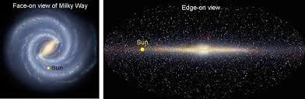

Figure 2.1 Schematic diagram of our sun in the Milky Way Galaxy. Image from earthsky.org

In Figure 2.2 a periodic table shows the stellar origin of the chemical elements found on Earth. Most elements were produced by remnants of small and large stars as well as by supernovae in our region of the galaxy. The solar system was subsequently formed from the condensation of interstellar gas and dust.

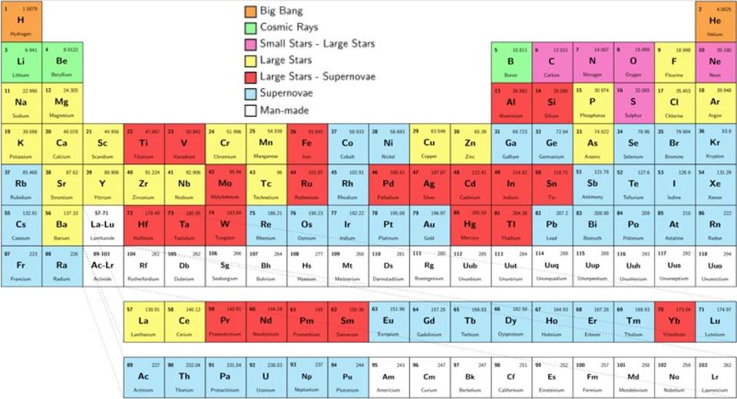

Figure 2.2 Periodic table showing stellar origin of the elements.
Image from sciencesprings.wordpress.com
7
Our solar system contains nine planets, an asteroid belt between Mars and Jupiter, and the Kuiper belt located beyond the orbit of Pluto as seen in Figure 2.3. It is interesting to note that the plane of the Earth’s orbit, called the ecliptic plane, is inclined at an angle of 62 degrees relative to the galactic plane.

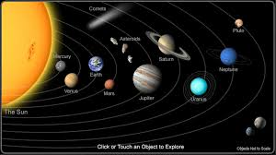

Figure 2.3. The Solar System. Image from seasky.org

Clyde Tombaugh (1906-1997) was a Kansas farm boy who built his first telescope with tractor parts. In 1930, Clyde discovered the planet, Pluto, at the Lowell Observatory in Flagstaff, Arizona, Figure 2.4. Using a blink microscope, hundreds of photographic plates taken with the telescope were compared, looking for motions of faint objects. The motion of one object, relative to the stellar objects, turned out to be Pluto. Dr. Tombaugh was awarded a degree from the University of Arizona and taught astronomy at New Mexico State University. On many occasions, he told the story of his discovery, recalling that when viewing these plates, he intermittently had to check for bears peering into the observatory.

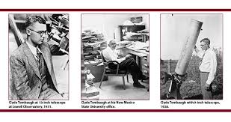
Figure 2.4. Clyde Tombaugh. Image from contentdm.nmsu.edu

8
In 2006, the spacecraft, New Horizons, was launched towards Pluto using the planets, Jupiter, and Saturn, as gravitational “sling shots” to propel the spacecraft, Figure 2.5. After a ten-year flight, the spacecraft revealed astonishing photographs of the furthest planet from the sun. As Pluto is about 70% the size of our moon, it has been re-classified as a dwarf planet; Pluto also has five moons.

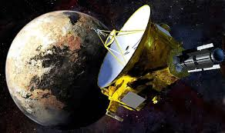

Figure 2.5. Spacecraft leaving Pluto. Image from express.co.uk

Our comfortable Earth, the only planet in the solar system with advanced life forms, lives amid a variety of extremes. With nuclear fusion reactions powering the sun, its core temperature is 20 million K and its surface temperature is 5,778 K, Figure 2.6.

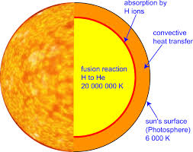

Figure 2.6. The sun. Image from pveducation.com

The age of the earth has been accurately determined to be 4.56 billion years with early life forms beginning around 3 billion years in the past, as organic material began to form fossil fuels 300 million years ago, and human-type species dating to approximately 3 million years before the present. As the solar system’s age is about one-third that of the universe’s age, previous generations of stars within the Milky Way galaxy have been able to “cook” the elements during their life cycles which are now present throughout the solar system and on the earth as seen in the period table of Figure 2.2.

9
2.2 Planet Temperatures

The “inverse square law” states that the intensity of electromagnetic radiation or electric and gravitation force fields decrease as 1/r² as shown schematically in Figure 2.7.

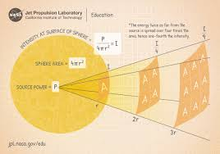

Figure 2.7 The inverse square law. Image from jpl.nasa.gov

An example of the inverse square law is a calculation of the solar irradiance at Mars. The “Solar Constant” is the solar irradiance at the top of the earth’s atmosphere, 1,368 W/m². The distance to Mars, as measured in “astronomical units,” or a.u. is 1.5 a.u., where one a.u. is the distance from the sun to the Earth, 1.5 x 10¹¹ m. From the inverse square law, this irradiance at Mars is given by:

I_{M} = I_{E}[r_{E}/r_{M}]²

or

I_{M} = 1,368 W/m² [1.0/1.5]² = 608 W/m²

A similar calculation for Pluto at an average distance from the sun of 39.5 a.u. gives an irradiance of 0.877 W/m². Thus, a solar panel of 10 m² with an efficiency of 20 % would produce only 1.74 W.

As will be shown in subsequent sections of this guide, the earth’s “Solar Constant” is a fundamental parameter in the analysis and development of solar cells. The solar irradiance at the zenith on the earth’s surface is approximately 1,000 W/m² as about 30% of the solar irradiance is absorbed by the atmosphere or reflected back into space.

10
As might be expected, planet temperatures decrease with distance from the sun. This decrease, however, does not follow the inverse square law as shown in Figure 2.7 because the surface temperatures also depend on planet atmospheres. Planet temperature are shown in Figure 2.8.

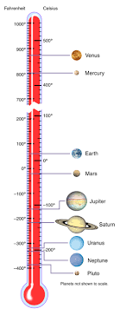
Figure 2.8. Planet Temperatures. Image from solarsystem.nasa.gov

It will be shown in Appendix 1 that the earth’s temperature without an atmosphere would be about – 18 C and that the actual and current temperature, due to the normal greenhouse-gas effect within the atmosphere is, on average, around + 15 C. Thus, the greenhouse gases, primarily carbon dioxide and methane, have added +33 C to an otherwise uninhabitable planet. It is the excesses of these gases since the beginning of the Industrial Revolution in 1750 that have caused global atmospheric warming.

Surprisingly, the slight increase in the earth’s atmospheric temperature of only1 C has now placed this temperature-sensitive ecosystem in jeopardy with the threat of an additional rise in temperature in the range of 2 C to 4 C during the 21st century. Such increases will cause irreversible damages to the habitats and living species of our planet.

11
3. Energy Supplies

3.1 Fossil Fuels

Even before recorded history, inhabitants of the earth have used various forms of fossil fuels.

Beginning around 1750, at the start of the Industrial Revolution, the use of these fuels increased as did the concentration of CO₂ in the earth’s atmosphere from its earlier value of 290 ppm to the present level of 400 ppm. The basic physics and chemistry of global warming is discussed in Appendix 1. Chronologically, fossil fuel use has consisted of coal, then oil, and then natural gas. A brief summary of fossil fuel utilization will be presented here.

3.1.1 Coal

Coal was first formed in the Earth around 300 million years ago from plant materials [3.1]. Heat and pressure produced coal in various forms. This non-renewable fuel was used by early man, and a brief history is outlined here.

100-200 AD Romans used coal near Hadrian’s Wall in England
1300’s Hopi Indians used coal to make pottery
1673 Coal was later discovered in United States by explorers
1770’s James Watt used coal in his new invention, the steam engine, at beginning of the
Industrial Revolution
1875 Coke, made from coal, was used to make steel
1961 Coal became the largest fuel source to generate electricity in the United States

3.1.2 Oil

Oil has been the world’s primary source of energy since 1900 [3.2].

3000 BC - Early uses of oil have been found in China
1859 – Edwin Drake discovered oil in Northwestern Pennsylvania
1865 – John D. Rockefeller became first oil baron
1901 – Spindletop field discovered in Texas
1907 – Standard Oil, Royal Dutch Shell, and British Petroleum became first major companies
1960 – OPEC formed

3.1.3 Natural Gas

Natural gas consists primarily of methane, CH₄, and an oxidation product is CO₂ [3.3]. Because of this molecule’s complex structure relative to that of carbon, CO₂, it has more ways of absorbing the Earth’s emitted blackbody radiation in the infrared region of the electromagnetic spectrum and, therefore, is 30 times more potent as a greenhouse gas than is CO₂. Even though its concentration is less than that of CO₂, increasing methane from anthropogenic sources is the second leading cause of global warming.

12
A few historical events of natural gas are shown here:

1000 BC – Oracle at Delphi built in Greece
500 BC – Chinese used bamboo pipelines
1626 – Naturally occurring gas identified by French explorers near Lake Erie
1785 – First commercial use of gas in Britain to light houses
1816 – Baltimore, Maryland used gas for street lights
1836 – Philadelphia, Pennsylvania created first municipally owned gas distribution company
1885 – Bunsen burner invented
Early twentieth century- gas pipelines developed
Today – Gas provides half of US energy consumed by residential customers and 40% of
industrial energy

World fossil fuel usage is shown in Figure 3.2.

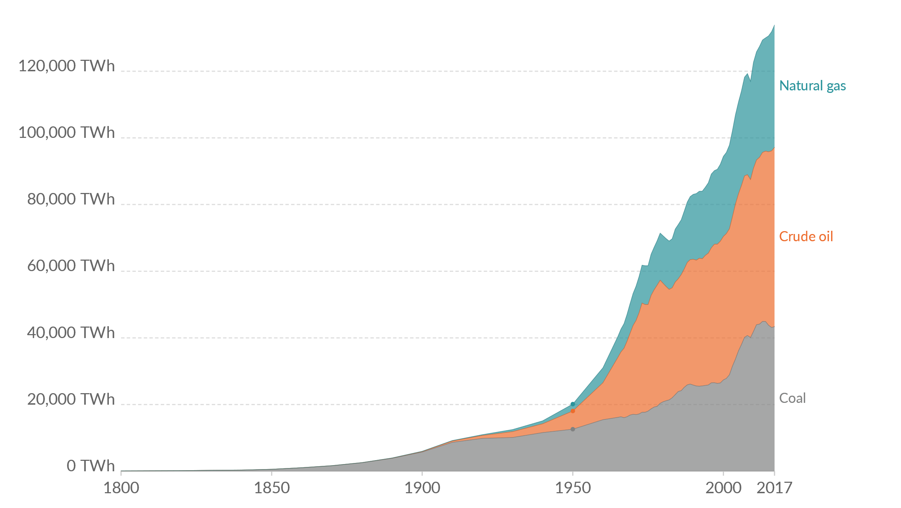
Figure 3.2 Growth of fossil fuel use. Image from ourworldindata.org/fossil-fuels

13
The quantities of the earth’s fossil fuels are limited, and their estimated remaining lifetimes are shown in Figure 3.3.

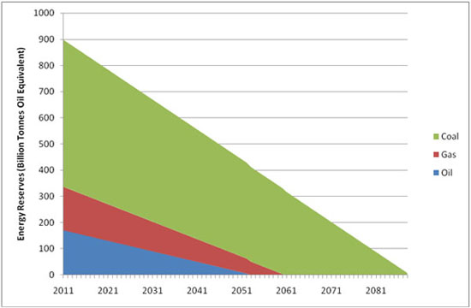

Figure 3.3 Projected lifetimes of the fossil fuels. Image from ecotricity.co.

3.1.4 Fracking

The term, “fracking” refers to the process, “hydraulic fracturing,” in which fluids (liquids or gases) are injected into existing oil and gas wells for the purpose of extracting additional fuels. In 2020, the US EPA [3.4] released a report concerning the environmental impacts of this process. The analysis reviewed about 1,200 cited sources of data. The following severe impacts on drinking water were cited:

- Water withdrawals in times of low water availability or limited ground water
- Chemical spills reaching groundwater resources
- Injection of fluids allowing gases or liquids to move to ground water resources
- Fluids directly injected int ground water resources
- Discharge of inadequately treated waste water to surface water resources
- Disposal or discharge of waste water into unlined pits resulting in contamination of ground water resource

Environmental Health News [3.5] reported that fracking has been related to pre-term births, high-risk pregnancies, asthma, migraine headaches, fatigue, nasal and skin disorders during the past 10 years.

14
A map of American fracking sites is shown in Figure 3.4. It is estimated that 50% of the oil and 67% of the natural gas produced in the US result from fracking [3.6]

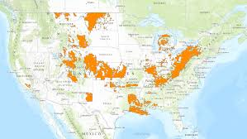

Figure 3.4 Fracking sites in the US. Image from climatecentral.org

Earthquakes have not observed until recently in Oklahoma. Figure 3.5 shows a record of these earthquakes attributed to fracking [3.7].

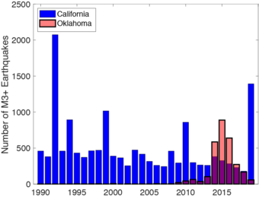
Figure 3.5 Earthquakes related to fracking. Image from usgs.gov

According to The Institute for Energy Research [3.8], the US EIA “credits fossil fuels for one of the most profound societal transformations in history.” In the interest of Earth’s survival, it is stated in this guide that the age of fossil fuel consumption should last only 300 years, from 1750 to 2050. By comparison, the natural production of fossil fuels began 300 million years ago. Furthermore, it is imperative that these non-renewable, temporal sources be replaced by renewable energy within a generation.

15
Just as the dinosaurs, along with 90% of the world’s living species, became extinct 65 million years ago when a meteor struck the Yucatan Peninsula, so will fossil fuels become depleted. The most expeditious date will be by 2050, but almost certainly, these fuels will become extinct, either physically or economically, by 2100. The causes for their extinctions will be based primarily on their availability, i.e. their depletion and therefore on their costs relative to renewable sources. The costs of renewables have also experienced a dramatic decrease during the past half century as will be seen in Section 8.

A crude “supply and demand” model of fossil fuel is presented in Table 3.2. The point of the illustration is to show that while fossil fuels were produced on a geological time scale, their utilization and depletion by civilization has occurred in a very short historical period.

Table 3.2 Supply and demand of fossil fuels.
Natural Supply of Fossil Fuels | Demand for Fossil Fuels
Fossil fuels began forming in the earth from organic matter in the Carboniferous period about 300 million years ago.  The ratio of the supply/production period  to the demand/consumption period is  Production period = 300 million years  Consumption period 300 years  = 1 million  1  Thus, this ratio of formation to use periods is  one-million to one. | A “societal transformation.”  Most fossil fuels will have been consumed during the “Industrial Era” dating from 1750 to 2050, a period of only 300 years.

16
3.2 Nuclear Energy

3.2.1 Nuclear Fission

In nuclear fission reactions [3.9], atomic nuclei are bombarded with neutrons, splitting the nuclei and releasing energy. This process can be controlled with slow chain reactions as in a nuclear reactor or with rapid reactions in nuclear weapons. Figure 3.6 shows a fission reaction in which U-235 nuclei are bombarded with neutrons resulting in U-236 nuclei and the release of energy.
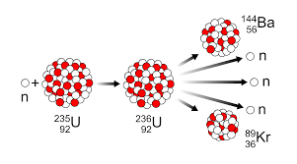

Figure 3.6 Nuclear fission reaction. Image from commons.wikimedia.org

Due to the difficulties associated with nuclear fission energy, the number of reactors worldwide is expected to continuously decline as seen in Figure 3.7

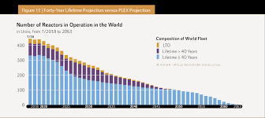

Figure 3.7 Projected number of nuclear reactors. Image from worldnuclearreport.org

17
3.2.2 Nuclear Fusion

Nuclear fusion [3.10] is the process by which our sun produces energy. It has also been utilized in weapons through the hydrogen bomb. In a fusion reaction, nuclei such as deuterium and tritium combine, giving neutrons, helium, and a large amount of energy, shown in Figure 3.8

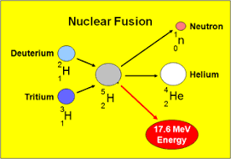

Figure 3.8 Nuclear Fusion Reaction. Image from mpoweruk.com

Research on this process has been conducted for more than half a century with the goal of its development as an energy source. However, fusion has not yet proven to be a practical means of producing electrical power.

3.2.3 Problems and Risks of Nuclear Energy

Major problems and risks of nuclear energy have been cited by Jacobson et. al. [3.11]:

1. Lag-times in construction
2. LCOE underestimates due to lag-time, melt-down, waste
3. Weapons proliferation risk
4. Meltdown risk
5. Lung cancer risk from mining
6. Carbon equivalent emissions and air pollution
7. Waste disposal risk

Examples of these problems include the estimated cost of waste disposal for the US nuclear plants in the amount of around $400 billion [3.12]. In financial terms only, the Chernobyl meltdown of 1986 in the former Soviet Union cost approximately $700 billion [3.13], and the 2011 Fukushima plant loss [3.14] as a result of the tsunami in Japan is expected to cost $1 trillion.

18
Nuclear radiation across Europe following the Chernobyl accident in 1986 is shown here in Figure. 3.9.

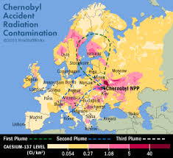

Figure 3.9 Nuclear radiation over Europe. Image from researchgate.net

The containment of nuclear waste remains a serious hazard, Figure 3.10.

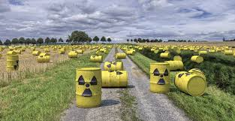

Figure 3.10 Nuclear waste cannisters. Image from phys.org

19
3.2.4 Reduction of Nuclear Weapons

The number of nuclear weapons around the world has decreased significantly since 1985 but remains at an alarmingly large level as Figure 3.11 reveals.

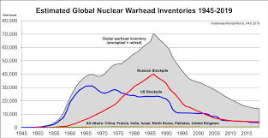

Figure 3.11 Global Nuclear Warhead Inventories. Image from fas.org

20
3.3 Renewable Sources

Renewable energy (RE) [3.15] sources and technologies are “clean” or “green” because they produce few if any pollutants in their development and utilization. These resources are continually replenished by nature producing usable energy that cannot be used faster than they are consumed. The major types of RE sources will be described briefly here.

A schematic diagram of renewable energy sources is shown in Figure 3.12. These sources include solar, wind, water, bio-mass, bio-energy, geo-thermal, and ocean tides.

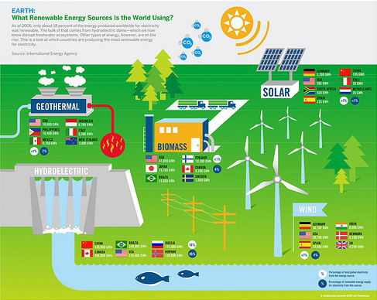

Figure 3.12 Illustration of renewable energy sources.
Image from alternative-energy-tutorial.com

21
3.3.1 Solar Energy

Solar energy provides the earth with both heat and light. When used “passively,” solar energy heats our homes, offices, and schools. Three physical process are involved:

Radiation is the incidence of solar energy in the form of visible photons on a building.

Conduction is the transfer of the absorbed heat through a solid structure such as a Trombe wall.

Convection is the circulation of air heating a room or a building.

In the “active” mode, solar radiation (photons), striking a semi-conducting solar cell, release charge carriers into an external electrical circuit, producing a current. A “p-n junction” within a silicon cell, for example, produces a voltage, and the product of this electrical current and voltage results in electrical power, measured in Watts. Although the focus of this guide will be in the area of solar photovoltaic (PV) cells and panels, other forms of RE will also be developed as replacements for fossil fuels during the transition period of 2020 to 2050. Their brief descriptions follow.

The world’s leading manufacturers of solar panels are shown in Figure 3.13.
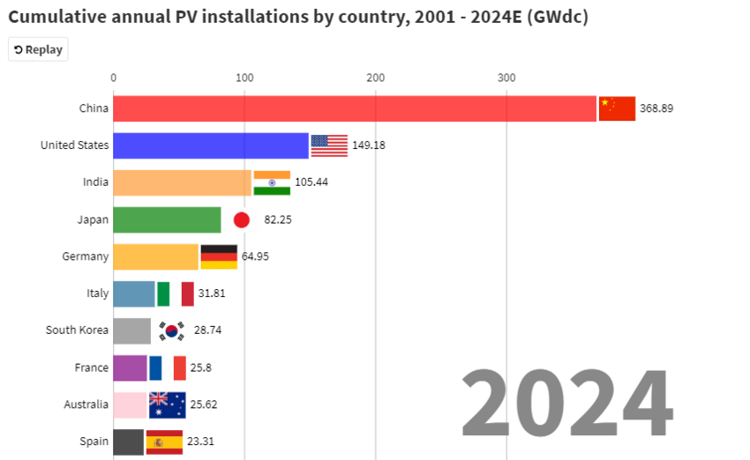

Figure 3.13 Leaders in PV installations. Image from weforum.org

Although China, the United States, and India are the worlds’ largest emitters of excess greenhouse gases, they are also the largest producers of solar panel
22
3.3.2 Wind Energy

Wind has been used for hundreds of years to power ships and mills. Today, large wind turbines are constructed on wind farms to produce electricity which is fed into utility grids. Wind energy is expected to produce a large percentage of renewable energy during the next generation

3.3.3 Geothermal Energy

Geothermal energy is the thermal energy within the Earth which originated from the original formation from the planet and from radioactive decay of elements. This source is theoretically adequate to supply the Earth’s needs, but only a small fraction may be profitably exploited. Geothermal energy may also have negative environmental consequences and is not expected to provide a major source of power.

3.3.4 Biomass Energy

A biomass source is a non-fossil fuel classified as being derived from organic, biological, or plant matter, which can be converted into a usable energy source. This source is advantageous as a fuel for aircraft and ocean shipping. Biomass also has the disadvantages of having a lower energy content than fossil fuels, requiring fossil fuels for their production, and requiring large areas for their production which reduces the available areas for agriculture and food growth.

3.3.5 Hydro Energy

Hydro energy results from water flowing through a water dam, producing electricity from turbines. Although the source is clean, the damming of streams and rivers has, in some cases, negative environmental consequences.

3.3.6 Ocean Energy

The energy from ocean tides and waves can be converted into electrical power when turbines and other equipment are placed at these sources.

23
Projections of non-renewable and renewable energy sources transitions to 2050 have been made with an example shown in Figure 3.14.

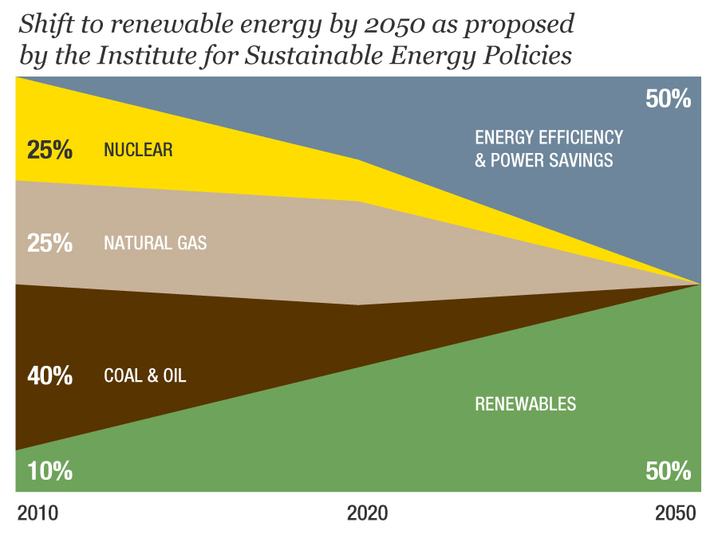

Figure 3.14 Projected non-renewable and renewable energy sources transitions to 2050.
Image from UNU Our World

24
4. Energy Demand

4.1 World Energy Demand

For the pupose of analyses in this guide, world energy consumption will be assumed to be a constant value of 500 EJ/year (EJ is an Exajoule or 10¹⁸ Joule; see Appendix 5 for explanation of energy units) is for the period of 2020 to 2050. Energy supply and demand projections are discussed further in Section 7. One consumption projection of various energy sources is shown in Figure 4.1.
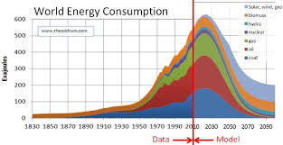
Figure 4.1 World Energy Consumption. Image from greencitytimes.com

25
4.2 The G20 Countries

The G20 group consists of the 20 largest economies in the world. G20 countries contribute
80 % of the world’s population, GDP, and excess greenhouse gas emissions.



Figure 4.2 Flags of the G20 countries. Image from freeimages.com

26
Included in the group is the European Union with 27 countries as full members of the G20. The United Kingdom is no longer a member, and Spain is a guest member.

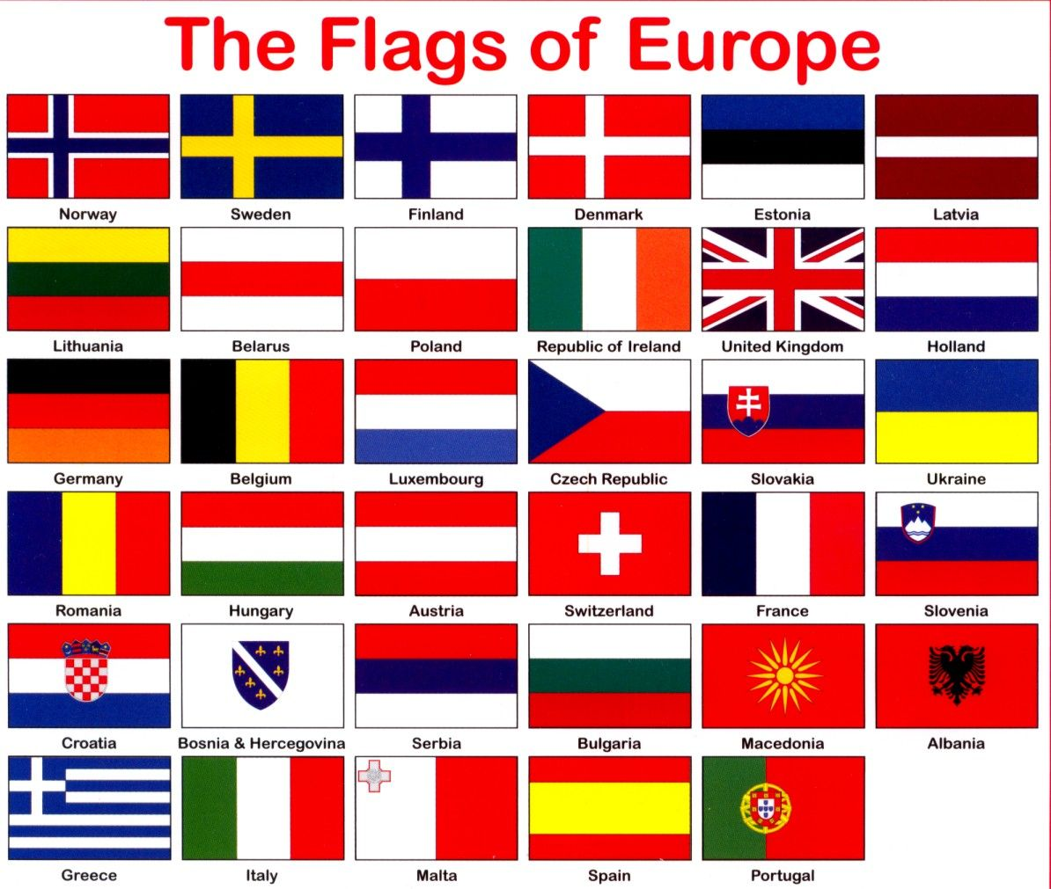

Figure 4.3 Flags of the European Union Countries. Image from pinterest.com

27
4.3 The United States

Each country has a number of economic sectors which consume energy and emit greenhouse gases at various rates. An example of these sectors in the US is the chart shown in Figure 4.4
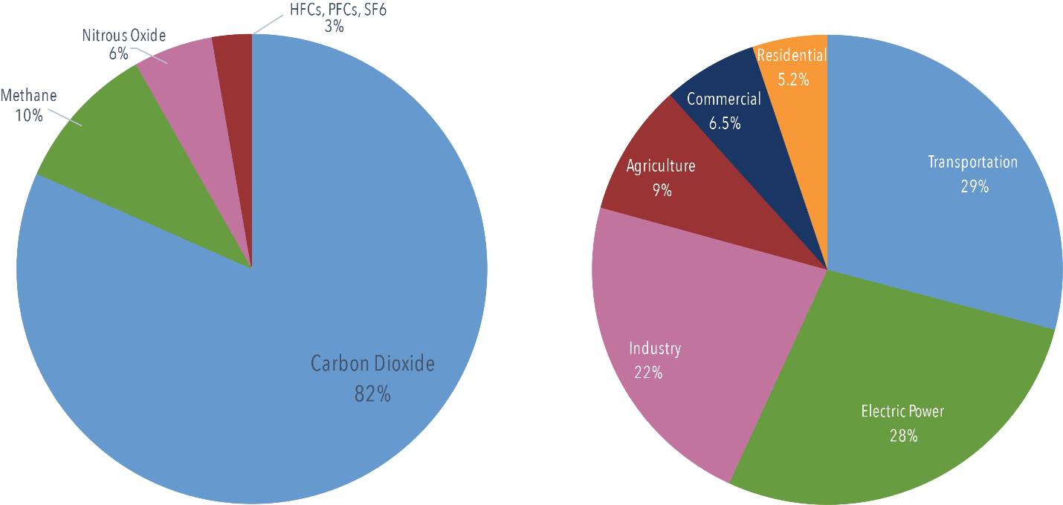
Figure 4.4 US economic sectors and greenhouse gas emissions. Image from c2es.org

Although various countries have differences in their sectors and differences of energy mixes within the sectors, their primary emissions are carbon dioxide. A global comparison of emission for these sectors is illustrated in Figure. 4.5.
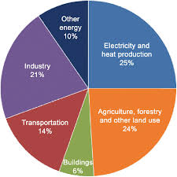
Figure 4.5 Global greenhouse gas emissions. Image from researchgate.net

The similarity in the US and global GHG emissions from the various economic sectors can be seen in the comparison of Figures 4.4 and 4.5.

Heating and cooling of residential and commercial buildings accounts for a large percentage of energy budgets [4.1]. The Passive House Institute [4.2] is an international organization which has made significant contributions to reducing these expenditures.
28
5. Environmental Factors

5.1 The Carbon Cycle, Carbon Budget, Carbon Neutrality, and Carbon Debt

Beginning with Svante Arrhenius’ analysis of global warming in 1897, a portion of the scientific background for this phenomenon is given in Appendix 1. It can be stated here that the term, “greenhouse gases” (primarily carbon dioxide and methane) is somewhat of a misnomer. In point of fact, it is these gases that raise the Earth’s temperature from -18 C, in the case of no atmosphere, or even an atmosphere of nitrogen and oxygen, to a comfortable temperature of +15 C with our present atmosphere. It is not these naturally occurring gases that have caused global warming, but rather their excesses which have been produced anthropogenically during the past three centuries i.e. since 1750, the beginning of the Industrial Revolution.

The “four carbon factors” discussed here are complex natural processes and analyses. Their detailed accounts are beyond the scope of this guide, but a few basic points will be illustrated in this section.

5.1.1. The Carbon Cycle

The Earth’s carbon cycle, which is illustrated in Figures 5.1, is a natural process of carbon migration throughout the biosphere.

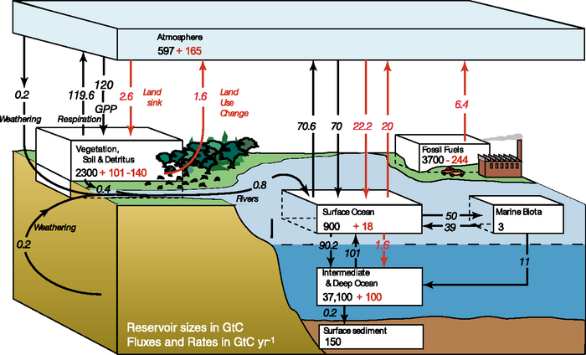

Figure 5.1. The Carbon Cycle. Image from latestghs.com

29
The carbon cycle [5.1] is the biogeochemical cycle by which carbon is exchanged among the biosphere, pedosphere, geosphere, hydrosphere, and atmosphere of the earth. Carbon is the main component of biological compounds. Along with the nitrogen cycle and the water cycle, the carbon cycle comprises a sequence of events that are key to making the earth capable of sustaining life. Since the beginning of the industrial revolution around 1750, human activity has modified the carbon cycle by changing is components and functions, as well as by directly adding carbon into the atmosphere. The major human impacts include (1) the burning of fossil fuels, (2) deforestation, (3) clinker production, a precursor of cement, (4) land use and land cover change, (5) air pollution, (6) changes in the ocean carbon cycle, and (7) acid rain.

It is the excessive levels of GHG emissions, primarily CO₂ as caused by the burning of fossil fuels since the beginning of the Industrial Revolution, which has caused global warming. Several scenarios for this warming effect, depending of the rate of these emission will determine the atmospheric temperature increase, shown here in Figure 5.2.
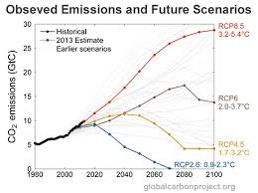
Figure 5.2 CO₂ Emissions and Resulting Global Warming. Image from the-shift.com

Forests absorb 30% of the earth’s CO₂ emissions through the process of photosynthesis [5.2]. On the other hand, deforestation is the second leading cause of global warming, causing 10 % of this process [5.3]. It is also known that the rate of deforestation is increasing despite pledges to the contrary [5.4]. Reforestation, as seen in Figures 5.3 and 5.4, has been considered as a viable contribution to restraining global temperature increases, but these measures are long-term in nature, often requiring 25-100 years for their effectiveness to be realized [5.5].
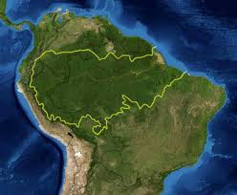
Figure 5.3 Peru reforestation Figure 5.4 Reforestation in the Amazon
Image from perureports.com Image from spark.adobe.com
30
5.1.2. The Carbon Budget

The carbon budget gives estimates of the maximum amount of greenhouse gases which can be released into the atmosphere over a period of time while maintaining the increase in temperature to less than 1-2 C relative to the temperature at the beginning of the Industrial Revolution, 1750 (the reference date of 1870 has also been used). Inside Climate News [5.6] gave a summary of this process with references to original sources. The period for this budget is calculated through division of the remaining allowed amount, 1.2 x 10¹² tonnes by the current annual emission rate of 40 Gt CO₂ /year which is 30 years. Other estimates use the value of equivalent GHGs as it includes other gases such as methane.

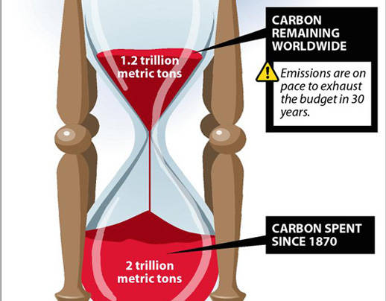

Figure 5.5 The carbon budget. Image from insideclimatenews.org

31
Other estimates of this budget vary widely due to model assumptions as seen in Figure 5.6. From these data, the remaining time periods range from about 14 to 39 years. In statistical terms, the average budget and standard deviation are 1,070 +/- 319 Gt CO₂ with the time periods of 27 +/- 8 years. The data also show a clear trend of lower carbon budgets for higher probabilities of success.
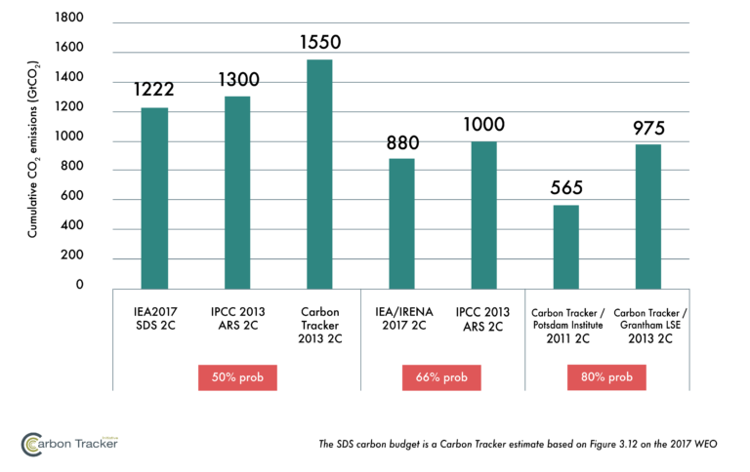

Figure 5.6 Estimates of carbon budgets. Image from carbontracker.com

The analyses use Integrated Assessment Models (IAMs). Carbon Brief [5.7] has written a good summary of these methods which are summarized in point-form here.

- Models are based on economic theories.
- Models attempt to meet 1.5 or 2.0 C targets.
- Models attempt to balance economic, environmental, and energy factors.
- Uncertainties involve diversities of socio-economic behavior.
- Models consider world energy, land use, agricultural, and climate systems.
- Models match supply and demand for energy based on fuels and technologies.

32
5.1.3. Carbon Neutrality

The term “carbon neutrality” is frequently used [5.8] in the context of reducing CO₂ emissions. However, the term implies a carbon balance or trade-off in the utilization of fossil fuels. The term also does not distinguish between the use of fossil fuels with carbon abatement and the overall reduction of carbon through the installation of renewable energy sources. One carbon-neutral technique is “Bioenergy with Carbon Capture and Sequestration (BECCS). As with Carbon Budgets, Carbon Neutrality estimates also use IAMs. While the two methods, “balancing” and “reducing,” are not mutually exclusive, they are completely different in their implementation. A brief summary of these two methods is shown in Table 5.1.

Table 5.1 Comparison of Carbon Reduction Methods
Balancing CO₂ Emissions | Reducing CO₂ Emissions
Carbon removal beyond natural processes  through carbon offsets, that is removing  or sequestering CO₂ from the atmosphere  to reduce emissions elsewhere.  Utilizing fossil energy sources but removing  CO₂ from the oxidation processes.  Integrated Assessment Models, IAMs, are  used in these analyses.  BECC S is an unproven technology.  Likely to be ineffective and prohibitively expensive for fossil fuels. | Changing energy sources and industrial  processes.  Replacing fossil fuel sources with renewables such as solar, wind, and water.  Employs the physical installation of renewable sources.

The IPCC has adopted the BECCS method as a strategy for carbon mitigation [5.9].

Oneearth.org [5.10] gave five reasons stating that BECCS is not a real climate solution:

1. The amount of BECCS in the IPCC’s own mitigation scenarios is unsustainable.
2. BECCS is unsustainable because of its competition with land use to produce food.
3. BECCS is not carbon neutral.
4. BECCS would harm bio-diversity.
5. BECCS is used to justify oil extraction and to promote “business as usual.”

Another source [5.11] advocated a similar view concerning BECCS, citing the negative impacts of “geo-engineering.

33
5.1.4. Carbon Debt
The synonymous terms, “carbon debt” and “carbon footprint,” [5.12] have been applied to most forms of energy production and utilization. Critics of RE sources have stated that wind and solar have a hidden carbon footprint which arose during their construction/manufacturing processes. However, these footprints are considerably smaller than those of other sources, Figure 5.7.
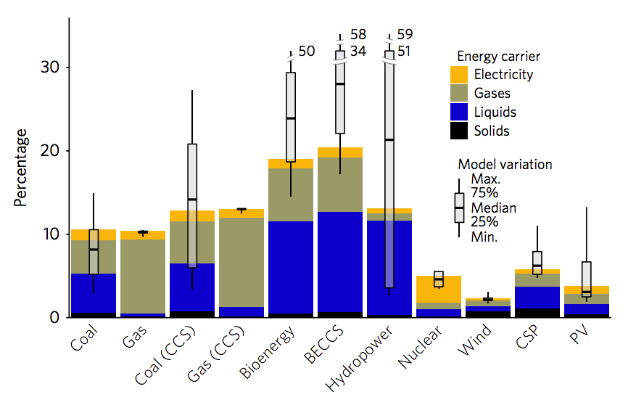
Figure 5.7 Embodied energy use. Image from carbonbrief.org
Another measurement of carbon debt or carbon footprint is the amount of equivalent CO₂ emissions per unit of electric supply technologies. The term “equivalent CO₂” refers to the total amount of greenhouses gases, typically CO₂, CH₄, NO from these emissions. Values of ratios for currently available technologies are given in Table 5.2 [5.13].

Table 5.2 Technology Emissions (g CO₂ eq/kWh) Emissions for electric space heater
Coal 820 This tables also shows the
Natural gas 490 emissions in grams resulting
Biomass 230 from operating a 1 kW electric
Solar PV – Utility scale 48 space heater for one hour
Solar PV – Rooftop 41 using these sources.
Geothermal 38
Concentrated solar power 27
Hydropower 24
Wind – Offshore 12
Nuclear 12
Wind – Onshore 11
34
Lifecycle greenhouse gas emissions for different sources of electricity have also been determined for various energy sources, seen in Figure 5.8.
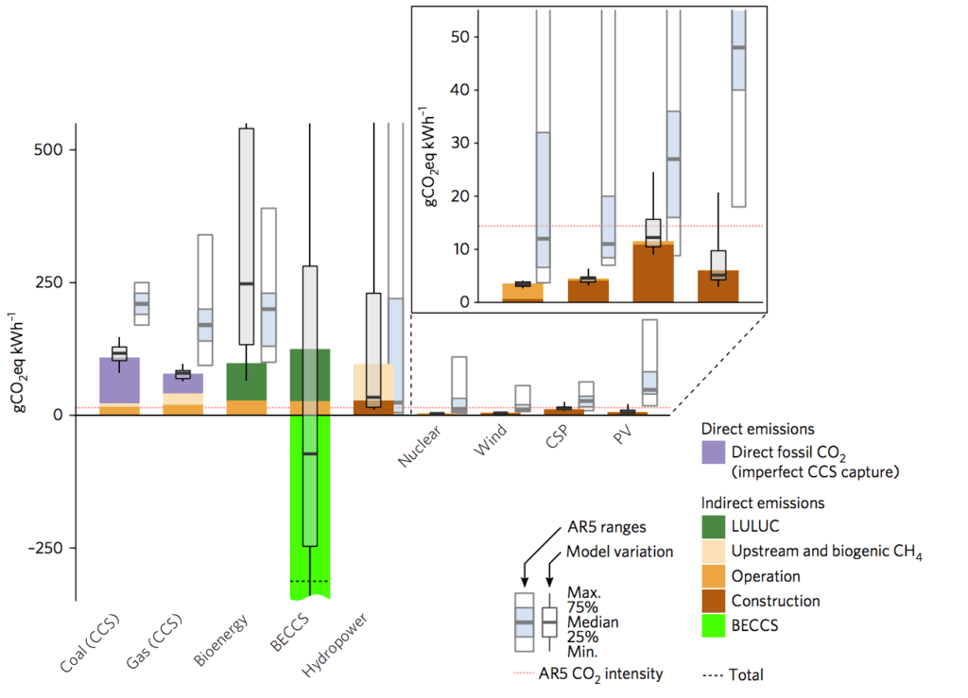
Figure 5.8 Comparison of lifetime emissions in grams CO₂/KWh
Image from carbonbrief.com

The major points of this section can be summarized as follows:

5.1.1. Carbon Cycle – a natural process of carbon migration throughout the biosphere which
has been adversely affected by excessive carbon emission and global
warming.
5.1.2. Carbon Budget – an accounting method stating the “allowable” cumulative carbon
emissions for restraining global warming to within certain limits, e.g. 1.0
to 2.0 C. These models contain large uncertainties and predict periods
of a few years to a few decades at current annual emission rates.
5.1.3. Carbon Neutrality – a flawed concept for capturing carbon emissions which encourages
the continued “business as usual” approach for fossil fuels.
5.1.4. Carbon Debt – refers to the “carbon footprints” of various energy sources where RE
types exhibit significantly smaller footprints than those of non-renewables.

The Social Costs of Carbon have been found to be invalid measures (Section 6.4).
The results of Carbon Taxes in several countries are discussed (Section 6.5).
35
5.2 United Nations Intergovernmental Panel on Climate Change, IPCC

The IPCC was formed in 1988 [5.14] as an intergovernmental panel of the UN. Its purpose is to provide objective information concerning the anthropogenic changes in climate. It attempts to give the scientific bases for these changes as well as the natural, political, economic, and social impacts. This organization does not conduct original research or evaluate literature. Its reports are produced periodically and the Fifth Assessment Report gave input for the Paris Agreement of 2015.

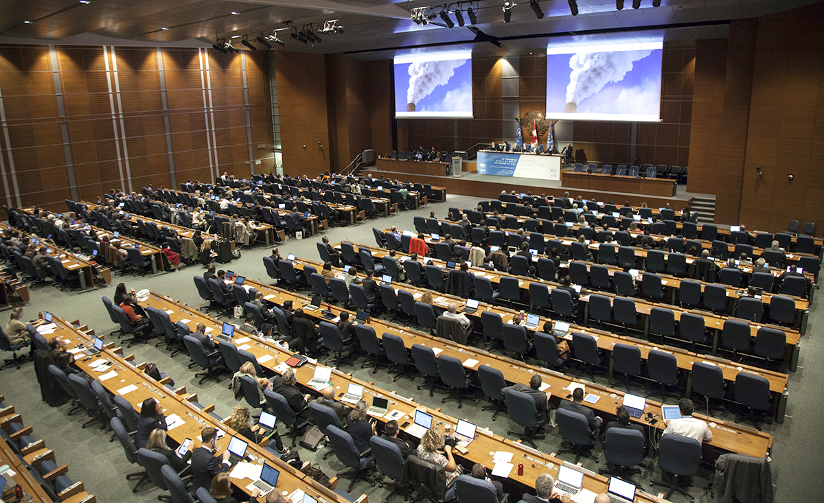

Figure 5.9 IPCC-AR6 scientists. Image from carbonbrief.org

36

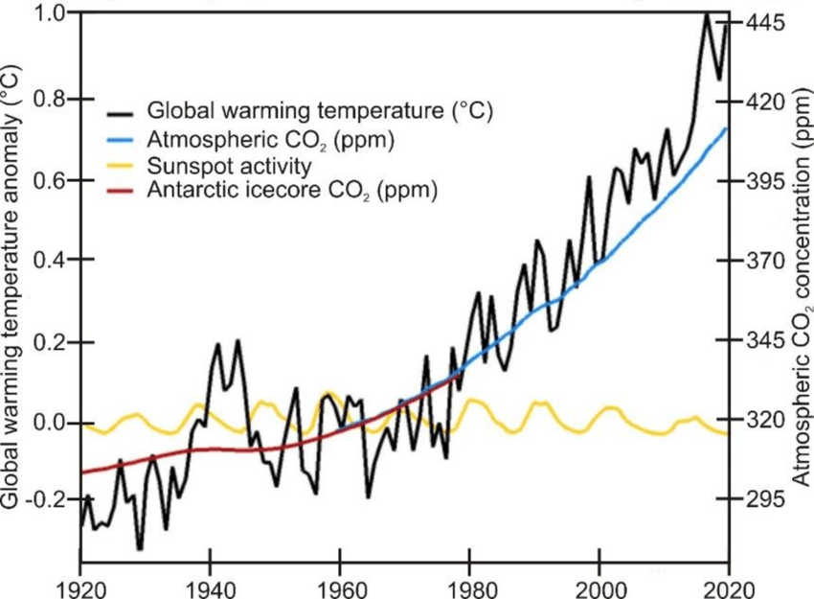

Figure 5.10 Correlation between increased CO₂ and atmospheric temperature.
Image from [5.15]

From Figure 5.10, it is seen that the correlation between increases in CO₂ emissions and atmospheric temperatures is striking [5.15]. While correlation is not causation, analytical relations between CO₂ levels and temperature are shown in Appendix 1. It is also apparent that during the relatively short IPCC period of 1988 to 2020 the global CO₂ level rose by approximately 50 ppm, and the temperature increased by about 0.6 C (1 F).

37
Projections of continued annual greenhouse gas emissions and resulting temperature increases are shown in Figure 5.11.

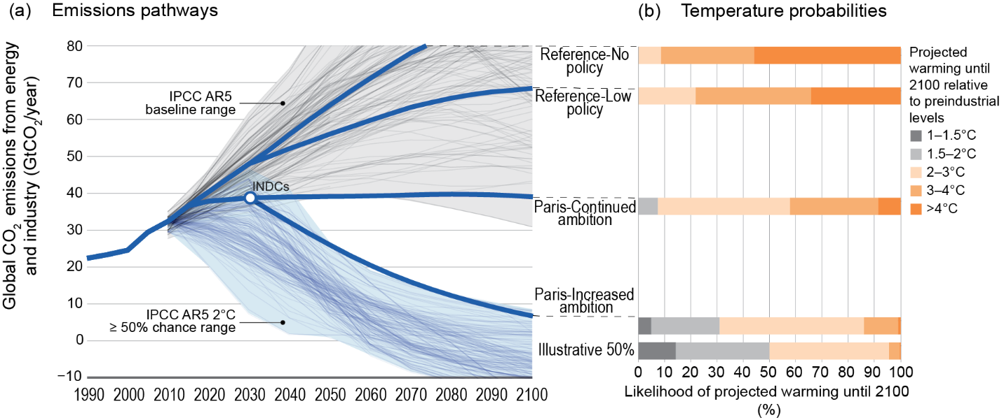Figure 5.11 Projections of increased CO₂ emissions and resulting temperature increases.
Image from Wikipedia.org

The IPCC [5.16] has projected various temperature increases depending primarily on the amount of CO₂ emitted into the atmosphere as a result of reports, current policies, and pledges. Some of these projections are shown in Fig 5.12.

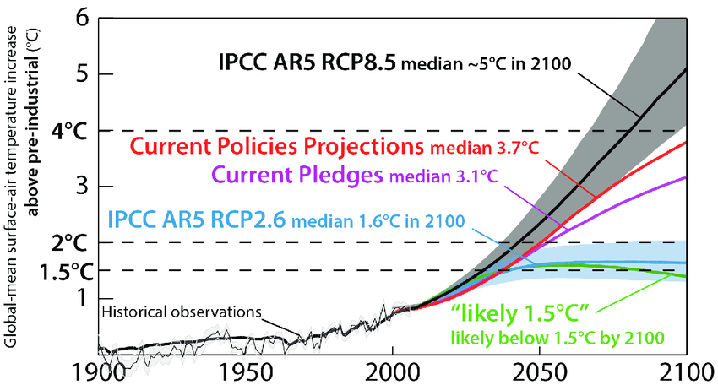
Figure 5.12 Projected atmospheric temperature increases. Image from researchgate.com

38
5.3 The Paris Agreement of 2015

The Paris Agreement (L’accord de Paris) [5.17] is an agreement within the UNFCCC dealing with greenhouse gas emission mitigation, adaption, and finance. Negotiated by 196 countries, all members signed the agreement, and 189 countries have become party to it. The significant emitters which are not parties are Iran and Turkey. The United States has withdrawn from the agreement.

The goal of the agreement is “to keep the rise in global temperature to within 1.5 – 2.0 C by reducing emissions as soon as possible in order to achieve balance between anthropogenic emissions and removals by sinks of GHG’s (BECCS) in the second half of the 21st century.”

Criticisms of the agreement include questions concerning the lack of its effectiveness, that is inadequacies, and enforcement. As written in 2015, the Agreement looks ahead 85 years for achievement of its goals. Thus, it seems necessary to emphasize that the time frame of this agreement is 2050 to 2100, a period which is self-defeating and inconsistent with the stated urgency of the IPCC reports.

5.4 Inadequacies of the Paris Agreement Pledges

Unfortunately, the pledges made by many countries, most notably the G20 Group, were found to be inadequate for limiting global warming. An assignment of the severity for some of these inadequacies has been made by Carbon Action Tracker [5.18] which is shown in Table 5.3. It is emphasized that the atmosphere has already warmed by about 1.0 C leaving only 0.5 C or 1.0 F to meet the Paris Accords. Table 5.3 also shows that 70% of the G20 countries have made inadequate pledges.

Table 5.3 IPCC pledge inadequacies of countries.
Critically  Insufficient  4 C + | Highly  Insufficient  < 4 C | Insufficient  < 3 C | 2 C  Compatible  < 2 C | 1.5 C Paris  Agreement  Compatible  < 1.5 C | Role Model  << 1.5 C
Russian Fed.* | Argentina* | Australia* | Bhutan | Morocco
Saudi Arabia* | Chile | Brazil* | Costa Rica | The Gambia
Turkey* | China* | Canada* | Ethiopia
USA* | Indonesia* | EU* | India*
Ukraine | Japan* | Kazakhstan | Kenya
Viet Nam | Singapore | Mexico* | Philippines
 | South Africa* | New Zealand
 | South Korea* | Norway
 | UAE | Peru
 |  | Switzerland
* = G20

39 5.5 Pathways and Resources for Renewable Energy

Recognizing the shortcomings of the Paris Agreement pledges, several organizations have proposed “pathways” which would meet the requirement of limiting global warming to 1.5 C or
2.0 C. Table 5.4 shows a comparison of four worldwide proposals using renewable energy (RE). As these proposals used different methods, models, and assumptions, their results vary widely.

Table 5.4 Proposals to meet Paris requirements
 | Bogdanov et.al. [5.19] | IRENA [5.20] | Teske et.al. [5.21]  One Earth | Jacobson et.al. [5.22]
Purpose | Meet Paris Guide  1.5C – 2.0 C | Meet Paris Guide  1.5 C – 2.0 C | Meet Paris Guide  1.5 C – 2.0 C | Meet Paris Guide  1.5 C
Goals | 100 % RE in 2050 | 75 % RE in 2050 | 100% RE in 2100 | 100% RE in 2050
Reduction in  CO₂ emissions | Approx. 100% | 90%  9.8 Gt CO₂/yr | 100% | 7.85 – 26.9  g-CO₂/KWh
Energy Supply  2050 (EJ/yr) | Solar 39,000 TWh/yr | 538 | 412 | NA
Energy Demand  2050 (EJ/yr) | NA | 351 | 5.0 C: 837 EJ/yr  2.0 C: 439 EJ/yr  1.5 C: 412 EJ/yr | 272 – 500
RE Sources | Solar  Wind | Multiple  RE sources | Solar  Wind | Wind (WWS)  Water  Solar
Land Areas  required for  RE sources  (% global land mass) | Assumes  < 6% solar  < 4% wind  hydro incr. 50% | BECCS  Considered | BECCS not required | 0.17% footprint  0.48% spacing
RE Investment Capital Costs | 22.5 T Euros  2015 – 2050 | $110 trillion,  2019 - 2050  2% global GDP  Average | 2.0 C $49 trillion  2015-2050  1.5 C: $51 trillion  2015-2050 | $73 trillion  2020 -2050
Non-RE Energy Savings | NA | NA | NA | Reduction  $17.7 T/yr to  $6.8 T/yr
Social Costs/  Savings | NA | $65 T to $160 T  over period to 2050 | NA | Reduction  $76.1 T/yr to  $6.8 T/yr
Economic  benefits  Table 6.1 | NA | GDP  increased 2.5%  Employment  Increased 0.2% | Employment  increased by  11million | Net employment  + 28.6 million  USA employment  + 3 million

40
One Earth presented a climate model and a three-pillar guide in Figures 5.13 and 5.14.

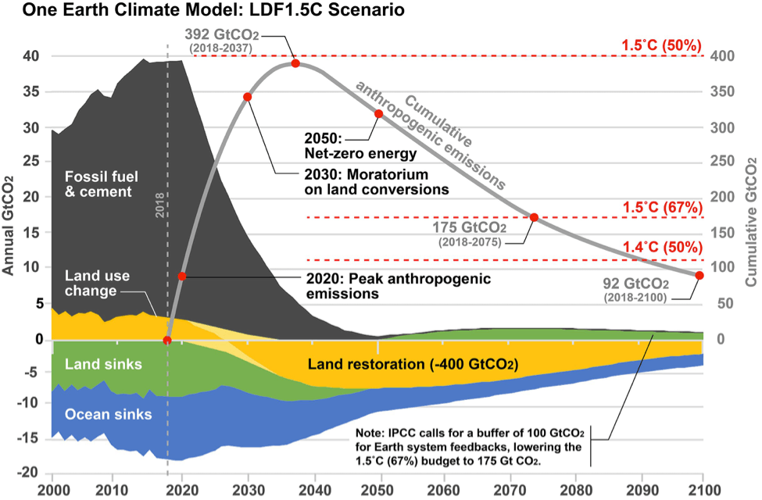
Figure 5.13 Climate model. Image from Karl Burkhart, oneearth.com

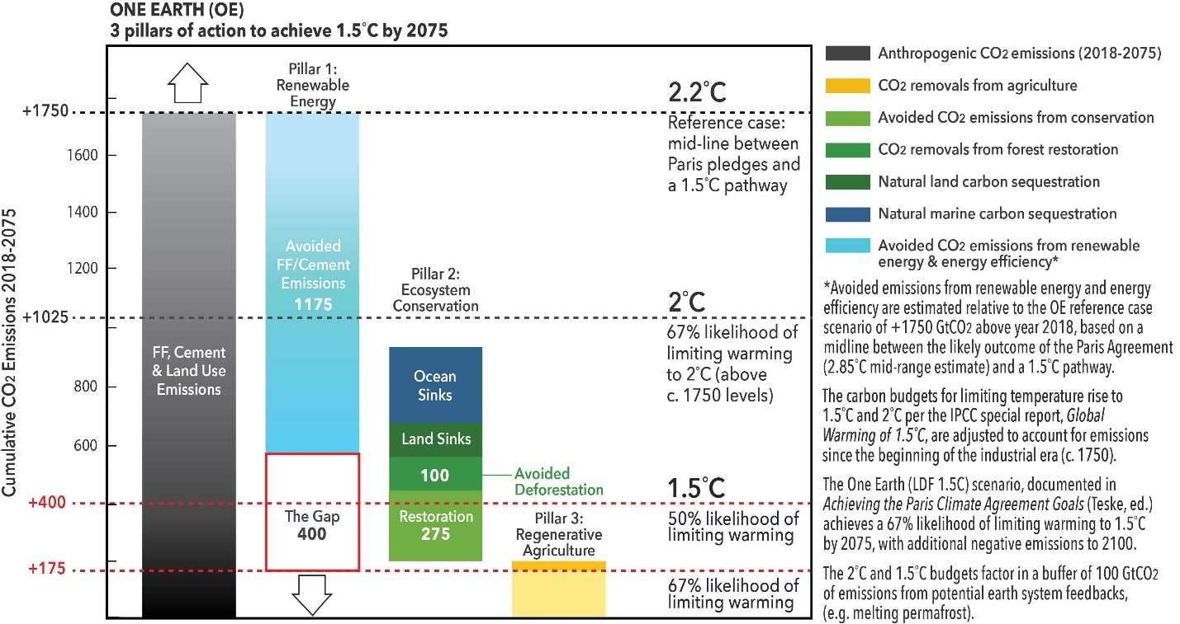
Figure 5.14 Three pillars for 1.5 C. Image from Karl Burkhart, oneearth.com

41
5.6 Renewable Energy for World Peace

Although oil is found in 96 countries [5.23], 77% of this source is located in only ten countries, with five countries as members of OPEC as seen in Table 5.5.

Table 5.5 The ten leading oil producing countries.

World Oil Production 81 bbl/day

United States 15
Saudi Arabia (OPEC) 12
Russia 11
Iraq (OPEC) 4
Iran (OPEC) 4
China 4
Canada 4
UAE (OPEC) 3
Kuwait (OPEC) 3
Brazil 3
63

Together with global warming and air pollution, Jacobson et. al. [5.24] consider energy insecurity to be one of the three greatest problems facing humanity.

In contrast to oil, solar energy is readily available in all global areas making it less vulnerable to external forces and thus providing security levels to those countries with installations. The annual amounts of sunshine for various countries are shown in Section 8. This security concept is shown schematically in Figure 5.15.

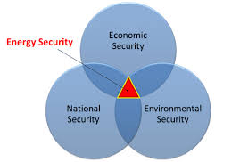

Figure 5.15 Energy Security links Economic, Environmental, and National Security.
Image from arava.org

42
6. Economic Considerations

6.1 Energy Supply and Demand

A general supply-and-demand curve is shown in Figure 6.1. It is known that the supply of fossil fuels is decreasing while the supply of renewable sources, notably solar energy, is increasing. It was also shown earlier that the world demand, as a result of increased efficiencies and conservation, should remain relatively constant over the next thirty years. According to this economic principle, the decreasing supply of fossil sources will cause an increase in its prices, and an increase of solar supplies will lower their prices.
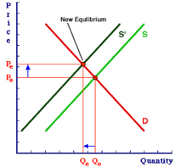
Figure 6.1 Shifts in supply cause changes in price. Image from amosweb.com

6.2 GDP and Employment

IRENA [6.1] stated that the cumulative GDP gain from 2018 to 2050 will amount to USD 52 trillion. This amount is approximately one-half of the total estimated IRENA required investment in RE of USD 100 trillion during this period.

The per capita world average GDP will increase from USD 10,800 in 2018 to USD 22,400 in 2050. The relative difference in global GDP between the Reference Case (Paris pledges, lower GDP) and the IRENA REmap (higher GDP) between 2018 and 2050 will be about 1% annually.

Also stated by IRENA, RE will result in a gain of 19.0 million new jobs and a loss of 7.4 million fossil-fuel jobs for a net global employment gain of 11.6 million jobs by 2050.

As shown by Jacobson et. al. [5.22], development of 100% RE (WWS) will result in a net employment gain worldwide of 24 million jobs by 2050.

43

Energy systems [6.1] are often treated as being self-contained, disconnected from the broader socio-economic structure they are built upon. This reference considers the IRENA pathway/transition REmap relative to the Reference Case which was based on the Nationally Determined Contributions (NDC), deemed to be inadequate as discussed in Section 5. The IRENA methodology utilized the E3M3 model, rather that the EM, EEM, or IAM tools. Figures 6.2 and 6.3 graphically illustrate the model concepts.
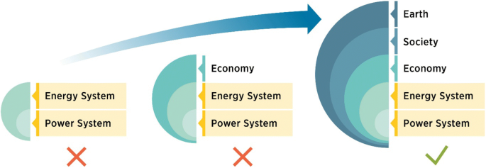
Figure 6.2 Energy and power as part of a broader system (IRENA).
Image from researchgate.net

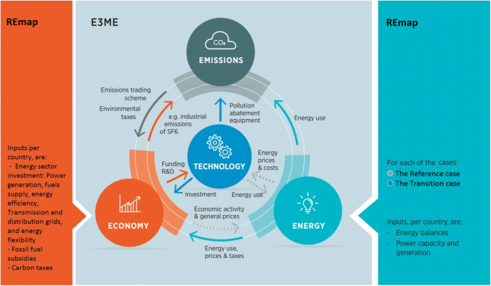

Figure 6.3 Incorporating the IRENA REmap into a E3ME model.
Image from researchgate.net

44
Garcia-Casals et. al. [6.1] also discussed the IRENA pathways in a socio-economic perspective on regional and worldwide bases. A portion of these results are shown graphically in Figures 6.4 and 6.5.

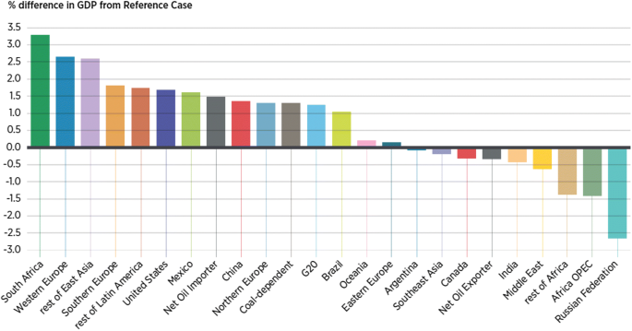

Figure 6.4 IRENA REmap vs Reference Case GDP. Image from researchgate.net

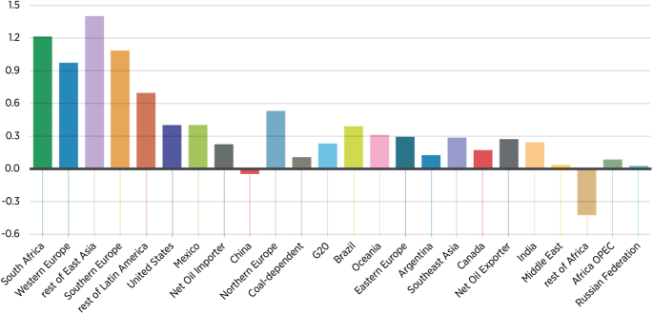

Figure 6.5 IRENA REmap vs Reference Case employment. Image from researchgate.net

45

In Table 6.1, economic estimates of various pathways to 2050 are compared. Although the diversity of the models used resulted in large differences, worldwide changes in GDP and employment are positive.

Table 6.1 Comparison of global GDP and employment projections by 2050.

Reference Global GDP Global Employment

 |  | Fossil Fuel  Losses | Renewable  Gains | Net  Gain
IRENA [5.20] | $52 T | 7.4 million | 19.0 million | 11.6 million
Teske [5.21] | NA | MA | 5.0 C 29.9 m  2.0 C 48.7 m  1.5 C 46.3 m | NA
Jacobson et. al.  [5.22] | NA | NA | NA | 24 million
Garcia-Casals [6.2]  (IRENA) | Global +1% | NA | NA | Global + 0.14%
Lappeenranta  Technical Univ.  of Finland [6.2] | NA | NA | Solar 22 m | NA

46
6.3 Social Costs of Carbon

The social cost of carbon (SCC), also considered as the “social costs of global warming,” is defined [6.3] as “the marginal cost of the impacts caused by emitting one extra tonne of greenhouse gas (carbon dioxide equivalent) at any point in time, inclusive of non-market impacts on the environment and human health.”

Calculating the SCC requires an estimate of the residence time of carbon dioxide in the atmosphere with impacts on climate change. In economic terms, a comparison of impacts over time requires a discount (interest) rate.

The best estimates of SCC come from Integrated Assessment Models (IAMs) such as the DICE, FUND, and PAGE models as shown in Figure 6.6 [6.4] which shows damages as percentage of GDP for different scenarios of temperature increase.
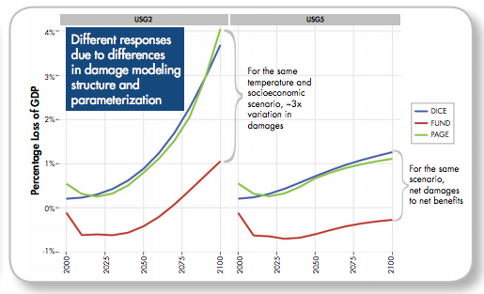
Figure 6.6 Loss of GDP due to SCC. Image from carbonbrief.org/qa-social-cost-carbon

In economic theory, if SCC estimates were complete and the markets were perfect, the SCC should equal a carbon tax:

SCC = CT

In reality, however, markets are not perfect and SCC estimates are not complete, resulting in an inaccurate carbon tax.

The SCC has been criticized as being extremely uncertain, having to change overtime and is claimed to be useless to policy makers as the Paris Agreement has a goal of a 2 C temperature rise. The SCC is no longer used for policy appraisal in the UK and the EU.

47
6.4 Carbon Tax/Trading

The pros and cons of carbon tax and carbon trading (emissions trading system, ETS), as seen in Table 6.2, continue in debate [6.5].

Table 6.2 Pros and Cons of carbon tax [6.5].
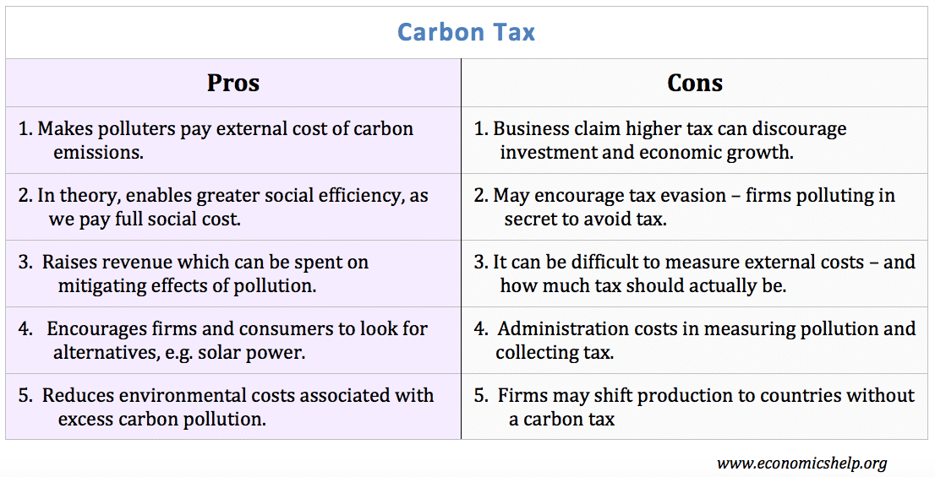

48

One area of concern [6.6] is the market prices of carbon which are considered to be lower than its social costs. These prices also vary widely and are typically in the range of $10 to $100 + US. Nevertheless, about 40 economic entities, countries, states, and provinces have implemented, scheduled, or placed under consideration these policies as can be seen in Figure 6.7.

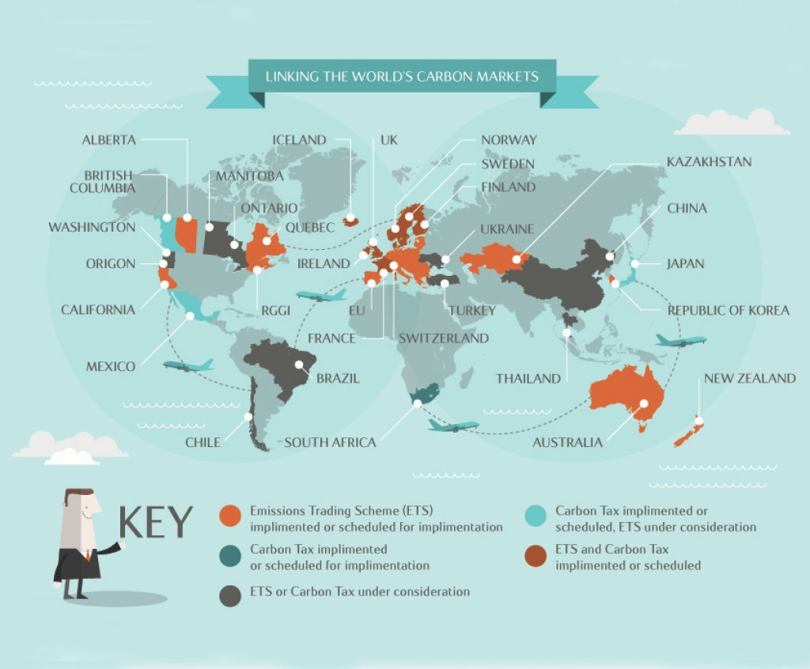
Figure 6.7 A view of world carbon markets. Image from greencitytimes.com

Estimates show [6.7] that carbon taxes in several countries have reduced GHG emissions by about 5-15 %.

49
7. Projections of World Energy Supply and Demand

7.1 Projections of Energy Sources

According the US Energy Information Agency, Figure 7.1, nuclear energy and coal are expected to decrease during the next 30 years with renewables overtaking these sources around 2040.

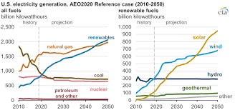

Figure 7.1 Projections of fossil fuel, nuclear, and renewable energy sources to 2050
Image from eia.gov

50
Projected world energy supply and demand levels are considered in this section. Although different energy mixes are shown in these projections, they tend to give similar maximum levels of about 500 EJ/yr. during the period of 2020 to 2050 as shown in Figure 7.2. This level of world energy demand during the transition period will be used in the analyses of Section 8.

Supply/Sources Demand/Consumption

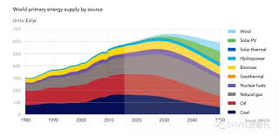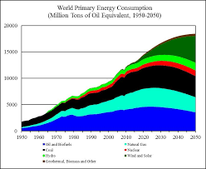
Image from DNV GL.com Image from seekingalpha.com

15,000 Mtoe/yr = 628 EJ/yr

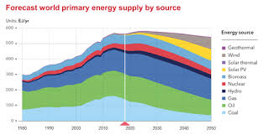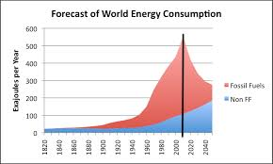

Image from drillingcontractor.org Image from eumearns.com

Figure 7.2 Projections of world energy sources and consumption.

51
7.2 Analysis of Transition Scenarios

The current and projected world’s energy supply and demand has been discussed in detail by several sources as seen in Table 7.1. These sources include IPCC models and subsequently proposed pathways. A review of these references has resulted in the assumed values for this guide of 500 EJ/year both currently and constantly from 2020 to 2050. Calculations concerning solar panel installations will be presented in Section 8.

Table 7.1. Comparison of projected scenarios for global energy transition (2050)
Supply in 2050 |  |  |  |  | Demand in 2050
 | TPES  EJ/yr | RE in TPES  EJ/yr | RE in TPES  % | Emissions  in 2050  Gt CO₂ /yr | TFEC  EJ/yr | Electric  in TFEC  % | RE in  Power  Sector  %
RE  IRENA [7.1]  REmap  Case  IPCC [7.1]  < 1.5 C  IPCC [7.1]  >1.5 C  Teske [5.21]  1.5 C  Jacobson [5.22]  1.5 C | 538  553  651  412  NA | 350  333  405  383  NA | 65  60  62  93  100 | 9.8  < 8  14  0  7.85-26.9  g-CO₂/KWh | 351  NA  NA  253  272 – 500 | 49  NA  NA  NA  100 | 86  77  82  100  100
IRENA [7.1]  Ref. Case  Paris Pledges | 712 | 185 | 26 | 33 | 479 | 30 | 69
This Guide  Assumptions | 500 | 500 | 100 | NA | 500 | NA | NA
Non-RE  McKinsey [7.1]  Shell-Sky [7.1] | 650  828 | NA  356 | NA  43 | 32.8  18 | 700  449 | 29  44 | 54  74
 | TPES =  Total  Primary  Energy  Supply |  |  |  | TFEC =  Total  Final  Energy  Consumption

52
8. A Plan for Global Solar Panel Installation

This section presents technical and financial analyses for a plan to power the globe by solar photovoltaic (PV) energy.

8.1 Can Solar Energy Alone Power the World?

It has been said that “one hour of solar can provide enough power to energize the earth for one year.” Stated differently, “the sun produces 10,000 times the power of the earth’s needs.” These statements are approximately correct as discussed here. In Figure 8.1, a schematic diagram of the Solar Constant, as explained in Appendix 2, is shown.
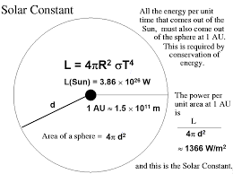
Figure 8.1 Solar power and the solar constant. Image from astroutoronto.ca

The sun produces 3.86 x 10²⁶ watts of power which is dispersed over the solar system including an imaginary sphere defined by the earth’s elliptical orbit which has an average radius of one Astronomical Unit (1AU) or 1.5 x 10¹¹ meters. This power received at the top of the earth’s atmosphere is called the “Solar Constant” and has a value of 1,368 Watts/square meter. Of this power, about 1,000 W/m² is received at the earth’s surface, the remainder being reflected or absorbed by the atmosphere.

It is commonly stated that the solar power received the earth is defined by the product of the Solar Constant and the area of the earth’s cross-sectional disk, A = πr², where r = 6.37 x 10⁶ m. However, it is more precise to say that the earth’s receiving area is the Lambertian hemisphere as shown in Appendix 12.2.3.2, in which the solid angle is π steradians rather than 2π steradians.

This power is 1.76 x 10¹⁷ W received above the atmosphere and 1.28 x 10¹⁷ W at the surface. As there are 8,760 hours per year, these powers are 1.54 x 10²¹ Wh/year and 1.13 x 10²¹ Wh/year.

It is estimated that the current annual world energy demand is approximately 500 EJ/year or
1.39 x 10¹⁷ Wh/year. Dividing the solar supply by the world demand gives about 11,000 and 8,100 as the ratios of solar supply to earth’s demand above the earth’s atmosphere and at its surface. While the sun can certainly power the worlds’ needs many times over, other renewable energy sources such as wind, hydro, and bio-fuels will also be utilized in the replacement of fossil fuels. This guide will focus on solar power, particularly photovoltaic (PV) devices.

53
8.2 Variable Renewable Energy

Solar and wind sources produce power intermittently and are known as forms of “Variable Renewable Energy,” (VRE). The availability of this power/energy is characterized by a quantity known as the “capacity factor,” CF, [8.1] defined here for the assumed solar world average annual sunlight of 2,000 hours/year as:

CF = Actual energy produced = Power x 2,000 hours sunlight/year = 23%
Potential energy Power x 8,760 hours/year

It has been stated [8.2] that the market penetration of VRE sources may be unable to surpass their capacity factors. However, others, as discussed below, have shown that the integration of these technologies into grids is quite feasible. In addition, “pathway” references, as seen in Table 8.1, include these sources as the majority of their energy-production capabilities.

The integration of VRE sources at high levels into electric power systems introduces the requirement of balancing load and generation at all times. An analysis of the problem is beyond the scope of this guide, but a reference-based outline [8.3] of the challenges and technologies, together with useful references [8.4, 8.5] is provided:

1. Background
  - Dispatchable generation: coal, nuclear, hydro, natural gas
  - Non-dispatchable sources: solar, wind
  - Inverter technologies: improved integration

2. Power system operation: maintain proper voltage and frequency
2.1 Regulation: fast response to disturbances
2.2 Load following: response to demand
2.3 Scheduling: planning to meet peak requirements

3. Challenges and solutions to integrate VRE: account for variability
3.1 Geographic diversity of variable source: reduces variability
3.2 Renewable forecasting: acts like scheduling mechanism
3.3 Generator flexibility: to balance load and generation
3.4 Energy storage: requirements increase with higher levels of VRE (or lower CF)
3.5 Curtailment: low capacity factors require over-building of solar/wind sources
which must be curtailed if storage is not feasible
3.6 Load control: load follows generation

54
The components of RE sources as given in various “pathways” are shown in Table 8.1.

Table 8.1 Renewable energy components of various pathways to 2050 (%).
RE Component | Jacobson [5.22] | Teske [5.21] | IRENA [5.20]  Power Sector | EWG-LUT [6.2]
Solar PV | 57 | 30 | 25 | 69
Solar CSP | NA | 15 | 2 | NA
Wind | 37 | 20 | 35 | 18
Hydro | 4 | 8 | 14 | 3
Bio-mass/waste | 1 | 5 | 7 | 6
Geothermal | 1 | 5 | 2 | 2
Ocean | NA | 5 | NA | NA
Total RE (approx.) | 100 | 100 | 86 (65 Total RE) | 100
Non-RE & nuclear | 0 | 0 | 14 (35 Total RE) | 0

Although considerable differences exist among these pathways due to their model variations, solar and wind dominate the RE component mix, with an average total amount of about 80%. Thus, the installation levels of solar and wind far exceed their capacity factors which are typically in the range of 10% to 30%. In some global regions, 100% solar energy may not only be feasible but necessary.

As a result of VRE sources’ capacity factors of less than 100%, it is necessary to “overbuild” these systems in order to produce power during times when the sun does not shine or the wind does not blow. These “overbuilt” amounts are included in the calculations given for world solar energy in Section 8.4 where the assumed annual sunshine for all locations is 2,000 per year. Tables 8.6 and 8.13 gives these levels for various countries which are typically 2,000 – 3,000 hours per year.

The solar capacity factor, CF, for these calculations is taken to be the ratio of the site’s annual sunshine to the actual yearly number of hours:

CF = 2,000 = 22.83%, 5.5 hours of sunshine per day (“live power”).
8,760

By this definition, the remainder of the time when the sun does not shine, at night or in cloudy weather, is the “Non-Capacity-Factor,” NCF:

NCF = 6,670 = 77.17%, 18.5 hours of non-sunshine per day (stored power”).
8,760

during which time power must be provided by another source, for example, battery or hydrogen storage. It should be noted that during the “active” periods when the sun shines, both “live power” and “storage power” are produced simultaneously by the solar panels. The above fractions of solar panels are dedicated to these tasks. Different solar power systems are compared in Section 8.13.

55
The overbuilt amount, OB, is given by the ratio of these two factors:

OB = NCF = 77.17 = 3.380
CF 22.83

For example, if 100 panels are required to produce “live power” for consumer distribution, 338 additional panels would be required to produce “stored power” for these consumers.

An example of a solar grid with battery storage is shown in Figure 8.2.

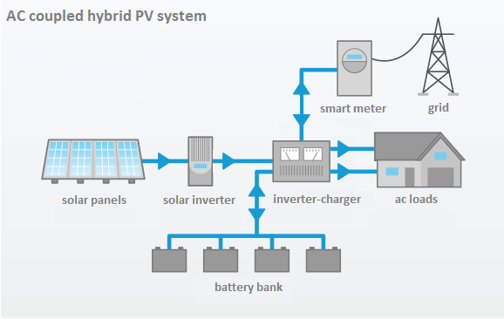

Figure 8.2 A smart solar grid with battery storage. Image from Solar Panels Melbourne

It will be shown in Section 8.4 that this total number of panels (e.g. 100 + 338), or panel area, is accounted for by the assumed capacity factor of 22.83% (2,000 of annual sunshine).

56

The feasibility of 100% RE sources has been considered, together with their barriers, in some detail [8.6]. This work concluded that the primary barriers were political, institutional-regulatory and societal-cultural rather than economic-financial or scientific-technological. An outline of these issues is given in Table 8.2 where “Barrier Heights” and “Reduction and Removal of Barriers” have been added based on results of this guide.

Table 8.2 Barriers to Renewable Energy
Barriers to 100% RE  [8.6] | Barrier Height  (From Guide)  (Arbitrary Scale) | Reduction and Removal of Barriers  (From Guide)
Political | 5 | Leadership  Education  International, national, regional cooperation  Accountability
Institutional-Regulatory | 4 | Legislative changes  Business-government collaborations  Fiscal and monetary policies  Policy implementation
Societal-Cultural | 3 | Community involvement  Reduced energy demand and conservation  Lifestyle changes and efficiencies  Commitment
Economic-Financial | 2 | See Sections 6.2 and 8.7  Public and private financing  Investment strategies  Economic benefits: GDP and employment
Scientific-Technological | 1 | Research and development  Increased solar and wind installations  Improved storage technologies  Grid enhancement and expansion

8.3 Solar Cell Materials

8.3.1 Photons and Materials
Photovoltaic solar cells operate by photons from the sun interacting with semiconducting materials. A brief description of this process is shown in Table 8.3 on the following page which is also a summary of the Appendices.

57 Table 8.3 Photons and Materials (Summary of the Appendices)
 | Photons and Materials
Appendix 1  Arrhenius atmospheric (greenhouse) warming model.  Increased CO₂, CH₄, other  gases - molecular absorption  of IR photons radiated from earth (T = 288K).  Quantum harmonic  oscillator model  E_{n} = (n + ½)hν, n = 0,1,2,3 ...  Appendix 2  Planck Radiation Law.  Quantized oscillators  E = nhν  Appendix 5  Units, Measurements,  and Conversion Factors  Energy  Photon Energy  Band-Gap Energy  Power = Energy  Time  Electrical Power, P = IV | Solar Cells  Metals Semiconductors Insulators  Appendix 3  Si, E_{g} =1.21 eV No electronic  Einstein GaAs, E_{g} = 1.42 eV conduction.  Photoelectric Perovskites Ionic  Effect. Organics conduction  Quantized Multi-junction in batteries,  Photons devices fuel cells.  and metals.  E = nhν  Step 1: Incident Current, I  Solar (T=5778K)  Photons  Conduction Band  Band Gaps  Fermi _________________________________________  Level  Valence Band  Appendix 4 Step 2: pn-junction  Solar Cells Voltage, V  Power, P = IV  Solar Irradiance Spectra  Solar Photon Flux Spectra  Quantum (Photon) = No. Electrons/sec.  Efficiency No. Photons/sec.  Conversion = P_{m}  Efficiency P_{inc}

58
8.3.2 Materials and Efficiencies

Many types of materials have been demonstrated to be effective in PV solar cells for the conversion of sunlight to electrical power [8.7]. Interestingly, these diverse materials share similar semi-conduction properties. A brief summary will be given here in Table 8.4 for three common compositions, silicon, perovskite, and organic cells.

Table 8.4 Properties of three solar-cell materials
Silicon | Perovskite | Organic
SiO₂ >>> Si + O₂  Doping elements:  p-type n-type  boron phosphorous  “holes” “electrons”  p-n junction at the depletion  layer creates electric field  and voltage driving charge carriers, producing current.  Silver contacts to external circuit.  See Appendix 4 for solar cell operation. | Perovskite form: ABX₃  Example:  A = methylammonium  (CH₃NH₃ ⁺)  B = Pb  X = Cl or Cl₃ | Two classes:  Small-molecule OPV  phthalocyanines  polyacenes  squareness  Polymer-based OPV  P3HT, MDMO-PPV

Efficiencies of these materials and others are shown in Figure 8.4.

59

Other solar cell materials and technologies are shown in Figure 8.3.

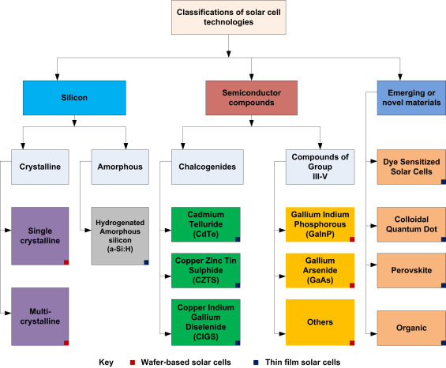

Figure 8.3. Solar cell materials and technologies. Image from researchgate.net

60
The efficiencies of solar cells can be compared with those of other processes and devices as shown in Table 8.5

Table 8.5 Comparison of efficiencies.

Process/Device Efficiency (%)
Electrochemical anodization 100
Solar cell quantum/photon up to 100
Fuel cells 50
Windmills 35-45
Internal combustion engines 25
Solar cell conversion 20-40
First selenium solar cell, 1883 1-2
Photosynthesis 0.1-2

The National Energy Research Laboratory in the US, NREL [8.8], has produced a graph of cell efficiencies over the past several years, Figure 8.4. Four types of technologies are shown: Heterojunction Cells, Crystalline Si Cells, Thin-Film Technologies, and Emerging PV. It is significant to note that the cell efficiencies for some of these devices are still increasing over time rather than showing a plateau or saturation with the highest levels above 40%. The Emerging PV’s exhibit the steepest rates of increasing efficiencies.

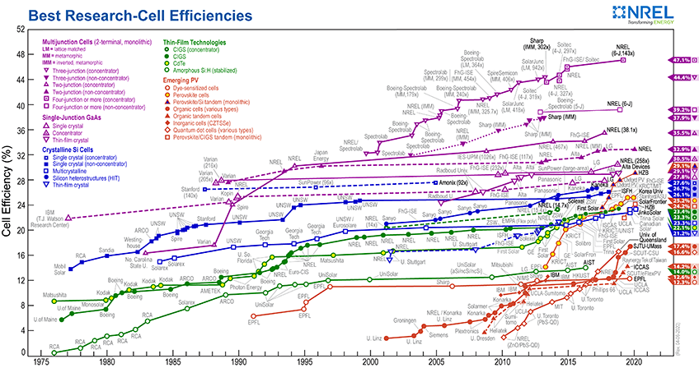

Figure 8.4 Solar cell efficiencies as recorded by NREL. Image from wikipedia.gov

61
8.4 Plan Assumptions and Limitations

The plan for worldwide PV solar-panel installation is based on the following assumptions and limitations:

- World energy demand: relatively constant at 500 EJ/year during 2020 – 2050 transition.
- Average annual sun light: 2,000 to 3,000 hours (capacity factors of 23% and 34%).
- Solar cell efficiencies: 20% to 40%.
- Cost of solar panels: $50 to $100.
- Solar power as a VRE can be integrated 100% into grids and electrical storage units.
- Omits detailed analysis of system infrastructure, transmission, distribution, storage.
7. Omits passive uses of solar energy for building heating.

8.5 Global Installations of Solar Panels

The concept of worldwide solar energy in not new. In 2009, Landart Generator [8.9] proposed a global solar panel system with a total area of 400,000 km₂, roughly the size of Spain. A similar analysis is given in this guide using current and projected world energy demands for the period, 2 020 to 2050 of 500EJ/yr. Panel areas are calculated for each of the G20 countries in Table 8.6.

An image of proposed solar panel installations in the Sahara Desert is shown in Figure 8.5.
Although the global distribution of solar power from a central source and single grid is unfeasible, it is important to note that the required total world area of solar panels is less than 0.5% of the earth’s land mass. Centralized solar power stations within individual countries are also likely to be impractical, but the results shown in Table 8.6 will provide a first-order approximation of the total required solar-panel areas and the costs for these countries.

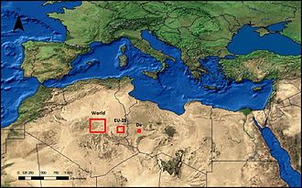

Figure 8.5 Proposed solar panel installations in the Sahara Desert
Image from Desertec-Wikipedia.org

62
One of the largest solar-producing nations is India. An Indian solar installation is shown in Figure 8.6
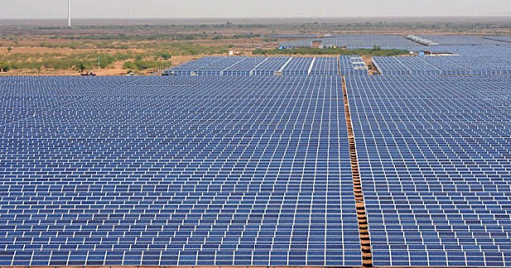
Figure 8.6 A large solar panel installation. Image from walkthroughindia.com

Solar irradiance at the top of the earth’s atmosphere, known as the “Solar Constant,” has been calculated (see Appendix 2) and accurately measured to have a value of 1,368 W/m² as shown schematically in Figure 8.7. The irradiance, I_{s}, at the earth’s surface and at the zenith has been measured to be approximately 1,000 W/m², and this value is commonly used, either directly or with laboratory sources, to calculate or measure the power density of solar cells. The conversion efficiency, e, (see Appendix 4) of silicon cells is approximately 20 %. The power density, D_{p}, is then given by the product of these two quantities,

D_{p} = I_{s}e (8.1)
or
D_{p} = 1,000 W (0.20) = 200 W = 0.20 KW
m² m² m²
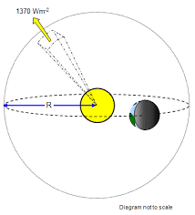
Figure 8.7 The Solar Constant. Image from schoolphysics.co.uk

63
The annual sunshine duration of the G20 and EU countries is given in Table 8.6 where the average and standard deviations for these two regions are also calculated. It should be noted that the G20 average is somewhat higher than the value of 2,000 hours/year used in the panel-area derivation. The G20 average is also higher than the average for the EU countries.

Table 8.6 Annual sunshine duration of G20 and EU countries (hours/year).
G20  Countries | Number  of Cities | Ave +/- S.D. | EU  Countries | Number  of Cities | Ave. +/- S.D.
USA | 9 | 2,888+/-491 | Austria | 1 | 1,884
EU | 34 | 2,096+/-590 | Belgium | 1 | 1,546
China | 6 | 1,976+/-346 | Bulgaria | 1 | 2,177
Japan | 2 | 1,809+/-97 | Croatia | 1 | 1,913
Germany | 2 | 1,644+/-25 | Cyprus | 1 | 3,314, max.
UK | 2 | 1,530+/-146, min. | Czechia | 1 | 1,663
India | 4 | 2,435+/-256 | Denmark | 1 | 1,739
France | 2 | 2,249+/-830 | Estonia | 1 | 1,826
Italy | 2 | 2,044+/-607 | Finland | 1 | 1,858
Brazil | 6 | 2,204+/-362 | France | 2 | 2,249+/-830
Canada | 9 | 2,028+/-306 | Germany | 2 | 1,644+/-25
South Korea | 2 | 2,197+/-185 | Greece | 2 | 2,976+/-181
Russia | 6 | 1,951+/-406 | Hungary | 1 | 1,988
Australia | 9 | 2,837+/-418 | Ireland | 1 | 1,453, min.
Mexico | 4 | 2,596+/-390 | Italy | 2 | 2,044+/-607
Indonesia | 1 | 2,983 | Latvia | 1 | 1,759
Saudi Arabia | 2 | 3,237+/-16, max. | Lithuania | 1 | 1,691
Turkey | 1 | 2,450 | Luxembourg | NA | NA
Argentina | 4 | 2,554+/-242 | Malta | 1 | 3,054
South Africa | 6 | 3,141+/-445 | Netherlands | 1 | 1,662
 |  |  | Poland | 1 | 1,571
G20 Average |  | 2,342+/-489 | Portugal | 1 | 2,806
 |  |  | Romania | 1 | 2,115
 |  |  | Slovakia | 1 | 2,038
 |  |  | Slovenia | 1 | 1,974
 |  |  | Spain | 3 | 2,755+/-158
 |  |  | Sweden | 2 | 1,872+/-71
 |  |  | EU Average |  | 2,096+/-590

These country annual sunshine levels were obtained from Google sources.

64
Global annual sunshine levels are illustrated in Figure 8.8.
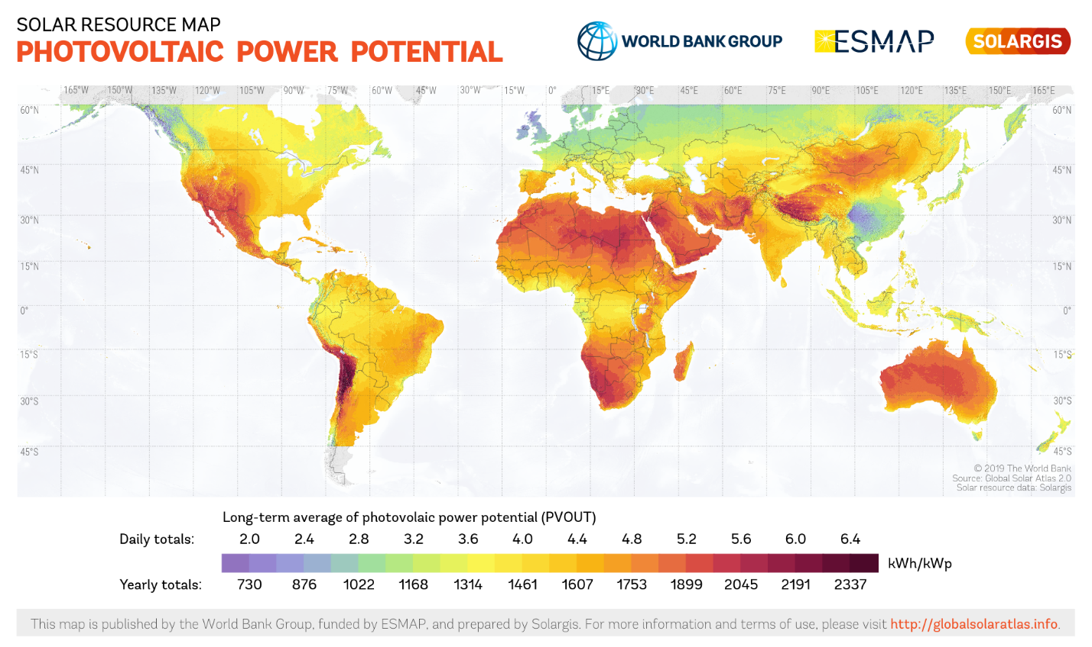
Figure 8.8 World annual sunshine hours. Image from cleantechnica.com

Energy is the product of power and time, meaning that energy density, D_{e}, is the product of power density and time. The value of 2,000 hours per year of sunlight, although somewhat less than the G20 average of 2,342 hours per year, is often taken as an annual average over all latitudes, seasons, and weather conditions. Thus,
D_{e} = D_{p}t (8.2)
or
D_{e} = 0.20 KW 2,000 h = 400 KWh
m² yr m² – yr

The world’s annual energy consumption, E, is taken (see Table 7.1) to have a current and projected value of 500 EJ/yr or 1.39 x 10¹⁴ KWh/yr. The solar-panel area required to produce this amount of energy annually is given by

A = E (8.3)
D_{e}

or
A = 1.39 x 10¹⁴ KWh . 1______
yr 400KWh
m² – yr

A = 3.48 x 10¹¹ m² = 348,000 km²
65

As the world’s total land-mass area is 1.49 x 10⁸ km², the solar-panel area represents 0.23% of the world’s land-mass area. This area may be compared with the analysis by Jacobson et. al. [5.22] in which 0.17% and 0.48% were calculated for areas of land for footprint and space of the wind-water-solar (WWS) system.

The world panel area is also equal to 134,000 square miles, or 367 x 367 miles. From Table 8.8, the US could be powered by solar panels with an area of 68,000 km² or 26,000 mi² (160 x 160 miles), which is approximately equal to the combined size of New Hampshire, Massachusetts, Connecticut, and Rhode Island. This area is equal to 0.83% of the continental USA, and a map of the USA is shown in Figure 8.9.

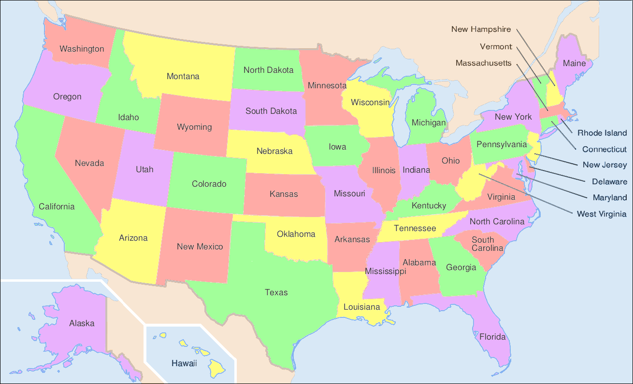

Figure 8.9 Map of the USA. Image from commons.wikimedia.org

66
8.6 Cost Analyses

8.6.1 Module Costs

The costs of solar modules have decreased dramatically during the past half century as shown by Swanson’s Law in Figure 8.10.

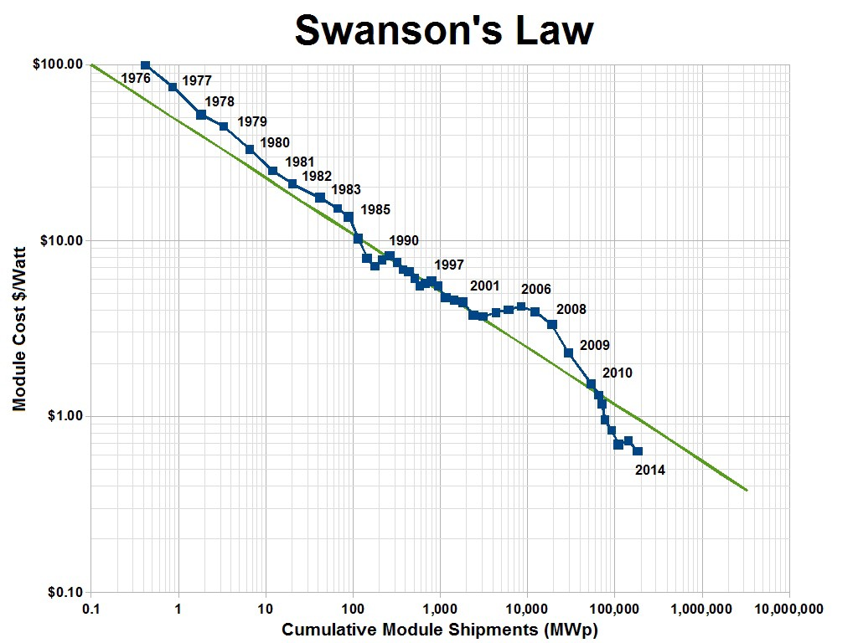

Figure 8.10 Decreasing Costs of Solar Panels. Image from medium.com

67
8.6.2 Installation Costs

A range of system costs has been calculated based on the assumptions given in Section 8.4. These costs for four different systems are shown in Table 8.7.

Table 8.7 Comparison of four systems.
Parameter | System 1 | System 2 | System 3 | System 4
Solar cell conversion efficiency (%) | 20 | 20 | 40 | 40
Surface zenith irradiance, I_{s}, (W/m²) | 1,000 | 1,000 | 1,000 | 1,000
Power density, D_{p}, (KW/m²) | 0.20 | 0.20 | 0.40 | 0.40
Average annual sunlight (hr/yr) | 3,000 | 2,000 | 3,000 | 2,000
Energy density, D_{e}, (KWh)/(m² – yr) | 600 | 400 | 1,200 | 800
Required panel area A = E/D_{e}, m² | 2.32 x 10¹¹ | 3.48 x 10¹¹ | 1.16 x 10¹¹ | 1.74 x 10¹¹
System cost at $100/m² | $23.2 T | $34.8 T | $11.6 T | $17.4 T
System cost at $50/m ² | $11.6 T | $17.4 T | $5.8 T | $8.7 T
T = 10¹²
or Trillion

For the purpose of making estimates among the G20 countries, a system cost of $34.8 T will be used. This cost reflects an efficiency of 20%, an annual sunshine duration of 2,000 hours, and a panel cost of $100/m². Lower system costs will result from increased cell efficiencies, higher sunshine duration periods as experienced in some locations, and reductions in cell/panel costs per unit area.

68
8.6.3 G20 Installations

In Table 8.8, The GDP of France, Germany, Italy, and the United Kingdom have been deducted from the total value to give a net GDP of the remaining countries.

Table 8.8 Solar Panel Costs for G20 Countries.
Column 1 | Column 2 | Column 3 | Column 4 | Column 5 | Column 6 | Column 7
G20  Countries | GDP  $T = $10¹²/yr | Energy  consumption  KWh/yr  x 10¹² | Required  solar panel  area  km² | Total solar panel  cost  $T = $10¹² | Annual solar panel cost  over 30 years  $T = $10¹²/yr | Annual cost  as a  percentage  of GDP
United States | 21 | 27 | 68,000 | 6.8 | 0.23 | 1.1
Total EU | 19 | 22 | 56,000 | 5.6 | 0.19 | 1.0
China | 13 | 38 | 95,000 | 9.5 | 0.32 | 2.5
Net EU | 7.7 | 10 | 43,000 | 4.3 | 0.14 | 1.8
Japan | 5.0 | 5.3 | 13.000 | 1.3 | 0.044 | 0.88
Germany | 3.8 | 3.9 | 9,800 | 0.98 | 0.033 | 0.87
United Kingdom | 2.8 | 2.2 | 5,500 | 0.55 | 0.018 | 0.64, min.
India | 2.7 | 9.5 | 24,000 | 2.4 | 0.080 | 3.0
France | 2.7 | 2.8 | 7,000 | 0.70 | 0.023 | 0.85
Italy | 2.0 | 1.7 | 4,300 | 0.43 | 0.014 | 0.70
Brazil | 1.9 | 3.3 | 8,300 | 0.83 | 0.028 | 1.5
Canada | 1.7 | 3.9 | 9,800 | 0.98 | 0.033 | 1.9
South Korea | 1.7 | 3.6 | 9,000 | 0.90 | 0.030 | 1.8
Russia | 1.7 | 8.3 | 21,000 | 2.1 | 0.069 | 4.1, max.
Australia | 1.4 | 1.7 | 4,200 | 0.42 | 0.014 | 1.0
Mexico | 1.2 | 3.3 | 8,300 | 0.83 | 0.028 | 2.3
Indonesia | 1.0 | 2.2 | 5,500 | 0.55 | 0.018 | 1.8
Saudi Arabia | 0.79 | 3.1 | 7,800 | 0.78 | 0.026 | 3.3
Turkey | 0.77 | 1.7 | 4,300 | 0.43 | 0.014 | 1.8
Argentina | 0.52 | 1.1 | 2,800 | 0.28 | 0.0093 | 1.8
South Africa | 0.37 | 1.4 | 3,500 | 0.35 | 0.012 | 3.2
Ave. +/- S.D.
1.80 +/- 0.97

An explanation of Table 8.8 follows:

Column 1: List of G20 countries in decreasing order of GDP. The G20 countries include the European Union as a
full member (Total EU). Net EU excludes Germany, France, Italy, Great Britain.
Column 2: GDP of G20 Countries. The GDP of France, Germany, Italy and Great Britain have been deducted from
the G20 value as they appear as separate countries. Great Britain is no longer a member of the EU.
Column 3: Energy consumption in KWh/yr x 10¹².
Column 4: Required solar panel area in km².
Column 5: Total cost of solar panels at $!00/m² in $T.
Column 6: Annual cost of solar panels over period 2020-2050.
Column 7: Solar panel cost as a percentage of GDP.

69
8.6.4 Levelized Costs of Energy

The levelized cost of energy (LCOE) for sources can be determined [8.10] by the relation:

LCOE = sum of costs over lifetime
sum of electrical energy produced over lifetime
or
_{n} I_{t} + M_{t} + F_{t}
LCOE = Ʃ _{t=1} (1 + r)^{t}
_{n}
Ʃ_{t=1} E_{t}
(1+ r)^{t}
where
I_{t} = investment expenditures in year t
M_{t} = maintenance and operations expenditures in year t
F_{t} = fuel expenditures in year t
E_{t} = electrical energy generated in year t
r = discount rate
n = expected lifetime of system or power station

Limitations to LCOE calculations are associated with:
Dispatchable sources
Intermittent sources (VRE)
Efficiencies and conservation

LCOE values tabulated by Lazard [8.11] for fossil, nuclear, and renewable sources are presented in Table 8.9.

Table 8.9 LCOE for energy sources
Source | Min ($/MWh) | Max ($/MWh)
Coal | 66 | 152
Gas peaking | 150 | 199
Gas commercial line cycle | 44 | 68
Nuclear | 118 | 192
Geothermal | 69 | 112
Wind offshore (midpoint) | 89 | 89
Wind onshore | 28 | 54
Solar thermal tower with storage | 126 | 156
Solar PV roof top residential | 151 | 242
Solar PV roof top C & I | 75 | 154
Solar PV community | 64 | 148
Solar PV Crystalline utility scale | 36 | 44
Solar PV Thin film utility scale | 32 | 42

70
LCOE trends are also shown graphically in Figure 8.11.

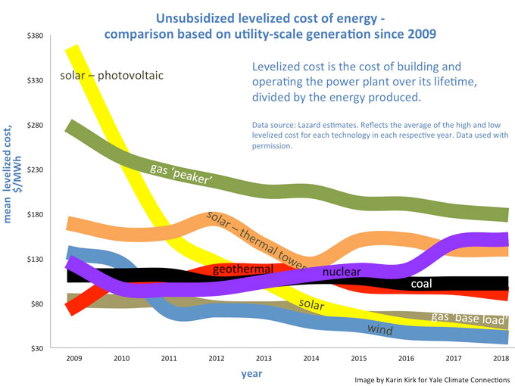
Figure 8.11. LCOE values for various energy sources. Image from yale360.com

From this graph, the dramatic reduction in the cost of solar PV technologies is clear. In addition, the costs of solar and wind sources are now less than their non-renewable counter parts.

71
8.6.5 Subsidy Costs

IRENA [8.12] has prepared an analysis of global energy subsidies. The annual costs of these subsidies for the year, 2018, are shown in Table 8.10.

Table 8.10 Comparison of subsidies for various energy sources
Energy Source | Subsidies (Billion USD for 2018)
Fossil Fuels  Air pollution  Climate and health  Direct  Nuclear  Fission  Renewable  RE power  Transport | 2,263  366  447  21  128  38

From this table, it can be seen that subsidies for fossil fuels is larger than that for renewable sources by a factor of 19 (fossil fuels receive 95% of total subsidies). In the report, methods used by the WTO, IEA, OECD, WB, and IMF were compared showing their various strengths and weaknesses. A greater harmonization of methodologies was advocated.

An additional source [8.13] reported subsidy values from a study by the International Monetary Fund (IMF) as shown in Figure 8.12. Here, it was found that the global subsidies amounted to $5.2 trillion or 6.4% of GDP. The majority of these subsidies are indirect, post-tax forms of support such as failing to price (i.e. tax) greenhouse gas emissions. Subsidies usually include environmental and health co

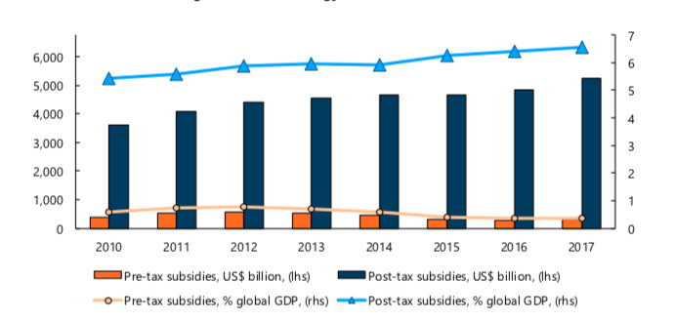
Figure 8.12 Global fossil fuel subsidies. Image from desdemonadespair.net

72
8.7 Financing Renewable Energy Projects

Four geographical regions and plans will be considered in terms of RE financing. While these funding methods were directed to specific countries or regions, they may have more general applicability to other areas.

8.7.1 International

IRENA [8.14] states that the required RE investment must come from the private sector as public funding is unlikely to increase above its current level of 15%. Here, institutional investors such as pension funds, insurance companies, endowments, and sovereign wealth funds will play a crucial role. These investors manage a total of $90T in assets within the developed countries. It is estimated by the OECD that $2.8T per annum is potentially available for RE investment. Financing methods are summarized here.

Capital Sources
On-lending structures
Loan syndicates
Subordinated debt
Convertible grants
Convertible loans

Risk Mitigation
Guarantees
Current risk
Liquidity risk

Recommendations
1. Advance RE projects from initiation to investment maturity.
2. Engage local financial institutions in RE finance.
3. Mitigate risks to attract private investors.
4. Mobilize more capital market investment.
5. Create facilities dedicated to scaling up RE investment.

73
8.7.2 United States

The Loan Programs Office of the US Department of Energy [8.15] has developed a series of programs to support the full arc of energy technology commercialization. A modified diagram of these commercialization programs is shown in Figure 8.13.

Funding Sources
Corporate Equity
Corporate Bonds

Private Equity
Government Bonds

Grants

Grants

High Low

Commercial Technical
Maturity Risk

ffffffdd

f GG

Low High

Low Technical Maturity High

Basic Research Applied Research Development Production
Universities Government Labs Industries Industries

Figure 8.13. Research and development spectrum for renewable energy technologies.

74
8.7.3 G20 Countries

A “Brown to Green Report, 2019,” has been written by Climate Transparency which is a comprehensive review of climate actions by the G20 countries [8.16]. This report is based on inputs from 14 research organizations and NGO’s and covers 80 indicators on decarbonization, climate policies, finance, and vulnerability to the impacts of climate change. These assessments of countries’ positive and negative results were made at the national or “macro-economic” level, and only the financial aspects of the report will be summarized here.

Under the Paris Agreement, the challenge was said to be “not only to grow green public and private finance”, but also to shift from “brown” finance.” The IPCC referred to a global stock of
US$ 386 T in financial capital (US$ 100 T in bonds, US$ 60 T in equity, and US$ 226 T in loans managed by the banking system). Governmental actions were given in a table as reproduced here in Table 8.11.

Table 8.11 Shaping the transition by G20 governments
Tool | Financial policies  and regulations | Fiscal policy levers | Public finance
Objective | Influencing behavior through binding laws, regulations, and enforcement | Influencing behavior through price signals | Influencing behavior through shifting financial risk
Examples | Green financial principles  Climate risk disclosure  Climate-related risk assessment and climate stress tests  Enhanced capital and liquidity requirements | Fossil fuel subsidies  Carbon pricing | Domestic and international public finance for fossil fuels (including divestment and commitments from  financial institutions)  International climate  Finance

One area of success has been the funding of climate vulnerable countries as discussed in the next sub-section.

75

The Climate Finance Leadership Initiative (CFLI) [8.17] addresses two key pillars for financing an effective transition to a low-carbon world: (1) increasing low-carbon investment (Challenges 1, 2, and 3) and (2) supporting the transition of carbon-intensive sectors (Challenges 4 and 5). The solutions address the roles of private finance, public finance, and policymakers as summarized in Table 8.12.

Table 8.12 Financing the transition to a low-carbon world

Challenges Solutions

 |  | Private Finance | Public Finance | Public Policy
1. Proven investment  models are not  replicated at scale |  | Electricity consumers enter into power purchase agreement (PPA’s) with project developers and utilities.  Project bonds. | Public budgets can guarantee revenues, making clean technologies more attractive.  Deploy long-term capital. | Governments set long-term targets for decarbonizing energy sector supported by short-to-medium term procurement goals.
2. Risks in emerging  markets constrain  low-carbon  investments |  | Investors provide asset financing where conditions permit.  Invest in developers rather than projects.  Organizations communicate appealing investment factors. | Development finance institutions (DFI’s):  Establish track record for investment, regulatory change, and project development.  Partner with banks and asset managers. | Mobilize private  investment through e.g. clean energy targets, grid access, auctions, feed-in tariffs.  Establish general investment climate.  Provide policy stability.
3. Many low-carbon  investments in key  sectors are not yet  profitable |  | Companies producing high-carbon commodities (steel, cement, aluminum) can develop labeling standards for low-carbon products. | Public funding can provide revenues through e.g. market-based subsidies. | Apply stable, long-range carbon pricing across sectors to spur investment.  Phase out fossil fuel subsidies.  Emphasize public procurement, incentives, standards.
4. The transition away  from carbon-  intensive  business models may  create financial and  social risk |  | Develop financial products, e.g. transition bonds, corporate bonds linked to strategies.  Support community transitions with social criteria, retraining. | Public budgets for:  Short-term impacts e.g. compensation, workforce development, grants.  Long-term strategies that may not generate returns for private investment. | Governments encourage owners of carbon-intensive assets to make transition through regulations, emissions standards.
5. A lack of tools and  incentives to align  financial portfolios  with a low-carbon  future |  | Financial-sector leaders can emphasize importance or climate-related disclosures.  Investors and lenders can work to align financial flows with < 2 C paths. | Development banks, sovereign wealth funds, government pension funds can ensure that institutions move to align portfolios with < 2 C paths. | Central banks and financial regulators can promote understanding of climate-related risks.  Policymakers can develop standards for transparency.

76
8.7.4 Climate Vulnerable Countries

Funding for the 48 countries of the Climate Vulnerable Forum was considered by the World Forum Council [8.18]. The annual sunshine levels for these countries are shown in Table 8.13.

Table 8.13 Annual sunshine for the 48 Climate Vulnerable Forum countries
Country | Annual Sunshine | Country | Annual Sunshine
Afghanistan | 3175 | Maldives | 2700
Bangladesh | 2066 | Marshall Islands | 2500
Barbados | 3000 | Mongolia | 2792
Bhutan | 2500 | Morocco | 3131
Burkina Faso | 3136 | Nepal | 1800
Cambodia * | 2400 | Niger * | 3100
Columbia | 1892 | Palau | 2500
Comoros * | 2500 | Palestine | 3311
Costa Rica | 2160 | Papua New Guinea | 2463
Dem. Rep. Congo | 1739, min. | Philippines * | 1900
Dominican Rep. | 3000 | Rwanda | 2100
Ethiopia | 3129 | Saint Lucia | 2800
Fiji | 2540 | Samoa | 2575
The Gambia | 2630 | Senegal | 3214
Ghana | 2432 | South Sudan | 3700, max.
Grenada | 2800 | Sri Lanka | 2620
Guatemala | 2445 | Sudan | 3737
Haiti | 3200 | Tanzania | 3143
Honduras * | 2260 | Timor-Leste | 2980
Kenya | 3114 | Tunisia | 2808
Kiribati | 2700 | Tuvalu | 2400
Lebanon | 2500 | Vanuatu | 2500
Madagascar | 2626 | Viet Nam | 2182
Malawi | 2797 | Yemen | 3300
Ave. +/- S.D.
2687 +/- 465
Capacity Factor = 30.6%
Large deforestation areas = *, Figure 8.14
Country sunshine data from Google sources was used.

On average, the annual sunshine for these countries is 13% higher than the average for the G20 countries.

77

Visions of the CVF states appear to be somewhat inconstant relative to the position of the Paris Agreement in that these countries wish to achieve 100% RE status as soon as possible while the Agreement calls for a temperature stabilization of 1.5 to 2.0 C only in the second half of the twenty first century. Nevertheless, it is significant to note, as stated by the WFC, that it is the most climate vulnerable (and developing) countries that are pioneering this global transformation.

The recommendations of the World Future Council are summarized as follows:

1. The CVF countries should develop a roadmap in the form of a proposal which describes the methods of reaching 100% RE production together with the necessary infrastructure. The proposal would also include funding mechanisms initially in the form of “Green Climate Bonds” from the G20 central banks.

2. If the RE investments reach profitability (due to credit guarantees or financial grants), it would then be possible to engage private capital for co-financing.

It is noted in this guide that some of the CVF countries have undergone substantial deforestation (20 to 55 %) as shown in the graphic of Figure 8.14.

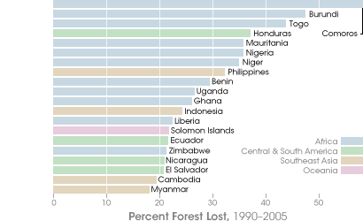

Figure 8.14 Tropical deforestation. Image from earthobservatory.nasa.gov

In the opinion of this guide, financial aid from other countries should be based, in part, on the environment policies and practices, e.g. deforestation, of the CVF countries.

78
8.8 Current and Projected Installations

Various models and data provide information for making projections of future RE installations.
Projections of future events often take the form of exponential growth which can be expressed mathematically as:

N = N₀ e^{kt}

where

N is a number at some future time
N₀ is an initial amount
k is a growth rate
t is time

An exponential graph is shown in Figure 8.15.

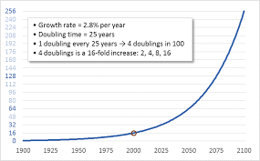

Figure 8.15 Exponential growth. Image from DarrinQualman.com

This relation can also be written (for the time-value-of-money, e.g. investments) as:

F = P(1 + r)^{n}

where

F is a future value
P is the present value
r is the growth (interest) rate
n is the number of periods.

79
Example 1

At the present time solar supplies about 3% of the world’s total energy needs [8.19]. In order to provide 100% of demand at the end of the transition period from 2020-2050, the annual rate of growth should be known. A time-value, exponential, calculation gives this rate using a financial calculator. To simplify this analysis, consider that the world currently has three units of energy supply and requires 100 units for 100% solar power:

3 units +/- PV, Present Value, (the +/- operator is a function of the financial calculator)
100 units FV, Future Value
30 n, years
r = 12 %, growth rate

A rate of 12% is substantial considering that stocks and bonds historically earn about 10% and
5 % annually. However, The Guardian [8.20] cites a 2019 IEA report that expects a 50% expansion of RE during next five years. This annual growth rate would be 9%.

Example 2

IRENA [8.21] advocates a tripling of RE investment during the 2020’s, and an annual growth rate for this period can be calculated as follows:

10 +/- PV
30 FV
10 n, years
r = 12 %

Example 3

Solar installations in the US have been projected to increase rapidly [8.22]. Consider the following example of growth rates.

2020: 1 % +/- PV (1% total capacity)
2028: 5 % FV (5% total capacity)
8 n, years
r = 22 %

With this growth rate, the date to reach full solar power can be calculated:

2020: 1 % +/- PV (1% total capacity)
100 % FV (100% total capacity)
22 r
n = 23 years

From this calculation, the US can expect 100% solar power in 2043.
80
8.9 Comparison of Energy-Source Land-Area Uses

Figures 8.16 and 8.17 compare land-use areas of various energy sources.

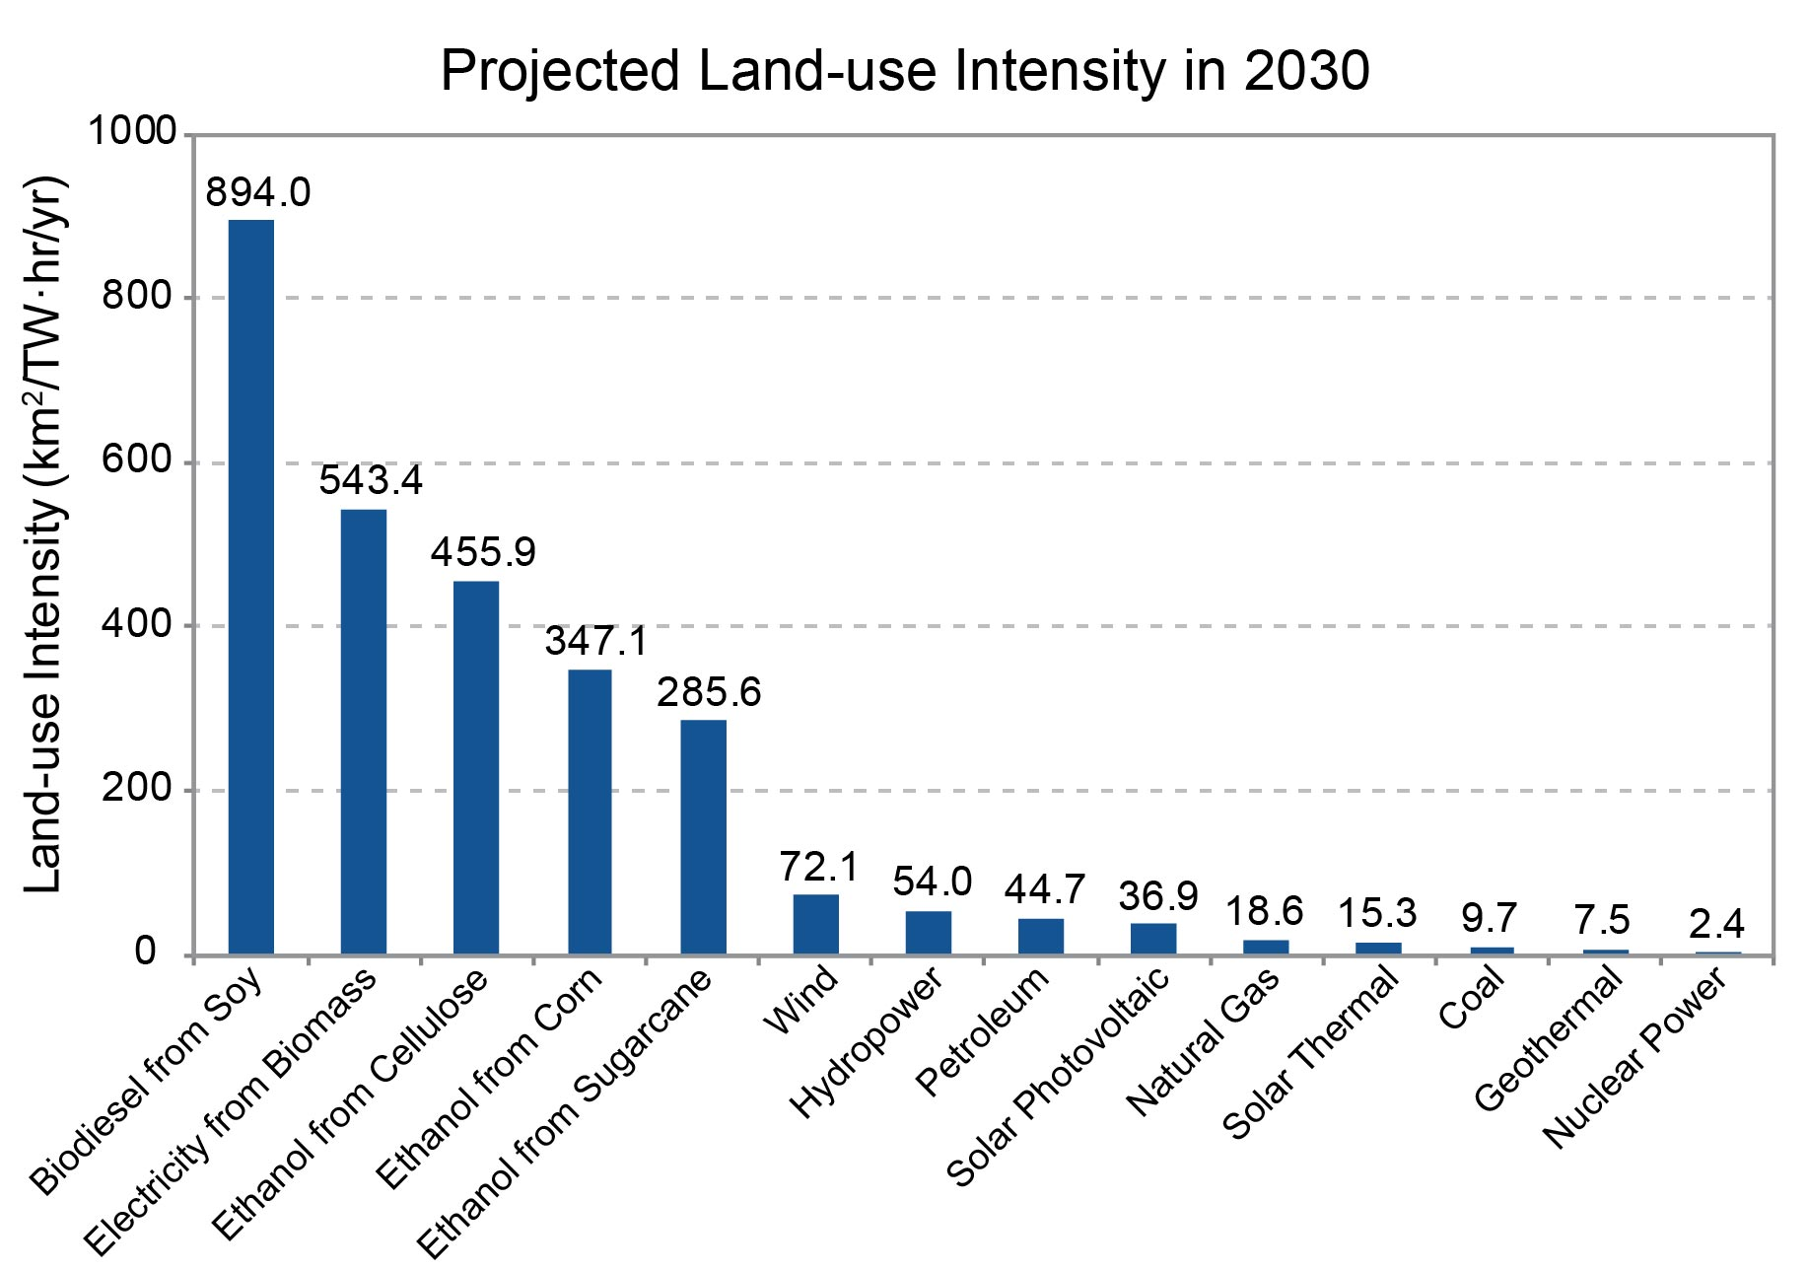

Figure 8.16 Land-Area Uses of Energy Sources. Image from nca2014.globalchange.gov

81

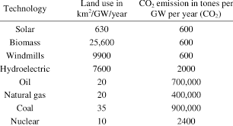

Figure 8.17. Land-Area Uses and CO₂ Emissions for Energy Sources.
Image from researchgate.net

When considering land use and CO₂ emissions together with equal weighting, the data in Figure 8.17 can be multiplied and ranked as shown in Table 8.14.

Table 8.14 A ranking of energy sources based on combined land use and CO₂ emission
Energy source km² x Tonnes CO₂
(GW – year)²

Coal 3.2 x 10⁷
Biomass 1.5 x 10⁷
Hydro 1.5 x 10⁷
Oil 1.4 x 10⁷
Natural gas 8.0 x 10⁶
Wind 5.9 x 10⁶
Solar 3.8 x 10⁵
Nuclear 2.4 x 10⁴

Clearly, these products should be minimized, and the data can be summarized as follows:

1. Coal, by far, has the largest value.
2. Surprisingly, the renewable sources, biomass and hydro, rank above oil.
3. Natural gas and wind have similar values.
4. Nuclear ranks below solar, but its cost and safety factors should be evaluated relative to
other sources.
5. Solar is an order of magnitude smaller than wind.

82
8.10 Guidelines Limitations

8.10.1 Design

The solar cells and panels considered in this guide are only some of the components in a complex system of energy generation, transmission, distribution, and storage.

8.10.2 Materials

Solar cell efficacy is limited not only by efficiency but also by manufacturing costs and lifetimes. Continued R&D efforts will result in improvements.

The availability of many materials may also become a limit. However, it is now expected that the use of silver for contacts will be reduced in future devices.

This restriction can be mitigated to a large extent by the recycling of the materials for the production of newer devices. In addition, recycling will also alleviate some of the environmental issues.

8.10.3 Environment

Solar photovoltaic cells, like all electronic devices, require the use of chemicals and manufacturing processes. Protocols for their manufacture will limit potential hazards.

8.10.4 Climate Effects

The required percentage of earth’s land mass required to power the entire world with solar energy is in the range of 0.2% to 0.4%. To date, no radiative forcing components due solar panels have been identified (see Appendix 1), and it appears likely that these small areas will not produce significant atmospheric changes in the future.

83
8.11 Areas for Research and Development [8.23, 8.24]

National Renewable Energy Laboratory, U.S.

Photovoltaic Research
Silicon materials and devices
Polycrystalline thin-film materials and devices
III-V multijunction materials and devices
New materials, devices and processes
Measurements and characterization
Performance and reliability
Engineering

Solar Grid and Systems Integration
Integration with the electric grid
Modeling including the System Advisor Model
PV engineering
PV performance, reliability and safety

Solar Market Research and Analysis
Data collection, analysis, and stakeholder engagement
Supporting a more efficient and better performing U.S. electricity system

Fraunhofer ISE and IWE, Germany
Solar thermal
Solar buildings
Solar cells
Electrical power supplies
Chemical energy conversion
Energy storage
Wind energy

Centre for Renewable Energy Systems and Technology, UK
Wind
Solar PV
Grid connections
Energy storage

UK Energy Research Centre
Energy systems change
Electric, heat, liquid fuels
Energy modelling

Offshore Energy Research Centre, UK
Wind, wave, tidal energy
84
8.12 Space-Based Solar Power

Solar power from space was first considered in the science fiction book, xxx, by Isaac Asimov in 1941 [8.25]. The advantages and disadvantages of this concept have also been considered [8.26].

Following the method used in Section 8.5, it is interesting to calculate the required area of solar panels if this system could be placed in orbit around the earth. Outside of the earth’s atmosphere, the incident solar energy, the “solar constant,” is 1.368 W/m². In addition, the panels would receive continuous radiation for 8,760 hours per year. Following the analysis of Section 8.5 with a conversion efficiency of 20 %, the required panel area would be 5.88 x 10¹⁰ m² or 22,700 square miles (150 mi. x 150 mi.), which is 17% of the earth-based system. Increased efficiencies would reduce these areas. Numerous designs of space-based solar systems have been proposed, an example of which is shown in Figure 8.18.

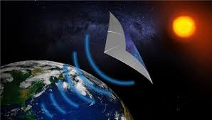
Figure 8.18 A space-based solar power system. Image from solargrid.pk

An “enhancement factor,” EF, can be defined for a space-based system relative to a ground installation. First, the Solar Constant at the top of the earth’s atmosphere is 1,368 W/m² and the capacity factor is 8,760 hours/8760 hours or 100%. Therefore,

EF = Space-Based = (1,368 W/m²) x (8,760 hours/year) = 5.99
Earth-Based (1,000 W/m²) x (2,000 hours/year)

The reciprocal of this factor gives the relative area of the panel installation above, 17%.

There are, however, a number of serious problems associated with space-based solar power. The primary restriction of SBPS is the cost of about $200 per kW as compared with the earth-based system cost of $1 (or less) per kW. In addition, transmission losses will occur when visible solar radiation is converted to the microwave region. Space is a hostile environment, making maintenance of a space system difficult.

SBSP will likely be feasible for earth-orbit, lunar, and planetary manned and un-manned applications. It should be recalled from Section 2 that on Mars, as determined by the inverse square law, the Solar Constant for this planet is only 608 W/m².

85
8.13 Comparison of Solar Systems

Among the various forms of 100% renewable energy (VRE) as discussed in Section 8.2, this guide has focused on solar power, specifically photovoltaic cells and panels. These devices are only some of the necessary components of a complete energy system which include transmission, distribution, control, and storage systems. Table 8.15 summarizes a portion of these factors for different systems.

Table 8.15 Comparison of solar systems
Factors | Multiple  “Roof Tops” | Utility Scale  Microgrids | Utility Scale  Traditional Grids | Single World  Grid | Space Based
Solar constant  (W/m²) | 1,000 | 1,000 | 1,000 | 1,000 | 1,368
Capacity factor  (assumed) (%) | 2000 = 22.83  8760  5.5 hours/day | 22.83 | Possibly larger  than microgrid  if >1 time zone | 8760 = 100  8760  24 hours/day | 8760 = 100  8760  24 hours/day
Cell efficiency (%) | 20-40 | 20-40 | 20-40 | 20-40 | 20-40
World panel area (km²) | 348,000 | 348,000 | 348,000 | 348,000 | 58,800
Battery storage  Section 8.2 | 77.17% of  total energy | 77.17% of  total energy | <77.17% of  total energy | NA | Earth based
Technically  Feasible | Yes | Yes | Yes | No | Yes, major problems
LCOE ($/MWh)  Table 8.9 | $151- $242 | Similar to  traditional grids | $36 - $40 | NA | 100 x ground  based

From this table, a few points emerge:

1. No single system will provide all of the required world energy needs.

2. “Roof tops,” microgrids, and traditional grids are currently in use and are the most
feasible systems, although the cost of “roof tops” is considerable higher than grid forms.

3. A single world grid could, in principle, increase the system’s capacity factor. However, this
grid would be technically unfeasible. This factor was discussed in Section 8.2.

4. Space-based solar, as discussed in Section, 8.12 will have limited applications, but its
cost is currently prohibitive for wide use.

86
8.13 The Future of Solar Photovoltaic Energy
EWG-LUT [6.2] has discussed many aspects of PV energy. Among these considerations is the concept of integrating “smart grids.” Examples appear in Figures 8.19 and 8.20. 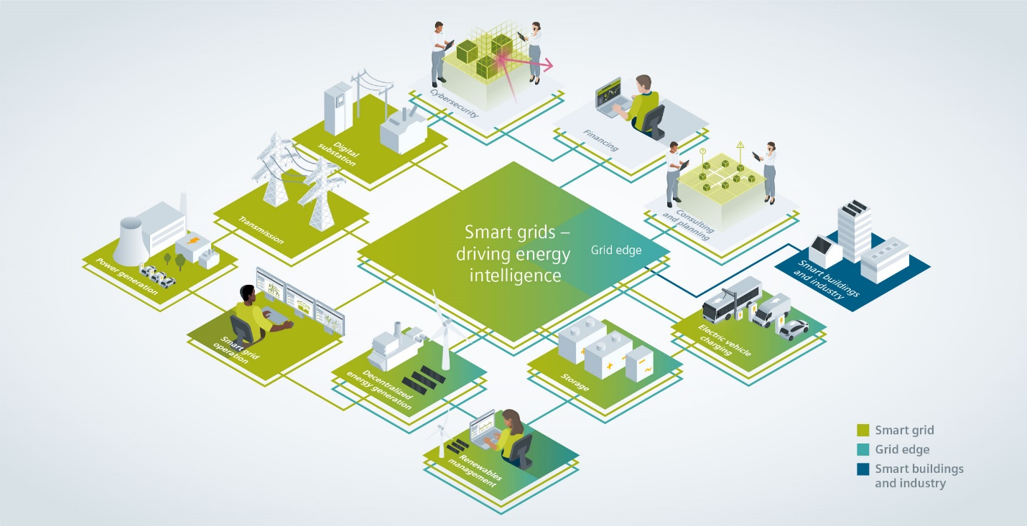
Figure 8.19 View of a smart grid. Image from siemans.com 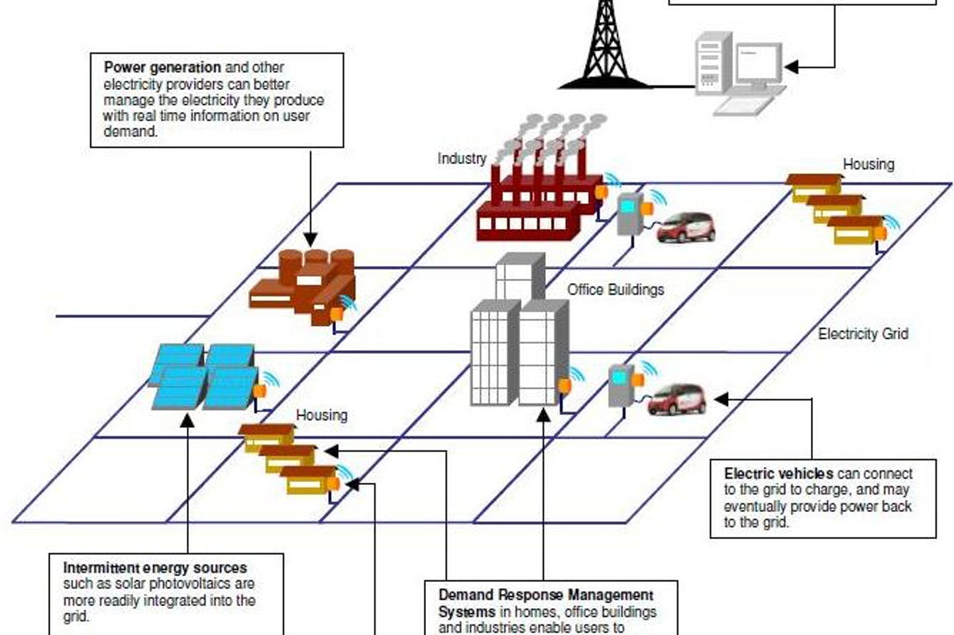
Figure 8.20 View of a smart grid. Image from Eco-Business.com
87
In addition to the physical aspects of RE and solar photovoltaics, business plans, including marketing strategies will be necessary. A few of these ideas are shown in Figures 8.21 and 8.22.

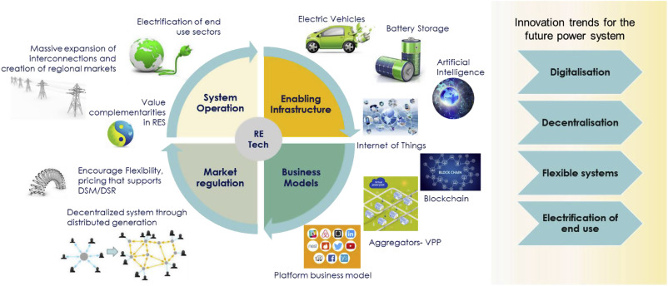
Figure 8.21 Business plans for RE. Image from sciencedirect.com

88

The website, solarpowerworldonline.com, [8.27] presented five digital marketing ideas as developed by Aurora Solar which are shown below and in Figure 8.22:

- Connect with customers while they are most engaged.
- Educate potential customers and answer their questions.
- Keep leads warm and turn visitors into customers.
- Reach new audiences by being social.
- Track success with data and refine strategies.



Figure 8.22 Solar marketing strategies. Image from solarpowerworldonline.com

89
8.14 A Simple Management Model

The commercialization of renewable energy on a global scale, including solar PV systems as discussed in this guide, will require substantial efforts at the national and corporate levels of all countries. As there are currently only about 10 countries which produce large numbers of solar cells, international trade will also result from installations. Other countries should be encouraged to continue their developmental capabilities in these areas.

Many universities and governments around the world conduct fundamental research on the materials which constitute the components of solar cells. Areas of future research and development concerning materials and systems have been discussed in Section 8.11. Collaboration between universities, government labs, and industry will be an essential element in the understanding, improvement, and commercialization of renewable-energy products. In addition, economic and business analyses of both the supply and demand sides of the commercialization process will be required. Interaction between these sides is key.

In Figure 8.23, a simple model is presented to meet these ends. “Macro” policies will be required nationally, and “micro” corporate structures are also seen to be necessary. The concept is one of matching the research and development (R&D) spectrum of RE sources with energy demand levels over time. In addition, the replacement of fossil-fuels with renewables during the transition period of 2020-2050 must be managed effectively.
Policy
Level

Management
Functions

Energy Demand/Consumption

Sales Marketing Determination Education
RE Supply/Sources

R&D Spectrum

Basic Applied Development Production
Research Research

Universities Governments Industries Industries

Balance
>>>>>>>>>>
<<<<<<<<<<

Figure 8.23. A model management for developing renewable energy.

90
8.15 Educational Programs for Renewable Energy and Environmental Sciences

In the section, programs for colleges and universities in the US and Europe are given in Tables 8.16 [8.28] and 8.17 [8.29].

Table 8.16. Educational Programs in the US
Allegheny College | Oregon Institute of Technology
American University | Pennsylvania State University
Appalachian State University | San Diego State University
Arizona State University | Santa Clara University
Ball State University | Stanford University
Butte College | State University of New York, New Paltz
Carleton College | Syracuse University
College of the Atlantic | Texas Tech University
Colorado State University | University of Arizona
Furman University | University of California, Berkeley
Georgetown University | University of California, Davis
George Washington University | University of California, Irvine
Guilford College | University of Connecticut
Gustavas Adolphes College | University of Delaware
Hampshire College | University of Massachusetts, Amherst
Humbolt State University | University of Massachusetts, Lowell
Las Positas College | University of Michigan
Middlebury College | University of Missouri
Massachusetts Institute of Technology | University of New Hampshire
Michigan State University | University of Tennessee, Knoxville
Northwestern University | University of Texas, Austin
Portland State University | Virginia Tech University
Oberlin College | Western Michigan University
Ohio State University
Oklahoma State University

91
Table 8.17 Educational Programs in Europe
Cologne University of Applied Science  Germany | Tampere University  Finland
Cranfield University  UK | Technische Universitat Berlin  Germany
Escuela de Negocios Diseccion  Spain | TU Wien  Austria
ESCP Business School  UK | UDIMA  Spain
European Masters in Renewable Energy  UK | UNIBA  Spain
Fraunhofer Academy  Germany | University of the Highlands and Islands  UK
FUNIBER  Spain | University of Nottingham  UK
Hanz University of Applied Sciences  Netherlands | University of Strathclyde  UK
IMF Business School  Spain | Universidad Europa  Spain
Institute for Technology and Resources  Germany | University of Oviedo  Spain
KTH Royal Institute of Technology
Sweden
Linnaeus University
Sweden
LUT University
Finland
Polytechnic Institute of Coimbra
Portugal
Poznan University of Technology
Poland

8.16 Professional Organizations for Solar Energy

Numerous national and international organizations and associations for solar energy are available [8.30].

92
9. Summary of Perspectives

A few of the many proposed methods for dealing with climate warming have been summarized in three general categories as shown in Table 9.1. Although these characterizations may be simplifications, details are readily available from the sources. A number of these references also consider the inadequacies of the many country pledges in the 2015 Paris Agreement. While they also present “stand-alone” solutions, it is likely that individual countries will employ a variety of measures to achieve their goals.

Table 9.1 Comparison of Proposed Methods
Technological | Hybrid  Technological and  Social Methods | Economic
Carbon Neutrality  Unproven BECCS methods likely ineffective and/or prohibitively expensive for fossil fuels  Space-Based Solar Power  Large-scale systems  not viable by 2050.  Possible limited installations  after 2050  Di Caprio/Teske  Plans cost $51T  less than fossil-fuel  subsidies, 2100  Di Caprio/Teske plans  reduce GHG emissions by  100 % | IPCC  Foundation:  Paris Agreement  Scenarios compared  Inadequate country pledges  View towards 2100  IRENA  Paris inadequacies addressed  Pathways for 1.5 C and 2.0 C  Cost estimate $110 T, 2050  Jacobson  100% RE (WWS)  Capital cost $73 T, 2050  Savings in energy and social  costs  RE installation proposals reduce GHG emissions by  75 -100%  Cost is $2 T to $3 T per year | Integrated Assessment Models (IAMs)  “Social cost of carbon”  no longer used by the UK and EU  Subsidy costs similar to  social costs $3 T to $5 T  per year  IMF  Fiscal - Carbon tax  $50 - $75/ ton CO₂  considered effective  Carbon taxes seen to reduce GHG emissions by 5-15%  in several countries

93
Arguments in favor of renewable energy (RE), particularly solar photovoltaic (PV) over fossil fuels, as presented in this guide, are summarized in Table 9.2.

Table 9.2 Guidelines Favorability of RE/PV vs. Fossil Fuels
Guidelines Sections | Considerations
Sections 3, 4, 7  Energy Supply and Demand | Supply of solar energy far exceeds the world’s demand  in perpetuity.  Solar power supply >1,000 x world demand.  Fossil fuels are depleting resources (about 100 years remaining).
Section 5  Environmental Factors | Anthropogenic use of fossil fuels during the past three  centuries well established as major cause of global warming.  Earth at a critical point with crucial transition period of  2020 to 2050.  “Carbon replacement” preferred over “carbon balancing.”  PV has lower embodied energy and lifecycle emissions than  fossil fuels.  Several “pathways” have demonstrated feasibility of RE/solar  even after Paris pledges found to be inadequate for 1.5 C  or 2.0 C.  RE sources for countries are more secure than fossil fuels.
Section 6  Economic considerations | Supply-and-demand principle favors RE over fossil fuels.  Prices of fossil fuels are increasing.  Prices of renewable energy sources are decreasing.  Increased net GDP and energy employment with RE.  RE installation costs less than costs of fossil-fuel subsidies.
Section 8  Plan for Global Installation | Plan is technically viable.  History of decreasing costs for PV cells and panels.  Lower LCOE with PV’s than non-renewable sources.  Installation rate projections, 10-13%, feasible through 2050.  Installation areas are less than 1% of land masses.  Current G20 solar panel cost estimate $35 T over 30 years  or about 1.8% of GDP
Section 9  Summary of Perspectives | RE pathway installation proposals reduce GHG emissions  75-100% by 2050; cost is less than fossil fuel subsidies or  the social cost of carbon.

94
10. Conclusions

Fossil fuels, in continued utilization, will be depleted within 50-100 years. The effective “fossil-fuel era,” as recorded later in history, will likely last around 300 years, from 1750 to 2050.

With no efforts to reduce global warming by replacing fossil fuels, the earth’s temperature is projected by the IPCC to increase about 4 C (7 F) in 2100 causing irreversible biosphere damage. The Paris Agreement of 2015, its pledges (although inadequate), and subsequent pathways to 2050 have laid the foundations for limiting further temperature increases.

The most effective means of limiting further global warming to 1.5-2.0 C through the mitigation of excess greenhouse gases will be the global replacement of fossil fuels with renewable energy (RE) sources which will reduce GHG emissions by 75-100%. These replacements in individual countries should be stated by their leaders as strategic national goals. In this regard, it is essential that the countries develop and implement long-term plans. Increases in the installations of RE sources should be matched by reductions in fossil-fuel usage.

To meet these goals, the world requires a transition period of about 30 years, (2020 -2050); this period is shorter than the IPCC view towards 2100. The second societal transformation with renewable energy will continue in perpetuity. Current barriers to achieving global, 100% RE are political, institutional-regulatory, and societal-cultural rather than economic-financial or scientific-technological. Among the technological barriers, storage is one of the most significant elements which will also increase the cost of 100% variable renewable energy (VRE).

Economic benefits of this replacement will include increases in global GDP and net energy employment.

Solar photovoltaic (PV) cells are proven technologies and will provide the majority of renewable energy. Continued R&D will further increase efficiencies and reduce costs. Annual installation growth rates should be about 10%.

Although solar energy alone is more than sufficient to power the world, other renewable energies such as wind and bio-fuels will also provide significant levels, depending on their geographical locations and economic sectors. In addition, lifestyle changes, lower energy demand, conservation, and higher efficiencies will reduce global warming.

The total cost of PV installations for the G20 countries is about $35T, and the average annual cost of solar panel installations for these countries is 1.8 % of their GDPs.

Financing of RE installations will be acquired primarily through private investment sources.
World energy subsidies are $3T to $5T per year with fossil-fuels above 90% of the total.

The total RE worldwide cost estimates from guideline references are in the range of about $50T to $100T over 30 years or $2T to $3T per year. This cost will be less than or roughly equal to the social costs of carbon or to the subsidy costs of fossil fuels.
95
11. References
3.1 “Coal.” Wikipedia, www.wikipedia.org/wiki/Coal.
3.2 “Oil.” Wikipedia, www.wikipedia.org/wiki/Oil.
3.3 “Natural gas.” Wikipedia, www.wikipedia.org/wiki/Natural_gas.
3.4 www.epa.gov/hfstudy
3.5 Earth Health News
3.6 www.sightline.org
3.7 www.usgs.gov/faqs/oklahoma-has-had-a-surge-earthquakes-2009
3.8 www.instituteforenergyresearch.org/?encyclopedia=fossil-fuels
3.9 “Nuclear fission.” Wikipedia, www.wikipedia.org/wiki/Nuclear_fission
3.10 “Nuclear fusion.” Wikipedia, www.wikipedia.org/wiki/Nuclear_fusion
3.11 Jacobson, M. Z., web.stanford.edu/group/efmh/Jacobson/articles/nuclearvswws
3.12 www.nbcnews.com/news/cost-taxpayers-clean-nuclear-jumps-100-billion-year
3.13 www.globalhealthusc.edu/2016/05/24/the-financial-costs-of-the-chernobyl-nuclear- powerplant-disaster
3.14 www.cleantechnica.com/2019/04/16/fukushima-final-costs
  - www.alternative-energy-tutorial.com

4.1 www.epa.gov/rhc/renewable-space-heating
4.2 www.pasivehouse.com

5.1 “Carbon cycle.” Wikipedia, 2020, www.wikipedia.org/wiki/Carbon_cycle.
5.2 www.sustainability-times.com/environmental-protection/2018.
5.3 www.ucsusa.org/resources/tropical-deforrestation-and-global-warming/2019
Error! Hyperlink reference not valid.5.4 www.earthwatch.org/save-forrest-trees/2019
5.5 www.wscreforrestation.org/reforrestation-25-100-years/2019
5.6 www.insideclimatenews.org/news/climate-primer-carbon-budget/2014
5.7 www.carbonbrief.com/analysis-how-much-carbon-budget-left/2018
5.8 “Carbon neutrality.” Wikipedia, 2020, www.wikipedia.org/wiki/Carbon_budget.
5.9 https://report.ipcc.ch/sr-15/pdf/sr15_spm_final.
5.10 www.oneearth.org/beccs-no-time-for-false-saviors/2019
5.11 www.oneearth.org/geoengineering-will-not-solve-climate-change/2019
5.12 “Carbon debt.” Wikipedia, 2019, www.wikipedia.org/wiki/Carbon_cycle.
5.13 “Life cycle greenhouse gas emissions of energy sources.” Wikipedia, 2020, www.wikipedia.org/wiki/Life_cycle_greenhouse_gas_emissions_of_energy_sources.
5.14 “International Panel on Climate Change.” Wikipedia, 2020, www.wikipedia.org/wiki/International_Panel_on_Climate_Change.
5.15 Moore, D., Heilweck, M., and Petros, P., Saving planet earth with appropriate biotechnology: 1. Diagnosing the problem, www.researchgate.net/348167043/2021
5.16 www.ipcc.ch/site/assets/uploads/2018/02/WG1AR5_Chapter_12_FINAL
5.17 “Paris Agreement.” Wikipedia, 2020, www.wikipedia.org/wiki/Paris_Agreement
5.18 www.climateactiontracker.org/countries/eu/pledges-and-targets/2019
5.19 Bogdanov, D., el. al., www.nature.com/articles/s41467-019-0855-1/2019.
5.20 www.irena.org//Digital/Articles/2019/Apr./-/media.
5.21 Teske, S., link.springer.com/book/10.1007/978-3-1030-6505843-2/2019.
96
5.22 web.stanford.edu/group/efmh/Jacobson/Articles/USStates/WWS/2019
5.23 “List of countries by oil production.” Wikipedia, 2019, www.wikipedia.org/List_of_countries_by_oil-production.
  - web.stanford.edu./group/efmh/jacobson/Articles/1/143WWSCountries/2019

6.1 Garcia-Casals, X., Ferroukhi, R., & Parajuli, B., Measuring the socio-economic footprint of
the energy transition. Energy Transitions, 3, 105-113 (2019)
6.2 www.energywatchgroup.org/wp-content/uploads/EWG-LUT_100RE_All_Sectors_Global-Report_2019.
6.3 “Carbon price.” Wikipedia, 2020, www.wikipedia.org/wiki/Carbon_price.
6.4 www.carbonbrief.org/qa/social-cost-carbon/2017.
6.5 www.economicshelp.org/blog/2207/economics/carbon-tax-pros-and-cons/2018
6.6 www.worldbank.org/en/programs/pricing-carbon/2020
6.7 www.ncbi.nlm.nih.gov/articlesPMC7050298/2018

7.1www.irena.org/media/Files/IRENA/Agency/Publications/2019/Apr/IRENA_GET_REmap_pathway_2019_

8.1 “Capacity factor.” Wikipedia, 2020, www.wikipedia.org/wiki, Capacity_factor.
8.2 www.vox.com/2015/6/24/8837293/economic-limitations-wind-solar
8.3 Kroposki, B., Integrating high levels of variable renewable energy into electric power systems. J. Mod. Power Syst. Clean Energy (2017) 5(6):831-837
8.4 www.pv-magazine-usa.com/2020/08/11/the-u-s-can-be-powered-100-by-renewable-energy-how-do-we-get-there/
8.5 www.ippu.msu.edu/wp-content/uploads/2018/01/IEEE-Achieving-a-100-Renewable-Grid.2017
8.6 Diesendorf, M. and Elliston, B., The feasibility of 100% renewable electricity systems: A response to critics. Renewable and Sustainable Energy Reviews 93 (2018) 318-330.
8.7 “List of types of solar cells.” Wikipedia, 2020, www.wikipedia.org/wiki,List-of-types-of-solar-cells.
8.8 www.nrel.gov
8.9 www.landartgenerator.org/blagi/archives/127
8.10 “Levelized cost of electricity.” Wikipedia, 2020, www.wikipedia.org/wiki,Levelized_cost_of_energy.
8.11 www.lazard.com/media/451086/lazard’s-levelized-cost-of-energy-version-130-vf
8.12 www.irena.org/-/media/Files/IRENA/Agency/Publications/2020/Apr/IRENA_Energy_subsidies_2020.
8.13 www.vox.com/2019/5/17/18624740/fossil-fuel-subsidies-climate-imf
8.14 www.irena.org/publications/2018/Jan/Global-Landscape-of-Renewable-Energy-Finance
8.15 www.nrdc.org/experts/amanda-levin/doe-program-propels-thriving-clean-energy-economy-industries
8.16 www.climate-trancparency.org/media/brown-to-green-report-2018
8.17 www.bloomberg.com/cfli
8.18 www.worldfuturecouncil.org/financing-100-re-in-cvf-countries
8.19 www.pv-magazine.com/2020/04/06/world-now-has-583-gw-of-operational-pv

97
8.20 www.theguardian.com/environment/2019/octg/2/renewable-energy-to-expand-50-in-next-five-years-report
8.21 www.irena.org/newsroom/press-releases/irena
8.22 www.seia.org/solar-industry-research-data
8.23 www.nrel.gov/solar
8.24 www.interestingengineering.com/5-top-renewable-energy-research-centers-in-europe-and-the-usa
8.25 “Reason, a short story by Isaac Asimov.” Wikipedia, 2020, www.wikipedia.org/wiki/Reason_short_story_by_Isaac_Asimov.
8.26 “Space-based solar power.” Wikipedia, 2020, www.wikipedia.org/Space_based-solar-power.
8.27 www.solarpowerworldonline.com/category/featured/Aurora-digital-marketing-series
8.28 www.greatvaluecolleges.net/best-alternative-energy-colleges
8.29 www.masterstudies.com/Masters-Degree-Renewable-Energy-Europe
8.30 www.solarfeeds.com/top-solar-associations-for-solar-professionals

12.1.1 “Svante Arrhenius.” Wikipedia, 2020, www.wikipedia.org/Svante_Arrhenius.
12.1.2 www.scied.ucar.edu/planetary-energy-balance-temperature-calculate
12.1.3 www.climate.gov/maps-data/primer-climate-forcing
12.1.4 www.chem.libretexts.org/Bookshelves/Physical-and-Theoretical-Chemistry-Textbook-The-Harmonic-Oscillator
12.1.5 www.vergil.chemistry.gatech.edu/endnotes/quantrev/node8
12.1.6 www.physics.gmu.edu/dmaria/590%20Web%20page/public_htm/qm_topics/harmonic/rachel_dudik/2004
12.1.7 www.tropicsu.org/wp-content/uploads/2019/01/Lesson_Plan_Chemistry_IR_Spectroscopy
12.1.8 www.acs.org/content/acs/en/climatescience/greenhousegases/properties

12.2.1 “James Clerk Maxwell.” Wikipedia, 2020, www.wikipedia.org/James_Clerk_Maxwell.
12.2.2 www.ocw.mit.edu/courses/electrical-engineering-and-computer-science
12.2.3 www.physics.usyd.edu.au/teach_res/mp.doc
12.2.4 www.courses.physics.ucsd.edu/2016/winter/physicssd/Ch3Nf
12.2.5 “Max Planck.” Wikipedia, 2020, www.wikipedia.org/Max_Planck.
12.2.6 www.edisciplines.usp.br/pluginfile.php/48089/course/section/164461/qsp-chapter10-planck
12.2.7 www.uu.diva.portal.org/smash/get/dwa2:/1219401/FULLTEXT-01
12.2.8 www.integral-calculator.com
12.2.9 www.people.physics/tamu.edu/Krisciunas/planck
12.2,10 “Lambert cosine law.” Wikipedia. 2020, www.wikipedia.org/Lambert_cosine_law.
12.2.11 www.hyperphysics.phys-astr.gsu.edu/hbase/thermo/stefan.2
12.2.12 www.spectralcalc.com/blackbody/integrate_planck

98
12.3.1 “Albert Einstein.” Wikipedia, 2020, www.wikipedia.org/Albert_Einstein.
12.3.2 “Photoelectric effect.” Wikipedia, 2020, www.wikipedia.org/Photoelectric_effect.
12.4.1 “Timeline of solar cells.” Wikipedia, 2020, www.wikipedia.org/Timeline_of_solar_cells.
12.4.2 “Theory of solar cells.” Wikipedia, 2020, www.wikipedia.org/Theory_of_solar_cells.
12.4.3 Neamen, D. A., Neamen’s Semiconductor Physics & Devices, 4th Edition, McGraw-Hill, 2011
12.4.4 “Quantum efficiency.” Wikipedia, 2020, www.wikipedia.org/Quantum_efficiency.

99
12. Appendices

12.1 Appendix 1, Arrhenius Model for Atmospheric Warming, 1897

12.1.1 Svante Arrhenius

Svante Arrhenius (1859 - 1927), a Swedish scientist, proposed models for atmospheric warming due to increasing CO₂ levels during the late nineteenth century. Ironically, Arrhenius actually considered global warming to be a positive development as it would prevent another ice age and be beneficial for agricultural production as world population increased [12.1.1].

Arrhenius was the first scientist to propose the equation for the increase in flux density, F, due to increased levels of atmospheric CO₂.

ΔF = αln(C/C₀), α = 5.35 W/m².

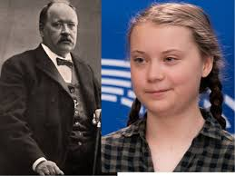

Figure 12.1.1 Svante Arrhenius and Greta Thunberg.
Image from thepostil .com

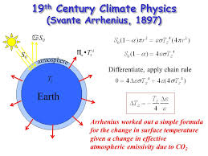
Figure 12.1.2 An early model. Image from slideplayer.com

100
12.1.2 Earth’s Heat Balance

For the case of no planetary atmosphere, the earth’s heat balance [12.1.2] can be described by the equality of the planet’s absorbed heat, H_{a}, and its emitted heat, H_{e}.

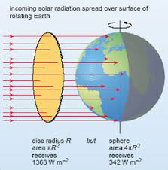
Figure 12.1.3 Earth’s heating and cooling effects. Image from open.edu

The heat absorbed is given by

H_{a} = (1 – a) πR² S₀

where a = planet’s albedo (reflection), 0.30, absorption = (1-a)
R = planet’s cross-sectional radius
S₀ = solar constant at the earth, 1,368 W/m²

The heat emitted or radiated over the entire earth’s surface is

H_{e} = (4πR²) σT_{e}⁴

where σ = Stefan-Boltzmann constant (see Appendix 2)
T_{e} = earth’s effective temperature

For heat balance,

H_{a} = H_{e}

(1 – a) πR² S₀ = 4πR² σT_{e}⁴

From this equality, the earth’s effective (black body) temperature, Figure 12.1.4, with no atmosphere can be calculated as

T_{e} = [(S₀/4)(1-a) σ]^{1/4} = 255 K = – 18 C.

101
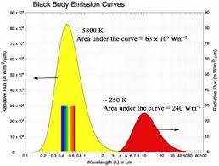
Figure 12.1.4 Black body emission curves for the sun and earth. Image from acs.org

This temperature is less than the actual surface temperature of the earth which, on average, is about 288 K or 15 C. The difference of 33 C is caused by the heat-trapping effect of the atmosphere, also known as the greenhouse effect, which is a normal process. The historically recent and current process of global warming may be considered as an “excess greenhouse effect,” raising this normal temperature by about 1.0 C since 1850. As the Paris Agreement seeks to limit further increases to 1.5 C or 2.0 C, it must be remembered that because of the past increase of 1.0 C, the remaining limits are only 0.5 C or 1.0 C.

From the Arrhenius Equation for an atmospheric CO₂ of 400 ppm, the flux density or radiative forcing is

F = 5.35 ln(C) = 32 W/m²

The value of F for water vapor is 75 W/m² giving a total ΔF = 107 W/m². It is also known [xx] that

ΔT = 0.31 ΔF

For CO₂ and water vapor the values of ΔT are 10 C and 23 C respectively, yielding the surface temperature increase of 33 C as stated above. Other GHG’s and feedback effects complicate these analyses which require more sophisticated models which include addition GHG’s and feedback effects.

In basic terms, the increase in atmospheric temperature is also related to the radiative forcing by the equation,

ΔT = λΔF

where λ is the climate sensitivity parameter, 0.8 K/(W/m²)

The Arrhenius Equation for CO₂ is

ΔF = 5.35 ln (C/C₀)
102

giving

ΔT = λ 5.35 ln (C/C₀)

ΔT = 0.8[5.35ln(400/290)]

ΔT = 1.4 K

As the temperature increase from the reference temperature in 1850.

For an increase in atmospheric CO₂ levels from 278 to 400 ppm,

This temperature is projected to increase by 4 C in the year 2100 as shown in Figure 11.x

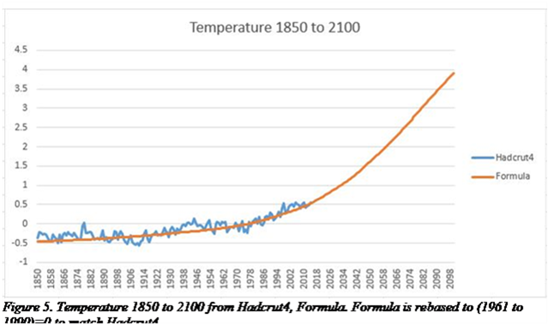

Figure 12.1.5 Atmospheric temperature increase from CO₂ emissions.
Image from whatsupwiththat.com

103
12.1.3 Radiative Forcing

Radiative forcing [12.1.3] is the difference between the earth’s incoming and outgoing radiation.

The contribution to radiative forcing due to CO₂ can be calculated from the relation:

ΔF = 5.35 ln(ΔC)

ΔF = 5.35 ln(C/C₀)

ΔF = 5.35 ln (390/280)

ΔF = 1.85 W/m²

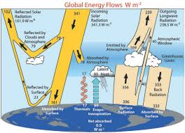

Figure 12.1.6 Radiative forcing. Image from hockeyschtick.com

104
The major components of radiative forcing are shown in Figure 12.1.7.
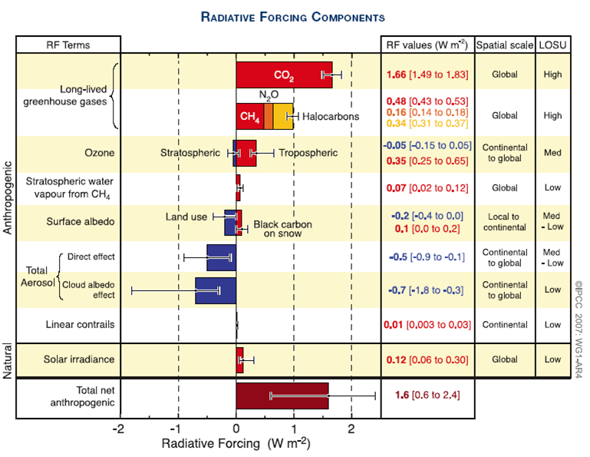

Figure 12.1.7 Radiative Forcing Components. Image from grimstad.uia.no

As of 2018, the amount of radiative forcing was found to be about 3 W/m².

105

Radiative forcing, with its primary constituents of CO₂ and CH₄, has been increasing as shown in Fig 12.1.8.
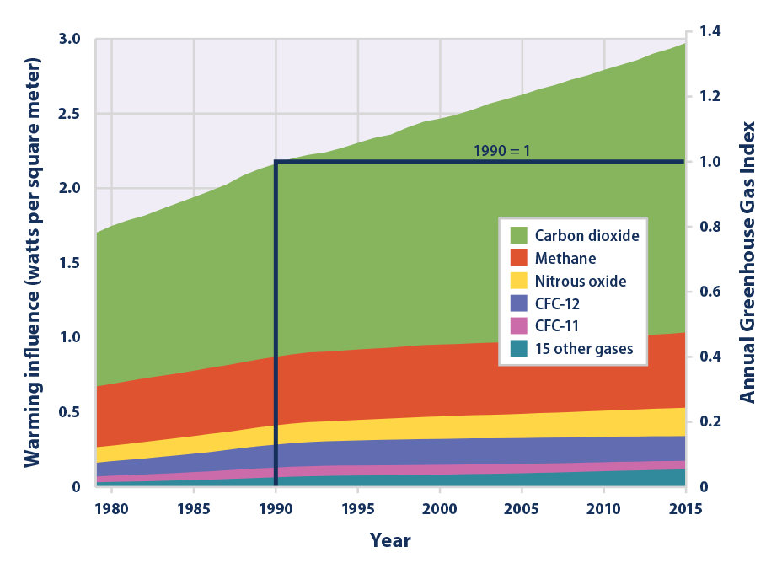
Figure 12.1.8 Increase of earth’s radiative forcing.
Image from epa.gov/climate-indicators/forcing

106
12.1.4 Theoretical Models of Green House Gas Molecules

The primary excess atmospheric gases which cause global warming are CO₂ and CH₄. A description of their absorption processes will be given here in both classical- and quantum- mechanical terms.

When considering the interaction of photons with matter, the following points are emphasized:

1. Energy levels of matter in the form of atoms and molecules are quantized, that is, discrete and are determined by the relation:

E_{n} = (n + ½) hν_{n}

In the context of IR radiation as emitted by the earth’s surface with an average temperature of 288 K, the frequencies observed are those of the vibrational levels of CO₂ and other greenhouse gas molecules.

2. The energy of individual photons, for example in a monochromatic laser beam, as shown by Planck and Einstein in Appendices 2 and 3 is given by:

E_{p} = hν_{p} = hc/λ_{p}

3. An atom or molecule will absorb a photon only when one of its energy-level differences,
ΔE = E₂ – E₁, matches the energy of an incident photon, E_{p}, as shown in Figure 12.1.9.

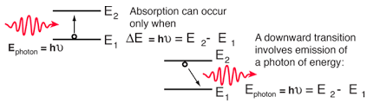
Figure 12.1.9 Photon absorption. Image from hyperphyscis.phys-astr.gsu.edu

4. The continuum, or spectrum, of black body radiation, at a particular temperature, T, as given in terms of frequency or wavelength by Planck’s Law in Appendix 2 as a spectral irradiance:

I_{ν}(ν,T) = 2h ν³
c² e^{hν/kT} - 1
or

I_{λ} (λ,T) = 2hc 1
λ⁵ e^{hc/λkT} – 1

107
12.1.4.1 Harmonic Oscillator

12.1.4.1.1 Classical Model

In the classical simple harmonic oscillator, a mass, m, is supported on a spring with a force constant, k. This system is used to simulate a diatomic molecule. The potential energy for the system is obtained [12.1.4] by integrating Hooke’s Law:

F = -kx = - dV
dx
to give

V = 1 kx²
2

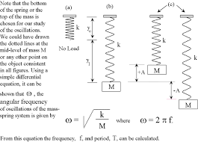

Figure 12.1.10 Hooke’s Law. Image from ptscc.edu

In molecular mechanics and molecular orbital calculations, the force constant is not known. However, the force constant can be calculated from the second derivative of the potential energy:

d²V = k
dx²

Hooke’s Law can be substituted into Newton’s Law, F = ma, and solved to obtain:

x(t) = Asin(2πνt)

where ν is the fundamental vibration frequency, and A is the amplitude of the vibration. The second derivative of x(t) gives:

d²x = - 4π²ν²x
dt²

108
from which

-4π²ν² mx = - kx

The vibrational frequency then becomes

ν = 1 [k/m] ^{1/2}
2π

and the potential energy is

V(x) = 1 mω²x², ω = 2πν
2

12.1.4.1.2 Quantum Model

The time-independent Schrodinger equation can be derived beginning with the one-dimensional classical wave equation [12.1.5] as reproduced here:

d²u = 1 d²u , v = velocity
dx² v² dt²

Using the separation of variables,

u(x,t) = ψ(x)f(t)

gives

f(t) d² ψ (x) = 1 ψ(x) d² f(t)
dx² v² dt²

With the standard wave equation solutions for f(t) having the form, e^{iωt} , the wave equation becomes:

d² ψ(x) = - ω² ψ(x)
dx² v²

This ordinary differential equation describes the spatial amplitude of the matter wave as a function of position.

Next, the total energy of a particle is the sum of its kinetic and potential components:

E = p² + V(x)
2m

109
which can be solved for the momentum, to obtain

p = [ 2m(E – V(x))]^{½}

The de Broglie formula can be used to produce an equation for the wavelength:

λ = h = h
p [2m(E – V(x))]^{½}

The term, ω² / v², can be re-written in terms of λ by recalling that ω = 2πν and νλ = v
(ν = Greek nu, v = velocity) which gives:

ω² = 4π² ν² = 4π² = 2m[E -V(x)]
v² v² λ² ħ²

Substituting this result gives the time-independent Schrodinger equation:

d² ψ(x) + 2m [E – V(x)]ψ(x) = 0
dx² ħ²

which is written in the form:

- ħ² d² ψ(x) + V(x) ψ(x) = E ψ(x)
2m dx²

This single-particle one-dimensional equation can be extended to three dimensions. In addition, a two-body problem can be addressed by this equation if the mass, m, is replaced by the reduced mass of the two particles.

The Schrodinger equation for the harmonic oscillator is:

d²ψ + [2mE/ħ² - m²ω²x² /ħ²]ψ = 0
dx²

This equation can be solved [12.1.6] using a dimensionless variable:

y = [mω/ħ]^{1/2} x

and a power series:

∞
u(y) = Ʃ a^{n} y^{n}
^{n=0}

110

The eigenvalues are then:

E_{n} = (n + ½) ħω

and the eigenstates, including Hermite polynomials for orthogonality are:

ψ(x) = [mω/πħ]^{1/4} 1 [(mω/ħ)^{1/2} x] exp( -mωx² /2ħ)
(2^{n}n!)^{1/2}

Various calculations of energy levels and eigenstates for CO₂ and other greenhouse gases have been made and will not be cited here. Experimental measurements of these gases will be discussed in the next section.

111
12.1.5 Experimental Measurements of Green House Gases

When considering warming of the earth’s atmosphere, it is instructive to first state its composition:

Nitrogen, N₂ – 78%
Oxygen, O₂ – 21%
Argon, A – 0.93%
Carbon dioxide, CO₂ – 0.04% (currently at 410 ppm)
Trace amounts: Methane, CH₄ (currently at 1,875 ppb, or approximately 2 ppm)
Water vapor, H₂O
Nitrous oxide, N₂O
Helium, He
Hydrogen, H
Neon, Ne
Krypton, Kr

The diatomic molecules, nitrogen and oxygen, do not absorb IR radiation. The more complex molecules, carbon dioxide, methane, water vapor, and nitrous oxide, have absorptions bands in the IR region, where the earth, itself, at T =15C or 288K, is the source of the IR radiation

Figure 1.2.11 illustrates, in macroscopic terms, the interaction of solar and earth radiation with the atmosphere.

Figure 12.1.11 Interactions of solar and earth radiation with the atmosphere
Image from whatsupwiththat.com
112
The interaction of electromagnetic radiation with matter can be investigated using the technique of spectroscopy [12.1.7]. As GHG’s have vibrational states primarily in the IR region, the technique will focus here with an example shown in Figure 12.1.12.
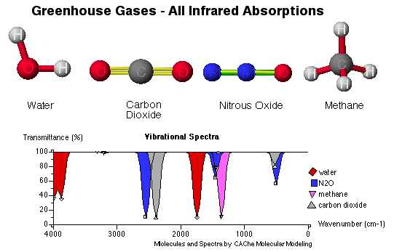
Figure 12.1.12 Vibrational spectrum of GHG’s. Image from emaze.com

In the case of CO₂ which accounts for 64 % of global warming, the chemical bonds between the carbon and oxygen atoms are stretched or bent resulting in the absorption of IR radiation at 4.26 μm and 15.00 μm as seen in Figure 12.1.13. These absorption processes cause the CO₂ molecules to move faster, increasing the atmospheric temperature.

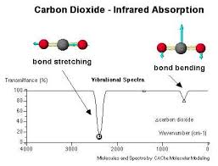
Figure 12.1.13 Spectrum of CO₂. Image from chemistry@elmhurst Elmhurst College

113

Molecules can absorb radiation as shown above when the energy of the incident photon equals the energy of a particular transition. In the UV and visible portions of the spectrum, atomic dissociation or electron ejection (ionization) may occur. In the IR region in which photons are produced by the earth’s surface, molecular vibrations result, Figure 12.1.14. At lower energies or longer wavelengths, in the microwave region, only molecular rotations occur.
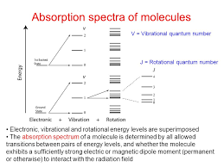
Figure 12.1.14 Absorption spectra of molecules. Image from slideplayer.co

Temperature is a measure of the average energy of molecular motion [12.1.8]. This motion can be translation, intramolecular vibration, and rotation. The sum of these motions’ energies is the “thermal energy” of the system, in this case, of the earth’s atmosphere.

These translational and absorption processes cause the CO₂ and other GHG molecules to move faster, increasing the atmospheric temperature. Increased concentrations of GHFs results in increased atmospheric temperature. This increase over time is shown in Figure 12.1.15 where the rise in temperature since around 1850 has been nearly 1.0 C (1.8 F).

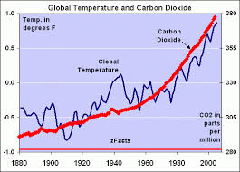
Figure 12.1.15 Increases in Atmospheric CO₂ Content and Temperature.
Image from wattsupwiththat.com

114
Methane is the second largest contributing GHG and is responsible for 14 % of global warming.
Natural and man-made sources of methane are approximately 30 % and 70 % respectively as seen in Figure 12.1.16.
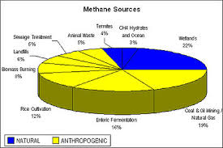
Figure 12.1.16 Natural and Man-made sources of methane. Image from Wikipedia.com

Methane concentrations have increased more than 10 % since 1980 seen in Figure 12.1.17.
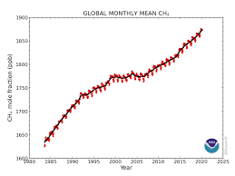
Figure 12.1.17 Increase in Atmospheric Methane Concentration. Image from esrl.noaa.gov

A few basic points from this section and from previous sections can be summarized here:
1. “Normal” concentrations of GHGs such as CO₂ and CH₄ are necessary for two reasons:
1.1. To raise the atmospheric temperature from – 18 C to + 15 C as its major constituents,
N₂ and O₂, do not absorb IR radiation.
1.2. To facilitate biosphere processes including the natural carbon cycle, photosynthesis, habitat
and species formation.

2. Excess levels of anthropogenic GHGs from fossil-fuel oxidation have led to more IR
absorption and, therefore, to higher atmospheric temperatures, currently about + 1.0 C from
pre-industrial concentrations.

3. These higher temperatures render the earth’s biosphere as unsustainable, meaning that future
increases must be limited to, at most, 1.5-2.0 C.

4. The most effective method of limiting GHG emissions and temperature increases will be
through the replacement of fossil fuels with renewable energy sources by 2050.
115
12.2 Appendix 2, Planck Radiation Law, 1900

12.2.1 Classical Background

Max Planck, one of the founders of quantum physics, considered the intensity of electromagnetic radiation as a function of frequency. The principles of electromagnetic radiation were laws as developed by earlier scientists and became known as Maxwell’s Equations which are shown in differential form in Figure 12.2.1.
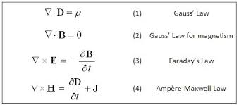

Figure 12.2.1 Maxwell’s Equations. Image from ethw.org

James Clerk Maxwell (1831-1879) was a Scottish scientist [12.2.1] who worked in the field of mathematical physics. He formulated the classical theory of electromagnetic radiation, unifying electricity, magnetism, and light as different manifestations of the same phenomenon.

His theories laid the foundations for later fields such as special relativity and quantum mechanics. These contributions are considered to be as important as the earlier works of Isaac Newton and the later theories of Albert Einstein.

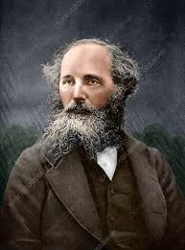

Figure 12.2.2 James Clerk Maxwell. Image from sciencephoto.com

116
The laws expressed in Maxwell’s Equations were founded by three scientists, Carl Friedrich Gauss, Michael Faraday, and Andre-Marie Ampere. From these laws, Maxwell derived the wave equations for electromagnetic radiation. For the cases when the electric field, E, and the magnetic field, H, vary harmonically (sinusoidal in time), they may be expressed as the products of spatial functions E(r) or H(r) and a time-varying function e^{-iωt}. It will be shown that the substitution of these products into the Maxwell Wave Equation results in the spatially-dependent or time-independent Helmholtz Wave Equation. Solutions of this equation, together with their boundary conditions provide the classical basis for derivation of the quantum Planck Radiation Law.

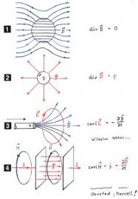
Figure 12.2.3. Electromagnetic fields. Image from blogs.helmholtz.de

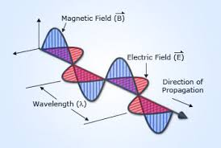

Figure 12.2.4 Electromagnetic wave. Image from simply.science.com

117

A schematic diagram of the EM spectrum is shown in Figure 12.2.5. This spectrum covers 16 orders of magnitude (16 factors of 10) in terms of energy, frequency or wavelength and 10 million + degrees of temperature. These waves or photons are associated with nuclear, atomic, molecular, or free electron reactions and a few transitions as summarized in Table 2.1.

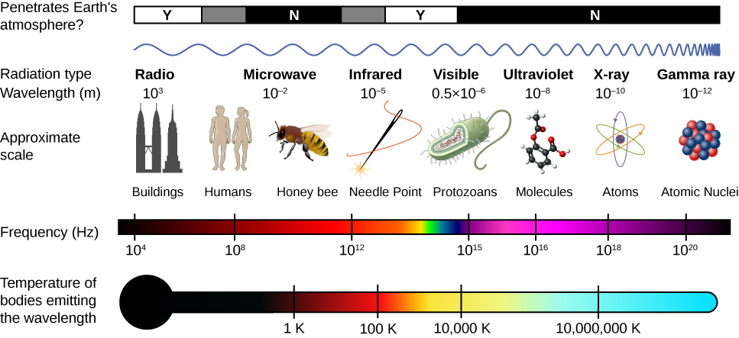

Figure 12.2.5 Schematic diagram of the electromagnetic spectrum.
Image from cnx.org.

118

There are seven regions across the complete EM spectrum as shown in the following table.
Given in Table 12.2.1 are these regions for a few energy reactions and aspects of the sun-earth-atmosphere system.

Table 12.2.1 Processes in the EM spectrum
EM Spectral Region | Reactions | Effects
Gamma ray radiation | Atomic nuclei | Reactor nuclear fission and stellar fusion reactions
X-ray radiation | Atomic inner electron  Transitions | Earth’s atmosphere  opaque to x-rays
Ultraviolet – UV  Radiation | Ionizing radiation and  chemical reactions | 10% of sun’s power; absorbed by atmospheric  nitrogen and oxygen
Visible light | Light absorbed and emitted by electrons in atoms and molecules during energy transitions | Solar peak power.  Photon energies near  solar cell semiconductor band gaps.
Infrared – IR  Radiation | Heat source is earth, 15 C  Molecular vibrations | Global warming due to excess GHG’s absorbing IR
Microwave  Radiation | Molecular rotations | Heating of fluids
Radio waves | Oscillating electrons in  antenna generate EM  waves | Earth atmosphere  transparent to radio waves except ionosphere

119
Images of four scientists associated with the electromagnetic spectrum are shown below.

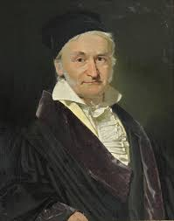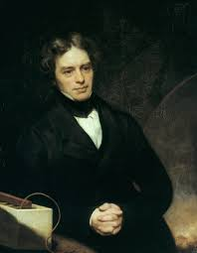

Carl Friedrich Gauss (1777-1865) Michael Faraday (1791-1867)
Image from en.wikipedia.org Image from britannica.com

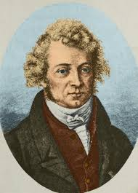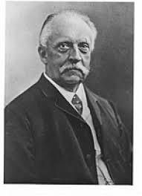

Andre-Marie Ampere’ (1775-1836) Hermann von Helmholtz (1821-1894)
Image from sciencesource.com Image from hzg.de

Figure 12.2.6 Four scientists who contributed to knowledge of the electromagnetic spectrum.

120
The derivation of Maxwell’s wave equation [12.2.2, 12.2.3] begins with Faraday’s Law:

$∇$ x E = - $∂$ B
$∂$t
Next, the curl is taken of this law:

$∇$ x ($∇$ x E) = - $∂$ ( $∇$ x B)
$∂ t$
Ampere’s Law is

$∇$x B = $∂$ E
$∂ t$
which gives

$∇$ x ( $∇$ x E) = - $∂$ E²
$∂$t²
The identity

$∇ x (∇ x A)$ = $∇$($∇$.A) - $∇$² A

yields

$∇$($∇$.E) - $∇$² E = - $∂$E²
$∂$t²

Gauss’ Law then gives the Maxwell wave equation for the electric field,

$∇$² E – k $∂$²E = 0 (1)
$∂t$²

A similar expression holds for the magnetic field,

The general solution [wiki] to the wave equation take the form

E(r,t) = g(ωt – kr)

And the simplest set of solutions to the wave equation result from assuming sinusoidal waveforms of a single frequency:

E(r,t) = Real [E(r) e^{-iωt}] (2)

121
By substituting equation (2) into equation (1) and recalling that iω = $∂/∂t$, the Helmholtz wave equation can be derived as:

$∇$² E + k² E = 0

which is the time-independent or spatially-dependent form of the Maxwell’s wave equation and is the simple harmonic oscillator equation with the solution [12.2.4],

E(x) = B cos k_{x} + C sin k_{x}

Imposing the boundary condition that E (x) is 0 at x =0 and at x = L leads to B = 0 and k_{x}L = n_{x}π, where n_{x} = 1,2,3, … are positive integers; similar solutions are obtained for E(y) and E(z), giving

E_{x}(x,y,z) = A sin (k_{x}) sin (k_{y}) sin (k_{z}), where k² = π² (n_{x} ² + n_{y} ² + n_{z} ²) as shown in Figure 12.2.7.
L²
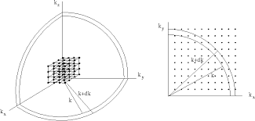
Figure 12.2.7 View of k-space. Image from theory.physics.manchester.ac.uk

The number of standing waves or modes, N(k), having wave number in dk is the volume of k-space divided by (π/L)³. The volume of the octant is 1/8 the volume of a spherical shell of thickness, dk, giving

N(k) dk = (1/8) (4πk² dk), = Vk² dk, V = L³
(π/L)³ 2 π²

For EM waves, there are two polarizations for each mode, which yields for the density of states in k-space,

N(k) dk = k² dk
V π²

In frequency space, k = 2 πν/c, so that the density of states is N(ν) dν = 8 πν² dν
c³
In wavelength space, ν = c/λ, giving the density of states as N(λ)dλ = 8 π dλ
λ⁴
The density of states is the same in both the classical and quantum models.

122
12.2.2 Derivation of Planck Law

Max Planck (1855 - 1947) was a German Scientist, who made many contributions [12.2.5] to physics, but his most important work was in the area of quantum theory. In the case of black-body radiation, he considered the intensity of electromagnetic radiation as a function of frequency (or wavelength). Planck knew that the Wien and Rayleigh-Jeans laws failed at high and low frequencies. These difficulties were solved by postulating that electromagnetic quanta (later called photons) could be emitted only in discrete packets with energies as multiples of frequency, E = hν, where h became known as Planck’s constant, and ν (Greek letter, nu) is the frequency.

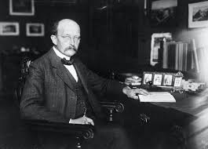

Figure 12.2.8 Max Planck. Image from thoughtco.com

The derivation of Planck’s Law reconciles the classical view of electromagnetic waves with quantum concepts [12.2.6], outlined as follows.

First, in the classical picture, as discussed above, the energy of the waves is contained within the oscillating electric and magnetic fields. The only constraint on the solutions to Maxwell’s wave equation and to Helmholtz was the boundary conditions which permitted certain modes. These boundary conditions require the waves to fit into a box with whole numbers of half-wavelengths in the x, y, and z directions.

Second, in the quantum analysis, an additional constraint is imposed. The quantization of the EM radiation means that the energy of a particular mode of frequency, ν, cannot have any arbitrary value. This energy must have values which are multiples of hν; that is, the energy of the mode is E(ν) = nhν, where n photons are associated with this mode.

Third, all modes (and photons) are considered to be in thermal equilibrium at temperature, T. In order to establish this equilibrium, there must be means of exchanging energy between the modes (and photons). This exchange can occur through interactions with any particles or oscillators within the enclosure or with the walls of the box.

123
Fourth, the Maxwell-Boltzmann distribution is then used the determined the expected occupancy of the modes in thermal equilibrium. The probability that a single mode has an energy E_{n} = nhν is given by Maxwell-Boltzmann factor,

exp(-E_{n}/kT)
p(n) = ∞
Ʃ exp(-E_{n}/kT)
_{n=0}

where the denominator is the Partition Function which ensures that the total probability is unity. Thus, p(n) is the probability that the state contains n photons of frequency, ν.

Fifth, the average energy of the mode of frequency, ν, is then

∞
∞ Ʃ nhν exp(-nhν/kT)
E_{av} = Ʃ E_{n} p(n) = _{n=0}
_{n=0} ∞ ______
Ʃ exp(-nhν/kT)
_{n=0}

This calculation can be simplified by substituting x = exp(-hν/kT). Then

∞
E_{av} = hν Ʃ nx^{n}
_{n=0}
∞
Ʃ x^{n}
_{n=0}

E_{av} = hν ( x + 2x² + 3x³ + … )
(1 + x + x² + …)

E_{av} = hνx (1 + 2x + 3x² + …)
(1 + x + x² + …)

Next, the series expansions are used:

(1 + 2x + 3x² + …) = 1/(1 – x)²

and

(1 + x + x² + …) = 1/(1 – x)

124
giving

E_{av} = hνx = hν = hν
(1– x) ( x⁻¹ – 1) e^{hν/kT} - 1

It was shown in the classical section that the density of states in frequency space is:

N(ν) dν = 8π ν² dν
c³

Sixth, the energy density of radiation in the frequency ranges is given by the product of the density of states and the photo average energy:

u(ν) dν = N(ν)dν E_{av}

u(ν)dν = 8π h ν ³dν
c³ e^{hν/kT} - 1

The energy density [12.2.7] describes the amount of energy in a volume element inside the black body cavity over a certain frequency range. If there is a small hole in the box, radiation
will be emitted from the cavity at a speed, c.

An energy element of the emitted radiation, dE, can be considered in two ways, either by (1) observing an element of energy density u_{Ω,ν} (ν,T) per unit volume, V, and unit solid angle, Ω,

dE = u_{Ω,ν} (ν,T) dν dV dΩ

or (2) by regarding the spectral radiance (Planck Radiation Law), I_{ν} (ν,T) during the time, dt, for an area element, dA,

dE = I_{ν} (ν,T) dν dA dt dΩ

Noting that this volume element can be written as dV = dAcdt, and equating the two expressions gives

u_{Ω,ν} (ν,T) c = I_{ν} (ν,T)

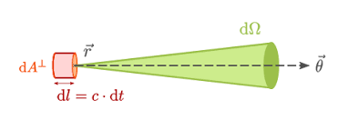
Figure 12.2.9 Volume element of radiation density. Image from physics-in-a-nutshell.com
125
Since the energy density, u_{Ω,ν}(ν,T), is given per unit solid angle, and is assumed to be isotropic, an integration of all solid angles is required in order to obtain the total energy density. This integration over a unit sphere gives

4π 4π
u_{ν} (ν,T) = ʃ u_{Ω,ν} (ν,T) dΩ = u_{Ω,ν},(ν,T) ʃ dΩ = 4π u_{Ω,v} (ν,T)
0 0

Planck’s Law of Radiation or the spectral radiance in frequency and wavelength spaces are then

I_{ν} (ν,T) = c u_{ν} (ν,T) = c 8πh ν ³
4π 4π c³ e^{hν/kT} – 1
or

I_{ν} (ν,T) = 2h ν³ , W
c² ( e^{hν/kT} - 1) m²-Hz-sr
and

I_{λ} (λ,T) = 2hc² 1 , W , wavelength, m: 1 nm = 10⁻⁹ m (nm = nanometer)
λ⁵ (e^{hc/λkT} - 1) m²-m-sr

An example of Planck’s Law in wavelength space is shown in Figure 11.x for various temperatures where the shaded area represents the visible portion of the spectrum.

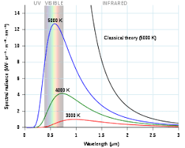

Figure 12.2.10 Black body spectral radiance curves. Image from en.wikipedia.org

126
12.2.3 Integration of Planck Law

Integration of the Planck radiation law requires a summation over space in spherical coordinates and also over either all frequencies or over all wavelengths. Several methods have been employed to integrate the frequency component of these integrals.

12.2.3.1 Integration over all frequencies

12.2.3.1.1 Method 1- Integration by Parts

The Planck radiation law can be integrated by parts, and this integration will be shown in some detail [12.2.8].

From the Derivation section, the Planck Law (spectral radiance) in frequency space is given by:

I_{ν} (ν,T) = 2h ν³
c² e^{hν/kT} – 1
The radiance is then

∞
I = ʃ I_{ν} (ν,T) dν
0
or
∞
I = ʃ 2h ν³ dν
0 c² e^{hν/kT} - 1

which may be written as
∞
I = 2 k³ T³ ʃ (hν/kT)³ 1 dν
h²c² 0 e^{hν/kT} - 1

Next, let x = hν and dx = h dν
kT kT
Then,
∞ ∞
I = 2 k⁴T⁴ ʃ x³ dx = 2 k⁴ T⁴ ʃ x³ e^{-x} dx
h³ c² 0 e^{x} - 1 h³ c² 0 1 – e^{-x}
∞
Noting that e^{-x} = Ʃ e^{-nx}
1 – e^{-x} ^{n=1}

∞ ∞
I = 2 k⁴ T⁴ Ʃ ʃ x³ e^{-nx} dx
h³ c² ^{n=1}
127
The general equation for integration by parts is:

ʃ fg’ = fg - ʃf’g

f = x³, g’ = dg = e^{-nx}
dx

f’ = df = 3x², g = ʃdg = ʃ e^{-nx} dx = - e^{-nx}
dx n

ʃ x³ e^{-nx} dx = -x³ e^{-nx} - ʃ- 3x² e^{-nx} dx
n n
---------------------------------------------------------------------------
Next, evaluate

ʃx² e^{-nx} dx

f = x² , g’ = dg = e^{-nx}
dx

f’ = df = 2x, g = ʃdg = ʃe^{-nx} dx = - e^{-nx}
dx n

ʃ x² e^{-nx} dx = - x² e^{-nx} - ʃ -2x e^{-nx} dx
n n
-----------------------------------------------------------------------
Next, evaluate

ʃ -2x e^{-nx} dx = -2ʃx e^{-nx} dx
n n

f = x, g’ = dg = e ^{-nx}
dx

f’ = 1, g = ʃdg = ʃe^{-nx} dx = e ^{-nx}
n

ʃ xe ^{-nx} dx = x e^{-nx} - ʃ - e^{-nx} dx
n n
---------------------------------------------------------------------------

128
Next, evaluate

ʃ - e^{-nx} dx
n

substitute u = - nx >>> du = -n >>> dx = - 1 du
dx n

ʃ -e^{-nx} dx = 1 e^{u} du
n n²

apply the exponential rule ʃa^{u} du = a^{u} , a = e
ln(a)

1 ʃe^{u} du = e^{u} = e^{-nx}
n² n² n²
-----------------------------------------------------------------------
Plug in solved integrals

xe^{-nx} - ʃ e^{-nx} dx
n n

= x e^{-nx} – e^{-nx}
n n²
-----------------------------------------------------------------

Plug in solved integrals

-2ʃxe^{-nx} dx
n

= 2x e^{-nx} + 2 e^{-nx}
n² n³
---------------------------------------------------------------

Plug in solved integrals

x²e^{-nx} - ʃ - 2ne^{-nx} dx
n n

= x²e^{-nx} – 2ne^{-nx} - 2e-nx
n n² n³
--------------------------------------------------------------

129

Plug in solved integrals

-3 ʃ x² e^{-nx} dx
n

-3x² e^{-nx} + 6x e^{-nx} + 6e^{-nx}
n² n³ n⁴
----------------------------------------------------------

Plug in solved integrals

x³ e^{-nx} - ʃ - 3x² dx
n n

= x³ e^{-nx} – 3x² e^{-nx} - 6x e^{-nx} - 6 e^{-nx}
n n² n³ n⁴
--------------------------------------------------------------
Problem solved

ʃ x³ e^{-nx} dx = - x³ e^{-nx} – 3x² e^{-nx} – 6x e^{-nx} – 6 e^{-nx} + C
n n² n³ n⁴

= (nx(nx(nx + 3) + 6) + 6) e^{-nx} + C
n⁴

= (n³x³ + 3n²n² + 6nx + 6)e^{-nx} + C
n⁴
---------------------------------------------------------------------

Insert integration limits
∞
ʃ x³ e^{-nx} dx = 6
0 n⁴

------------------------------------------------------------------

Replace summation

∞ ∞ ∞
Ʃ ʃ x³ e^{-nx} dx = 6 Ʃ 1
n=1 0 n=1 n ⁴

-------------------------------------------------------------

130
Reimann zeta function
∞
Ʃ 1 = ζ(4) = π⁴
n=1 n⁴ 90

------------------------------------------------------------------

Therefore,
∞ ∞
Ʃ ʃ x³ e^{-nx} dx = 6 π⁴ = π⁴
^{n=1 0} 90 15

and

I = 2 k⁴ T⁴ π⁴
h³ c² 15

I = 2 π⁴ k⁴ T⁴
15 h³c²

----------------------------------------------------------------

12.2.3.1.2 Method 2 - Integration using the Gamma Function and Reimann zeta function

The standard integral also involves a Gamma function and a Reimann zeta function [12.2.9]:

ʃ x³ dx = Γ(4)ζ(4)
(e^{x} – 1)
= 3! π⁴
90
= π⁴
15
giving

I = 2 π⁴ k⁴ T⁴
15 h³ c²

-------------------------------------------------------------------------

131

12.2.3.2 Integration over space

For the purpose of comparison, three surfaces will be considered rather trivally: sphere, hemisphere, and Lambertian.

Sphere

The integration geometry for a sphere is shown in Figure 11.11, with the longitude given by the angle, Φ, and the latitude by Θ.

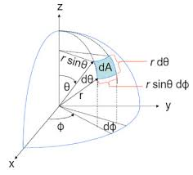
Figure 12.2.11 Spherical coordinates. Image from oceanopticsbook.info

Integration is performed as follows:

2π π
Ω = ʃ dΩ = ʃʃ dΦ sin Θ dΘ = ʃ dΦ ʃ sin Θ dΘ
0 0
π
Ω = 2π ( -cos Θ) = 4 π steradians
0
Hemisphere

In the case of a hemisphere, the coordinates are the same as for the sphere, but Θ is integrated from zero to π/2. Therefore,

2π π/2
Ω = ʃ dΦ ʃsinΘ dΘ
0 0
π/2
Ω = 2π( -cos Θ) = 2π steradians
0

132
Lambertian Surface

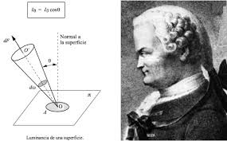
Figure 12.2.12 Johann Heinrich Lambert (1728-1777). Image from blog.ua.es

For a radiating surface, the intensity depends on the angle of observation, with the maximum intensity, I_{m}, viewed perpendicular to the surface. This intensity then decreases as the angle, Θ, increases from the normal according to the Lambert cosine law [12.2.10] as seen in Figure 12.213.
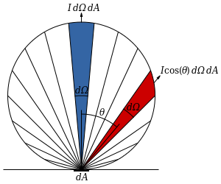
Figure 12.2.13 Lambert cosine law. Image from widiperia.org

The total power radiated per unit area, the radiant emittance, is found by further integrating the solid angle over the hemisphere of a Lambertian source:

2π π/2 π/2 π/2
M = ʃ dΦ ʃ I cos Θ sin Θ dΘ = 2π Iʃ sin (2Θ) dΘ = 2πI[ - cos(2Θ)/4] = πI
- 0 0 2 0
This solid angle for the Lambertian hemisphere is then π steradians rather than 2π steradians.

which gives the Stefan=Boltzmann Law [12.2.11] as M = 2 π⁵k⁴ T⁴ = σT⁴
15 h³c²

where the Stefan-Boltzmann constant is σ = 5.76 x 10⁻⁸ W/(K⁴ – m²).
133
12.2.4 Stefan-Boltzmann Law and the Solar Constant
The Stefan-Boltzmann law can also be written as:

P = 2πk⁴ T⁴ π⁴ = 2π⁵k⁴ T⁴ = σT⁴ , W
A h³c² 15 15h³c² m²

where the Stefan-Boltzmann constant is σ = 5.76 x 10⁻⁸ W
m² – K⁴
The total power radiated by a sphere of radius, R is

P = AσT⁴ = 4πR² σT⁴ , Watts

The sun with a radius of 6.96 x 10⁸ m and a surface temperture of 5,778 K radiates

P_{sun} = 3.86 x 10²⁶ W

Fom the inverse squae law, the Earth at a average distance of d = 1.5 x 10¹¹ m, or one Astronomical Unit (1 AU) receives:

S = P_{sun} = 1,368 W/m²
4πd²

which is the Solar Constant as illistrated in Figure 12.2.14.
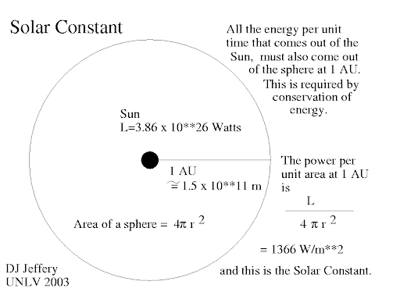
Figure 12.2.14 The Solar Constant. Image from UNLV.edu

134
12.2.5 Photon Flux
The photon flux can be obtained [12.2.12] through the division of the Planck distribution by the photon energy, E = hν or hc/λ, over the entire frequency or wavelength range. This quantity is necessary in order to determine the photon or quantum efficiencies of solar cells. An example of a solar photon flux spectrum is shown below in Figure 12.2.15.

12.2.5.1 Integration over frequencies

Analytically, the photon radiance is found by integration of the equation:

L = I
hν

L = 1 ʃh ν³ dν
hν c² exp(hν/kT) - 1

∞
L = 2 ʃ ν ² dν
c² 0 e ^{hν/kT} -1

where x = hν , dx = h dν
kT kT

ν² = (kT/h)²x² dν = kT dx
h

L = 2(kT/h)³ ʃ x² dx
c² e^{x} – 1

L = 2(kT/h)³ ʃ x² e^{-x} dx
c² 1 – e^{-x}
∞
Note: e^{-x} = Ʃ e^{-nx}
1 – e^{-x} n=1

∞ ∞
L = 2 (kT/h)³ Ʃ ʃ x² e^{-nx} dx
c² n=1 0
Integration by parts, similar to the Planck Law integral, gives
∞ ∞
L = 2 (kT/h)³ Ʃ 2 = 4(k/h)³ T³ Ʃ 1 = 4ζ(3)k³ T³ , photons
c² n=1 n³ c² n=1 n³ h³ c² m² – s - sr
∞
where Ʃ 1 = ζ (3) = 1.202 is the Riemann zeta function
n=1 n³
135
12.2.5.2 Integration over Space

Integrating L over the hemisphere for a Lambertian source [12.2.12] gives the total photon flux,

M = 4πζ(3) k³ T³ , photons
h³ c² m² - s

which is proportional to T³ whereas the radiance in the Planck Law is proportional to T⁴.

The photon flux produced per unit area at the sun’s surface is 2.93 x 10²⁶ photons/(m² – s). As the surface area of the sun is 6.088 x 10¹⁸ m², the total photon flux from the sun is
1.79 x 10⁴⁵ photons/s.

Consider an imaginary sphere defined by the earth’s orbit with a radius of 1.51 x 10¹¹ m, or
(1 A.U. = 1 Astronomical Unit) giving a surface area of 2.86 x 10²³ m². The solar photon flux received at the top of the earth’s atmosphere is then 6.23 x 10²¹ photons/(m² – s).

This flux at the surface of the earth can be estimated by taking the ratio of the surface radiance to the solar constant, 1,000/1,366 in units of W/m². Multiplying this ratio by flux outside the atmosphere gives a surface flux of 4.5 x 10²¹ photons/(m² – s)

An example of a solar photon-flux spectrum is shown in Figure 12.2.15

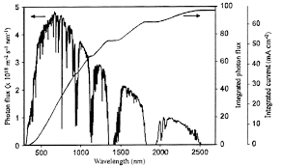

Figure 12.2.15 Solar photon flux spectrum. Image from researchgate.com

A rough graphical integration of this spectrum gives the solar photon flux at the earth’s surface of 5 x 10²¹ photons/(m² – s) which is in reasonable agreement (10 %) with the calculation above.

`

136
12.3 Appendix 3, Einstein Photoelectric Effect, 1905

Albert Einstein (1879 – 1955) [12.3.1] was most famous for his Special and General Theories of Relativity. He also developed the equation. E = mc², as it relates to nuclear reactions. Einstein was awarded a Nobel Prize in 1921 not for these theories but for his explanation of the photoelectric effect. This concept, as first suggested by Planck, was that light consisted of packets of energy called photons or quanta.

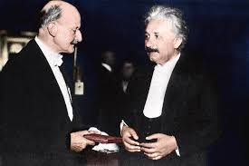

Figure 12.3.1 Max Planck and Albert Einstein. Image from fineartamerica.com

The photoelectric effect [12.3.2] can be described as follows in which the maximum kinetic energy of the ejected electrons is related to the frequency of the incident photon beam.

KE_{max} = h(ν_{a} - ν_{s})

KE_{max} = E_{a} – Φ_{s}

This relation is shown in Figure 12.3.2.

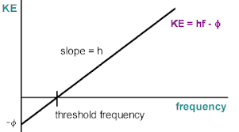

Figure 12.3.2 Photoelectric effect. Image from dev.physicslab.org

137
12.4 Appendix 4, Physics and Technology of Solar Cells

12.4.1 A Brief History of Solar Cells

A history of solar cells has been outlined [12.4.1] and a few highlights are given here:
1839 – Becquerel first observed the photovoltaic effect
1874 – Maxwell observed that light affects the conductivity of selenium
1883 – Fritz invented first working solar cell using selenium with 1% - 2% efficiency
1887 – Hertz discovered the photoelectric effect
1905 – Einstein explained the photoelectric effect in quantum terms
1916 – Millikan proved the photoelectric effect
1954 – Bell Labs produced solar cells for space applications
1973 – Skylab powered by solar cells
1994 – NREL developed Si cell with 30% conversion efficiency
2018 – GaAs PV cell with conversion efficiency of 29 %

It is an unfortunate result of history that the scientists, Arrhenius, Planck, and Einstein did not consider the potential negative effects of global warming. Although these scientists were contemporaries and associates, discussions concerning global warming apparently did not occur.

Perhaps if Arrhenius had lived in a British coal-mining area, he might have viewed the environmental and related health problems of the miners as serious matters. Today, these effects are known as the “social costs of carbon.”

Max Planck was involved in some of the WW I and WW II issues. His son was executed by the Nazis, along with many others, for one of the assassination attempts on Adolph Hitler.

Einstein signed a letter written by Leo Szilard encouraging President Roosevelt to begin a program for the development of an “atomic,” that is, a nuclear-fission weapon during WW II. This program was the Manhattan Project.

Besides being scientists, these men were “activists.” However, had they discussed the perceived issues of global warming and its mitigation means, their combined scientific knowledge would not have been sufficient to develop a useful solar cell. Although a working solar cell was invented in 1883, practical devices did not appear until around the mid-twentieth century.

In other historical developments, Edison invented the electric light bulb and the electric utility system in1879 as competition with city gas lights. Electric vehicles appeared between 1828 and late nineteenth century. Generators for electricity were initially powered by coal. Oil was discovered in the US in 1859 and large fields were found during the early 1900’s. Gasoline- powered vehicles then replaced their electric counterparts.

We are indebted to Arrhenius, Planck, Einstein, and to many others. Now, it is the responsibility of today’s generations and of future generations to develop the tools for producing a sustainable biosphere. A major component of this sustainability will be renewable energy.
138
12.4.2 Solar Irradiance and Photon Flux Spectra

The following figures show solar irradiance and photon flux spectra.

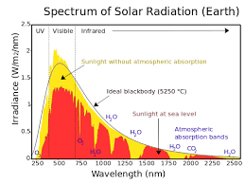
Figure 12.4.1 Spectrum of Solar Irradiance. Image from e-education.psu.edu

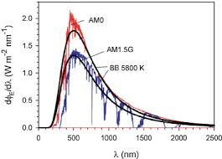
Figure 12.4.2 Spectrum of Solar Irradiance. Image from researchgate.com

Figure 12.4.3 Solar Photon Flux from the Earth’s surface. Image from researchgate.com

139
12.4.3 Solar Cell Operation

A brief description of solar cell operation will be given in this section. Readers may wish to consult detailed accounts of these processes [12.4.2] and of semiconductor physics [12.4.3].

The photovoltaic (PV) effect requires two processes. A current of charge carriers, I, is induced by the incident photons. In this regard, the current is similar to the photoelectric effect.
Additionally, a voltage, V, is produced, for example in a silicon cell, by a semiconductor p-n junction (diode), typically about 0.5volts. The product, of course, is the power of the cell, P:

P = IV

The paths of the incident solar photons can be considered in terms of the I_{p} - RAT formula:

I_{p} = R + A + T

where

I_{p} = incident photon radiation (spectral radiance)
R = reflected photons
A = absorbed photons
T = transmitted photons

These paths depend upon the energies, E_{p} = E_{n} = nhν = nhc/λ, of the incident photons such that:

Incident Reflected Absorbed Transmitted

E_{p} > E_{g} E_{p} < E_{g}

where E_{g} is the energy gap between the valence band and conduction band of the semiconductor cell. This gap is 1.2 eV for Si and 1.4 eV for GaAs.

The interactions of photons with a solar cell is shown schematically in Figure 12.4.4.
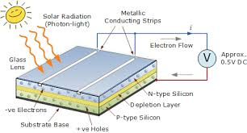
Figure 12.4.4 Photons striking a solar cell. Image from alternative-energy-tutorials.com

140
This interaction is also shown in Figure 12.4.5

Figure 12.4.5. Energy band diagram of a solar cell. Image from Wikipedia.com

141

Charges, electric fields, and voltages of pn junctions (diodes) are shown in Figures 12.4.6 and 12.4.7.

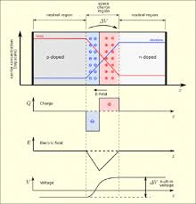

Figure 12.4.6 A pn junction. Image from solarcellcentral.com
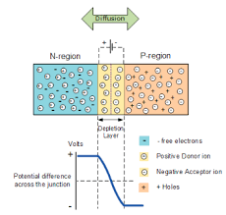

Figure 12.4.7 A pn junction. Image from news-energysage.com

142
An equivalent circuit for a solar cell is shown in Figure 12.4.8.
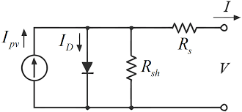

Figure 12.4.8. Equivalent Circuit of a Solar Cell. Image from mdpi.com

The basic equations for a solar cell are given here [12.4.4]].

The current produced by the solar cell is given by:

I = I_{ph} - I_{D} - I_{SH}

where

I = output current

I_{ph} = photon-generated current

I_{D} = diode (pn junction) current

I_{SH} = shunt current

The current through these elements is determined by the voltage across them:

V_{j} = V + IR_{S}

where

V_{j} = voltage across both the diode and resistor, R_{SH}

V = output voltage

R_{SH} = shunt resistance due to reverse saturation current, I₀, of the pn junction as caused by
manufacturing defects

R_{S} = series resistance caused by the ohmic metal-semiconductor contacts on n-type and p-type
sides

143
From the Shockley diode equation, the current diverted through the diode is:

I_{D} = I₀ [exp(V_{j} /nV_{T} ) – 1]

where

I₀ = reverse saturation current

n = diode ideality factor (1 for an ideal diode)

q = charge of the electron

k = Boltzmann’s constant

T = absolute temperature

V_{T} = kT/q, the thermal voltage. At 25 C, V_{T} = 0.0259 volt

From Ohm’s law, the current diverted through the shunt resistor is:

I_{SH} = V_{j}
R_{SH}

Substituting these terms into the first equation produces the characteristic equation of a solar cell which relates the solar cell parameters to the output current and voltage:

I = I_{ph} - I₀ {exp[(V = IR_{S})/nV_{T} ] – 1} – V + IR_{S}
R_{SH}

When the cell is operated at open circuit, I = 0, and the output voltage is the open-circuit voltage. Assuming that the shunt resistance is high enough to neglect the final term in the characteristic equation, the open-circuit voltage is:

V_{OC} = nkT ln [I_{ph/}I₀ - 1]
q

In addition, when the cell is operated at short circuit, V = 0, and the output current is the short-circuit current. For a high-quality solar cell (low R_{S}, low I₀, and high R_{SH}), the short-circuit current is:

I_{SC} = I_{ph}

144

The open-circuit voltage and short-circuit current are shown in the I-V curve of Figure 11.4.9

The Fill-Factor is given by

FF = I_{MP} V_{MP} = P_{MP}
I_{SC} V_{OC} I_{SC} V_{OC}

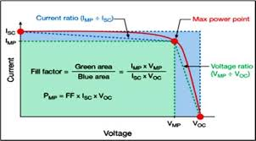

Figure 12.4.9 Solar cell I-V curve and fill-factor. Image from researchgate.cm

The conversion efficiency is given by the ratio of maximum power to the incident power:

η = P_{m} = I_{m} P_{m}
P_{inc} P_{inc}

where the incident power, P_{inc}, is based on the AM 1.5 solar spectrum of 1,000 W/m².

145

Two types of solar-cell quantum/photon efficiencies can also be defined [12.4.4] as shown in Table 11.4.1.

Table 11.4.1 Solar Cell Quantum Efficiencies
External Quantum Efficiency (EQE) | Internal Quantum Efficiency (IQE)
EQE is the ratio of the number of charge carriers collected by the solar cell to the number of photons of a given energy or wavelength incident on the cell.  EQE(λ) = electrons/sec  photons/sec  EQE(λ) = (current)/(charge of one electron)  (total photon power)/(photon energy)  The EQE(λ) depends on both the absorption of light and the collection of charges. Once a photon has been absorbed and has generated an electron-hole pair, these charges must be separated and collected. A “good” material avoids charge recombination which causes a drop in efficiency. | IQE is the ratio of the number of charge carriers collected by the solar cell to the number of photons of a given energy or wavelength incident on the cell which are absorbed by the cell.  IQE(λ) = electrons/sec  absorbed photons/sec  IQE(λ) = EQE(λ)  1 – Reflection – Transmission

146
These efficiencies are shown schematically in Figure 12.4.10

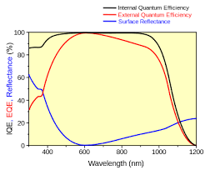
Figure 12.4.10. Solar cell quantum efficiencies. Image from wikiwand.com

An experimental graph of EQE is shown in Figure 12.4.11
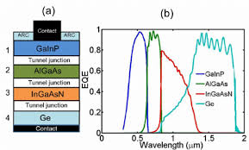

Figure 12.4.11 Quantum Efficiency of a Multi-Junction Solar Cell. Image from researchgate.net

147
12.4.4 Matching Irradiance Spectra and Cell Response

Various cell configurations have been designed to maximize the response to the solar irradiance spectra. Examples are shown in Figures 12.4.12 and 12.4.13, and 12.4.14

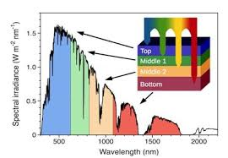

Figure 12.4.12 Response of a Multi-Junction Cell Across the Solar Spectrum.
Figure from researchgate.net

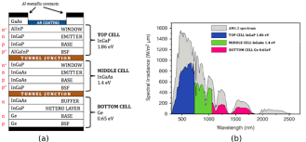
Figure 12.4.13 Response of a multi-junction cell across the solar spectrum.
Image from en.wikipedia.org

Figure 12.4.14 Multi-junction solar cell and solar spectrum
Image from researchgate.com

148
12. 5. Appendix 5. Units, Measurements, and Conversion Factors

Units and Measurements

In physics, the basic physical quantities are length, mass, and time; electrical charge is a fourth quantity. Einstein’s Theory of Special Relativity considered these three quantities as the particle or observer approached the speed of light. This theory, as proven experimentally, is insightful, elegant, and simple. Interestingly, Einstein was not awarded the Nobel Prize for this theory, but rather for the Photoelectric Effect and discussed in Appendix 3.

The primary systems of units are the Metric and Imperial. Within the Metric or SI system, the sub-systems are the MKS (meters-kilograms-seconds) and CGS (centimeters-grams-seconds). The Imperial system use feet-pounds-seconds. Within this guide, the system employed is the MKS which is also more convenient for electrical measurements. The concepts in this appendix are very basic but are included in the guide for clarity and completeness. As such, they may be useful for non-technical readers who might wish to consider these concepts in the broader terms of economic, social, and political policies.

The primary goal of this guide has been to lay a foundation for the transition of replacing fossil fuels with renewables, primarily solar energy. Thus, technical discussions shift from, say the chemical processes of oil refineries, to the conversion of solar photons to electrical power.

For the reasons stated in this guide, the transition will occur sooner rather than later over the periods of at least a generation (2020 – 2050) and, most likely, the transformation will continue in perpetuity.

Rather than considering the energy of oil, measured by Millions of Tons of Oil Equivalent (Mtoe), solar energies will be measured, for example, in terms of the energy band gap of silicon, 1.2 electron-Volts (eV) and photon energies. These quantities differ by a factor of about 10³⁵ as shown in Table 11.1. Solar power and energy will also be measured over panel areas and for different time periods.

The physical quantities of most interest in the guide are energy, power, electric current, area, temperature, mass, and length (or wavelength in the case of photons).

Energy is the ability to perform work and is defined as a force moving through a distance

In MKS units, energy is measured in Joules such that

1J = 1N x 1m

Where the force is measured in Newtons. and the distance is measured in meters.
149

Power is the rate of performing work or using energy.

Power, as measured in Watts, is given by:

1W = 1J/sec

Electrical power is the product of current and volts

P = IV

Watts = Amps x Volts

Electric Current is the flow rate of electrical charges

I = q/sec

where

q = charge of the electron, 1.60⁻¹⁹ Coulomb

1 Amp = 1 Coulomb x electron
sec 1.60 x 10⁻¹⁹ Coulombs

1 Amp = 6.24 x 10¹⁸ electrons/sec

Area is just a two-dimensional space.

The simplicity of area measurements renders them no less significant than other units in the development of solar energy technologies. Examples of area measurements are given below:

Solar Constant = 1,368 W/m², top of earth’s atmosphere
Solar power = approximately 1,000 W/m² at earth’s surface, zenith (also laboratory sources)
Photon flux = approximately 5 x 10²¹ photons/(m² – sec) at earth’s surface
Radiative forcing = 3 W/m², the (increasing) excess of incoming over outgoing radiation
World wide area of solar panels = 348,000 km² (0.23% of world land mass area, this guide)
Solar cell current densities = 50 -100 mA/cm²

These quantities also give the “densities” of various physical measurements per unit area.

150

Temperature is a measure of energy. This quantity is also one of the major parameters in the context of global warming. Three “thermometers” are used to quantify this measurement, Kelvin, Centigrade, Fahrenheit. Of most significance is the Kelvin scale for determining the absolute temperature as it is required for calculations involving chemical and nuclear reactions. The range of this scale is from “absolute zero” to millions of degrees in the case of nuclear processes. Simple conversions are:

K = C + 273
C = (F – 32 F) 5/9
F = 32 + 9/5C

Temperature becomes a measurement of energy when the Boltzmann Constant, k, is used,
E = kT. This term also appears as the ratio of hν/kT in the Planck Radiation Law (Appendix 2).

Mass occurs in the guide as a measure of atmospheric emissions. These emissions are usually recorded in terms of grams, kilo-grams, US tons, metric tonnes, or gigi-tonnes of carbon or carbon dioxide. The chemical reaction here is

C + 2O CO₂

with their atomic weights as

12 + 2(16) = 44

Also reported is the amount of CO₂ – eq. or CO₂ – equivalent which includes other GHG’s based on their GWP’s or Global Warming Potentials. The amounts are often given as Gt-CO₂ – eq, meaning giga-tonnes of CO₂ eq. per year (10⁹ tonnes/yr) or as accumulated amount over a period of time. The masses may also be reported as Imperial tons (2,000 pounds) or Metric tonnes (1,000 kgs). Caution should be used when reviewing emission data in order to distinguish whether these levels refer to carbon or carbon dioxide.

Length, in the case of solar photon wavelength, appears is various units.

Photon wavelengths are measured in Angstroms, nano-meters (nm), and micro-meters or microns (μm) where one Angstrom is 0.1 nm and one nm is1 x 10⁻⁹ m. One μm is 1 x 10⁻⁶ m.

151
Conversion Factors

While most countries employ the metric system for units and measurements, three “developing countries” still use the Imperial system; those countries are the United States, Myanmar (formerly Burma), and Liberia as seen in Figure 12.5.1.
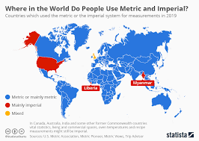
Figure 12.5.1 Countries who still use the Imperial System. Image from statista.com

An exception to this list also exists. It is well known that the British, with their mixed system, still measure the speed of light in units of “furlongs per fortnight.” This reliance is due to the influence of Sir Isaac Newton whom the English claim as one of their own. In order to convert this measurement from the MKS system to the mixed system, the following calculation can be made.

c = 3.00 x 10⁸ m furlong 60 s 60 min 24 hr 14 days
s 201 m min hr day fortnight

c = 1.81 x 10¹² furlongs
fortnight

Conversions of common energy values are shown in Table 12.5.1.

Table 12.5.1 Conversion table for energy units.
 | Joules  J | electron-Volts  eV | Kilo-Watt-Hours  KWh | Terra-Watt-Years  TWy | Million-Tonnes  Oil-Equivalent  Mtoe
J |  | 6.24 x 10¹⁸ | 2.78 x 10⁻⁷ | 3.17 x 10⁻²⁰ | 2.39 x 10⁻¹⁷
eV | 1.60 x 10⁻¹⁹ |  | 4.45 x 10⁻²⁶ | 5.08 x 10⁻³⁹ | 3.83 x 10⁻³⁶
KWh | 3.60 x 10⁶ | 2.25 x 10²⁵ |  | 1.14 x 10⁻¹³ | 8.60 x 10⁻⁵
TWy | 3.15 x 10¹⁹ | 1.97 x 10³⁸ | 8.77x 10¹² |  | 1.33 x 10⁻³
Mtoe | 4.18 x 10¹⁶ | 2.61 x 10³⁵ | 1.16 x 10⁴ | 752

These conversion values were found on Google.

